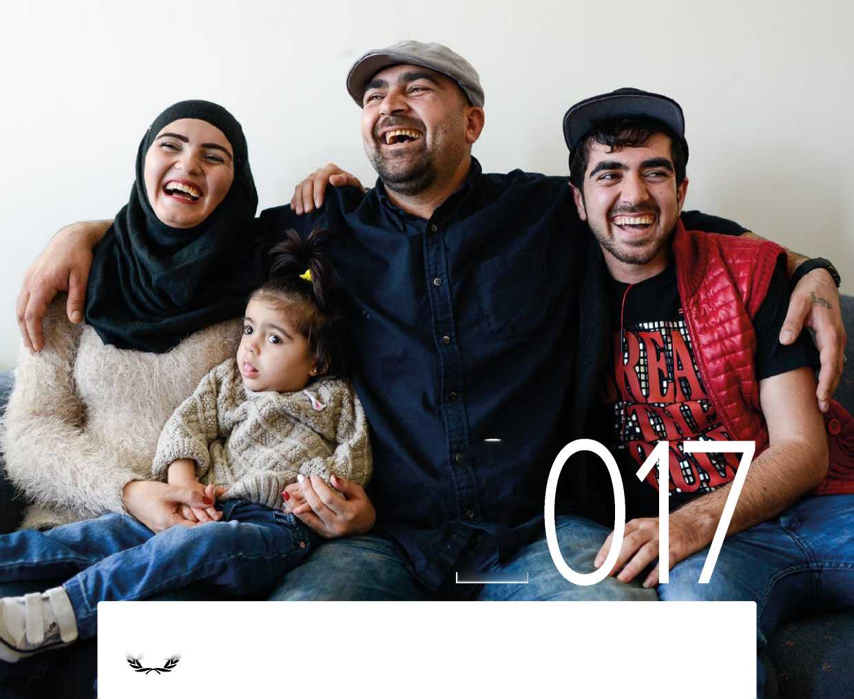UNHCR

PROJECTED

**GLOBAL RESETTLEMENT NEEDS.**

***M*UNHCR**

**The UN Refugee Agency**

**22nd Annual Tripartite Consultations on Resettlement, Geneva: 13-15 June 2016**

UNHCR

PROJECTED

**GLOBAL**

**RESETTLEMENT**

**NEEDS**

**(flyUNHCR**

**The UN Refugee Agency**

22nd Annual Tripartite Consultations on Resettlement, Geneva: 13-15 June 2016

Cover Photo: Newly arrived Syrian family enjoying their new home in Ottawa. The Mahmut family are Kurdish Syrians who arrived to Canada, from Turkey, at the end of January 2016, as part of Canada's humanitarian programme to resettle 25,000 Syrian refugees. Jamal Mahmut (center) arrived with his wife Ahlam, daughter Sems, and his younger brother Eymen (right). They are happy to be living in their own apartment in Ottawa. @UNHCR / J. Park / 14 April 2016

Layout & Design: BakOS DESIGN

Contents

Acronyms 5

World: UNHCR projected global resettlement needs by country of asylum 6

World: UNHCR projected global resettlement needs by country of origin 8

**Introduction** 10

2015 Trends and Developments 11

Upscaling Resettlement - Projected Global Resettlement Needs and Capacity for 2017 13

Managing and Implementing Resettlement 15

Strategic Response 2016-2017 18

**Africa** 20

**Africa Overview** 21

Map - Africa: UNHCR's total resettlement capacity for 2017 by country of asylum 22

Africa: 2017 Projected needs and targets 24

**The Americas** 28

**Americas Overview** 29

Map - Americas: UNHCR's total resettlement capacity for 2017 by country of asylum 3 0

The Americas: 2017 Projected needs and targets 32

**Asia and the Pacific** 34

**Asia and the Pacific Overview** 35

Map - Asia and the Pacific: UNHCR's total resettlement capacity for 2017 by country of asylum 36

Asia: 2017 Projected needs and targets 38

**Europe** 40

**Europe Overview** 41

Map - Europe: UNHCR's total resettlement capacity for 2017 by country of asylum 42

Europe: 2017 Projected needs and targets 44

**Middle East and North Africa** 46

**Middle East and North Africa Overview** 47

Map - MENA: UNHCR's total resettlement capacity for 2017 by country of asylum 48

MENA: 2017 Projected needs and targets 52

**Annex: UNHCR Global Resettlement Statistical Report 2015** 54

Introduction 54

At a Glance Figures 54

**Submissions** 55

Top Ten: UNHCR Resettlement Submissions in 2015 55

UNHCR Resettlement Submissions in 2015 56

UNHCR Submissions by Region of Asylum 2011-2015 56

**Departures** 57

Top Ten: UNHCR Resettlement Departures in 2015 57

UNHCR Resettlement Departures in 2015 58

UNHCR Departures by Region of Asylum 2011-2015 58

UNHCR Resettlement Departures 2011-2015 59

**Resettlement Categories** 60

UNHCR Resettlement by Submission Category in 2015 60

UNHCR Resettlement Under the Women and Girls at Risk (AWR) Category in 2015 60

UNHCR Resettlement Under the Medical Needs Category in 2015 61

UNHCR Resettlement by Priority in 2015 61

**Acceptance Rates** 63

Acceptance Rates of UNHCR Submissions by Resettlement Countries in 2015 63

**Priority Situations** 64

Protracted Refugee Situations Where Resettlement Takes Place 2013-2015 64

Per Capita Resettlement by Country of Resettlement in 2015 6 5

**ACRONYMS**

|  |  |
| --- | --- |
| **BIA** | Best Interest Assessment |
| **BID** | Best Interest Determination |
| **CAR** | Central African Republic |
| **COB** | Republic of the Congo |
| **COI** | Cote d'Ivoire |
| **DRC** | Danish Refugee Council |
| **DRC (the)** | The Democratic Republic of the Congo |
| **ECOWAS** | Economic Community of West African States |
| **HRIT** | Heightened Risk Identification Tool |
| **ICMC** | International Catholic Migration Commission |
| **ICRC** | International Committee of the Red Cross |
| **IOM** | International Organization for Migration |
| **IRAP** | International Refugee Assistance Project |
| **IRC-RSC** | International Rescue Committee-Resettlement Support Centre |
| **IUNV** | International United Nations Volunteer |
| **JPO** | Junior Professional Officer |
| **LGBTI** | Lesbian, Gay, Bisexual, Transgender and Intersex |
| **MENA** | Middle East and North Africa |
| **NOA** | Assistant National Officer |
| **NOB** | Associate National Officer |
| **NOC** | National Officer |
| **NOD** | Senior National Officer |
| **NUNV** | National United Nations Volunteer |
| **RRF** | Resettlement Registration Form |
| **RSD** | Refugee Status Determination |
| **UASC** | Unaccompanied and Separated Child |
| **UNFPA** | United Nations Population Fund |
| **UNICEF** | United Nations Children's Fund |
| **UNOPS** | United Nations Office for Project Services |
| **UNRWA** | United Nations Relief and Works Agency for Palestine Refugees in the Near East |
| **USRAP** | United States Refugee Admissions Program |

UNHCR PROJECTED GLOBAL* RESETTLEMENT NEEDS

**WORLD**

**as of 27 May 2016**

**BY COUNTRY OF ASYLUM**

ATION

BOLIVARIAN REPUBLIC OF VENEZUELA

Based on information reported by UNHCR's offices in countries included in this publication.

TRINIDAD AND TOBAGO

PANAMA

MEXICO

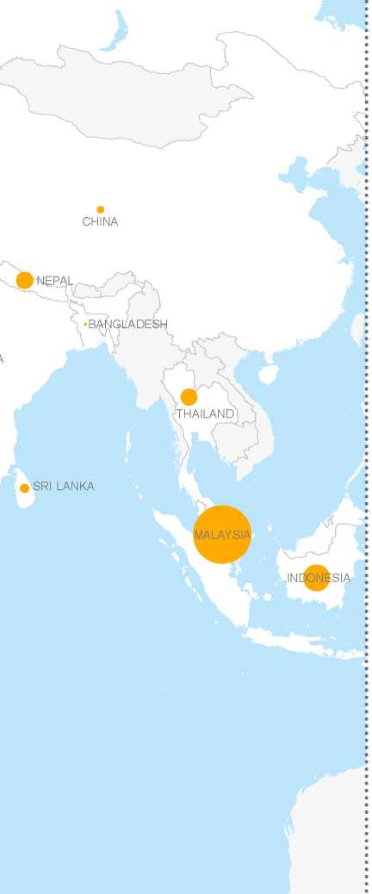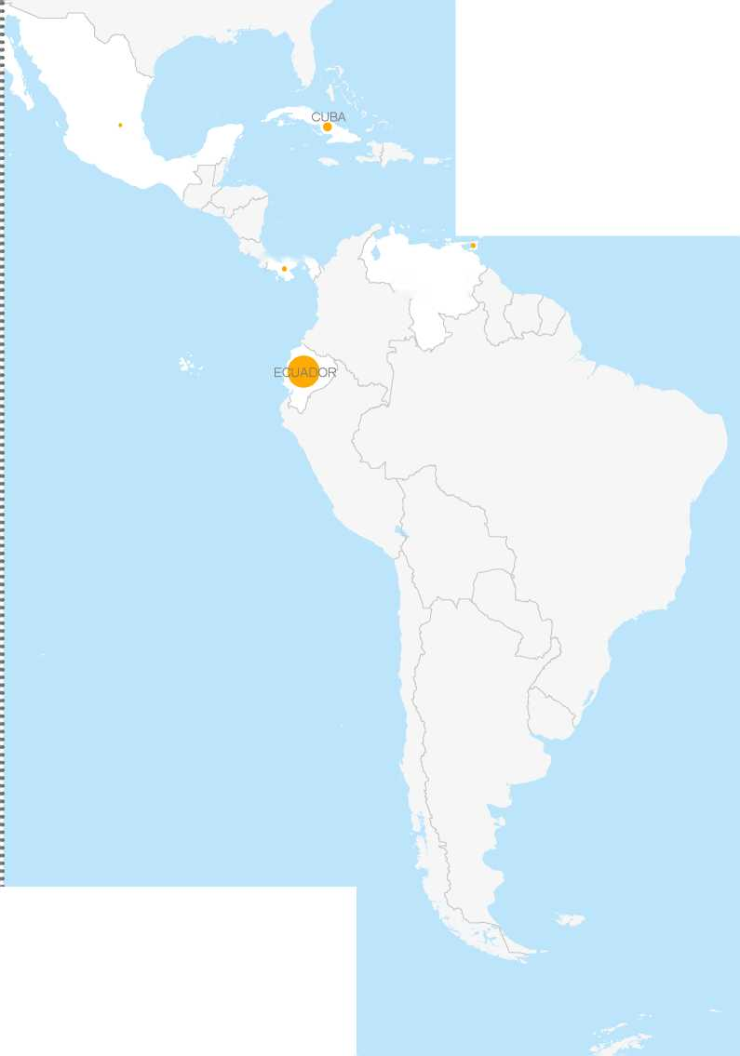

TURKEY

UKRAINE

LEBANON

MALTA

IRAQ

ISRAEL

MOROCC

JORDAN

KISTAN

LIBYA

EGYPT

INDIA

MAURITANIA

NIGER

SUDAN

YEMEN

SENEGAL

DJIBOUTI

NIGERIA

• SOMALIA

MERO

ETHIOPIA

LIBERIA •

GHANA

KENYA

RWANI

RUNDI

ANGOLA

• MOZAMBIQUE

ZIMBABW

NAMIBIA

BOTSWAN

COTE 'IVOIR

SOUTH

SUDAN

SAUDI ARABIA

DEMOCRATIC REPUBLIC OF THE CONGO

REP. OF CHAD

ISLAMIC

REPUBLIC OF IRAN

UNITED EPUBLIC O TANZANIA

.•UNITED ARAB EMIRATES

RUSSIAN

FEDERATION

>SRI LAN

300,000

rrV

REPUBLIC OF THE CONGO

?7

1,000km

*-'•<­*

SOUTH AFRICA

100,000

20,000

2,000

GAMBIA

guinea-bissau’/guinea

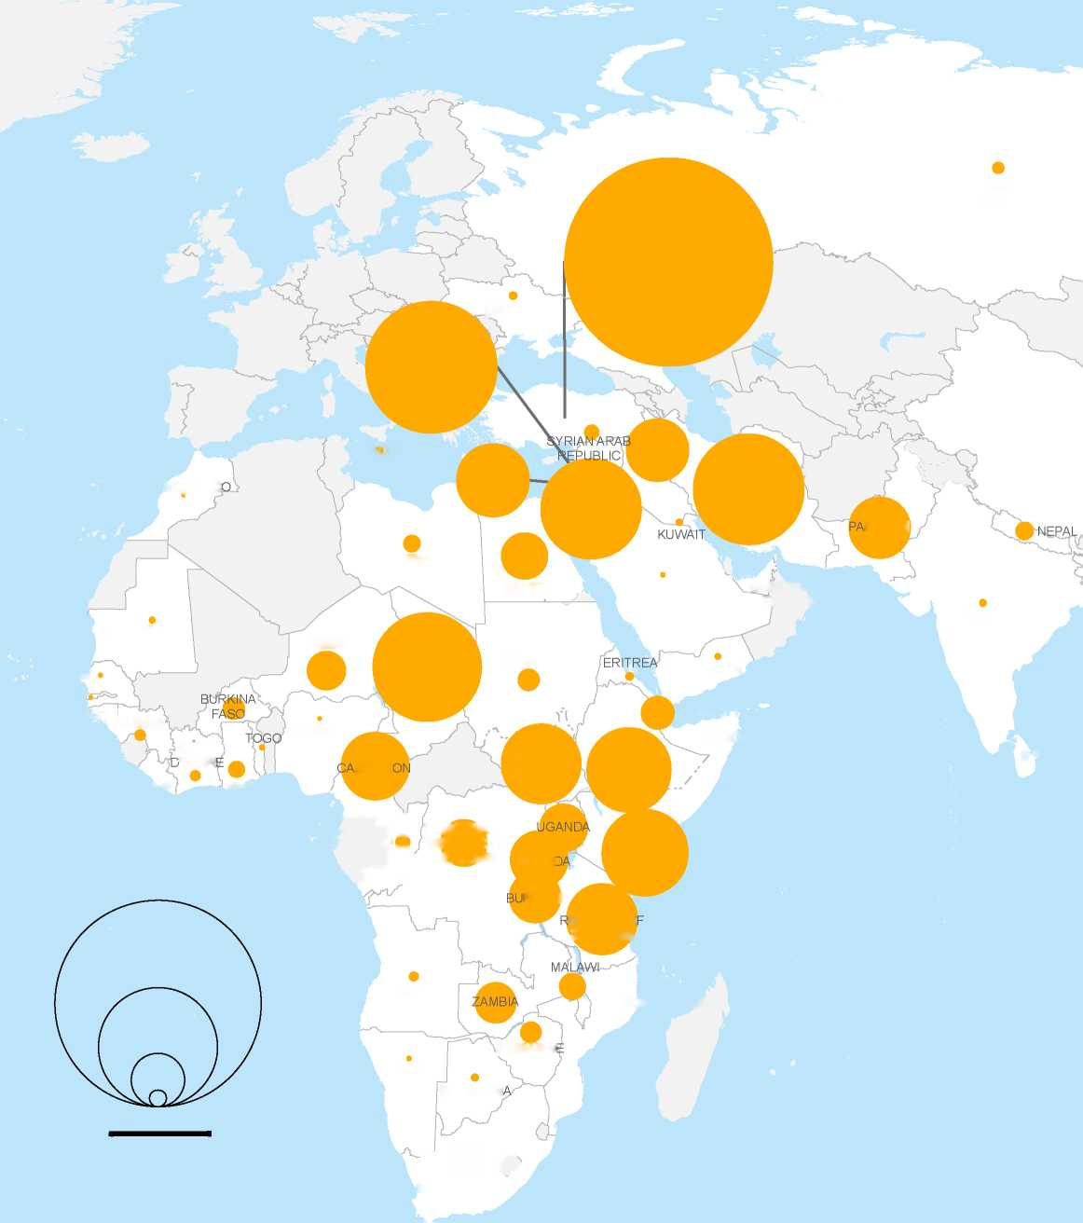

**Total projected resettlement needs**

The boundaries and names shown and the designations used on this map do not imply official endorsement or acceptance by the United Nations.

Printing date: 27 May 2016

© UNHCR - Geneva

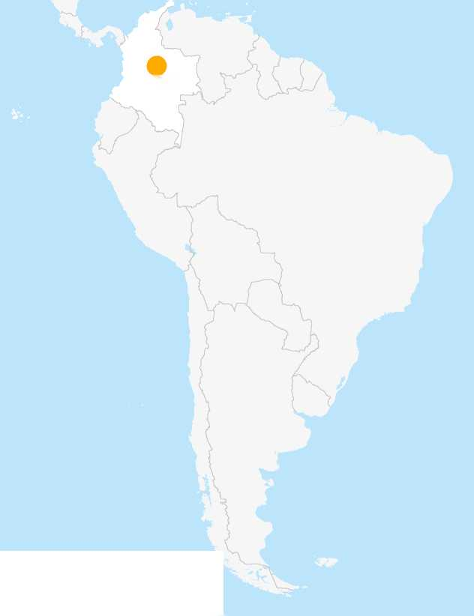

**WORLD**

**as of 27 May 2016**

UNHCR PROJECTED GLOBAL* RESETTLEMENT NEEDS

**BY COUNTRY OF ORIGIN**

COLOMBIA

* Based on information reported by UNHCR's offices in countries included in this publication.

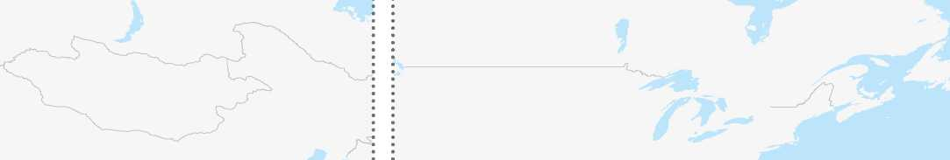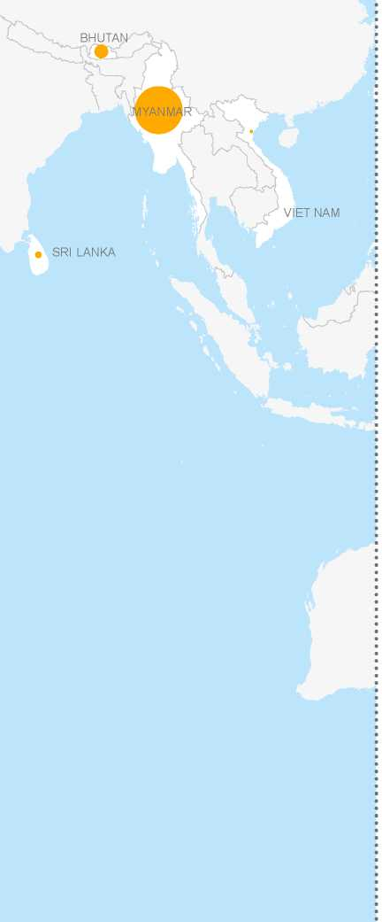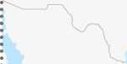

FGHANISTAN

IRAQ

PAKISTAN

MALI

SUDAN

ERITREA

YEMEN

NIGERIA

ETHIOPIA

CAMEROON

SOMALIA

ZIMBAB

NAMIBIA

CENTRAL

AFRICAN

REPUBLIC

DEMOCRATIC REPUBLIC OFR THE CONGO

ISLAMIC

REPUBLIC

OF IRAN

• SRI LANK

SYRIAN ARAB

REPUBLIC

200,000

1,000km

20,000

2,000

SIERRA

LEONE

Y, i •

COT I

D'IVOI •f

LIBERIA

500,000

LIBYA

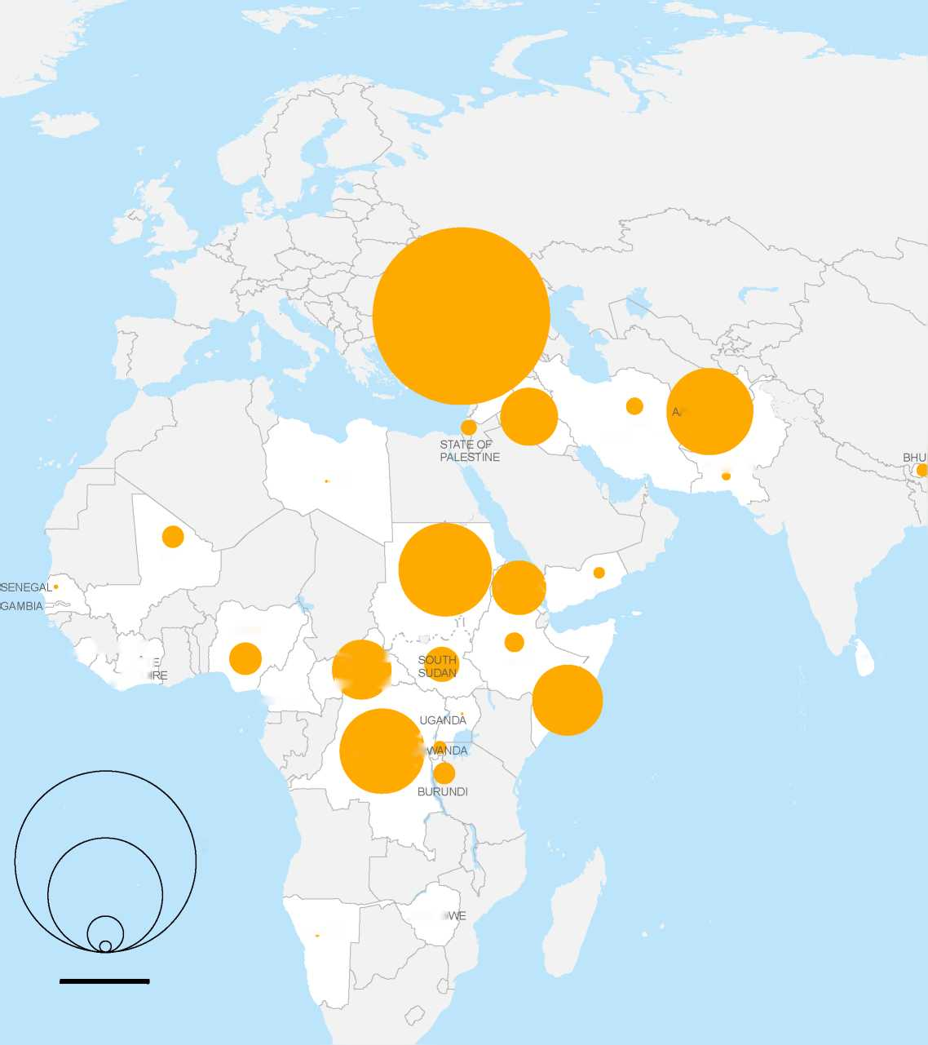

**Total projected resettlement needs**

The boundaries and names shown and the designations used on this map do not imply official endorsement or acceptance by the United Nations.

Printing date: 27 May 2016

© UNHCR - Geneva

Introduction

Syrians fleeing renewed fighting rush across broken down border fences at the Akcakale border crossing in Sanliurfa province in southern Turkey.

© Anadolu Agency / A. I. Ozturk / June 2015

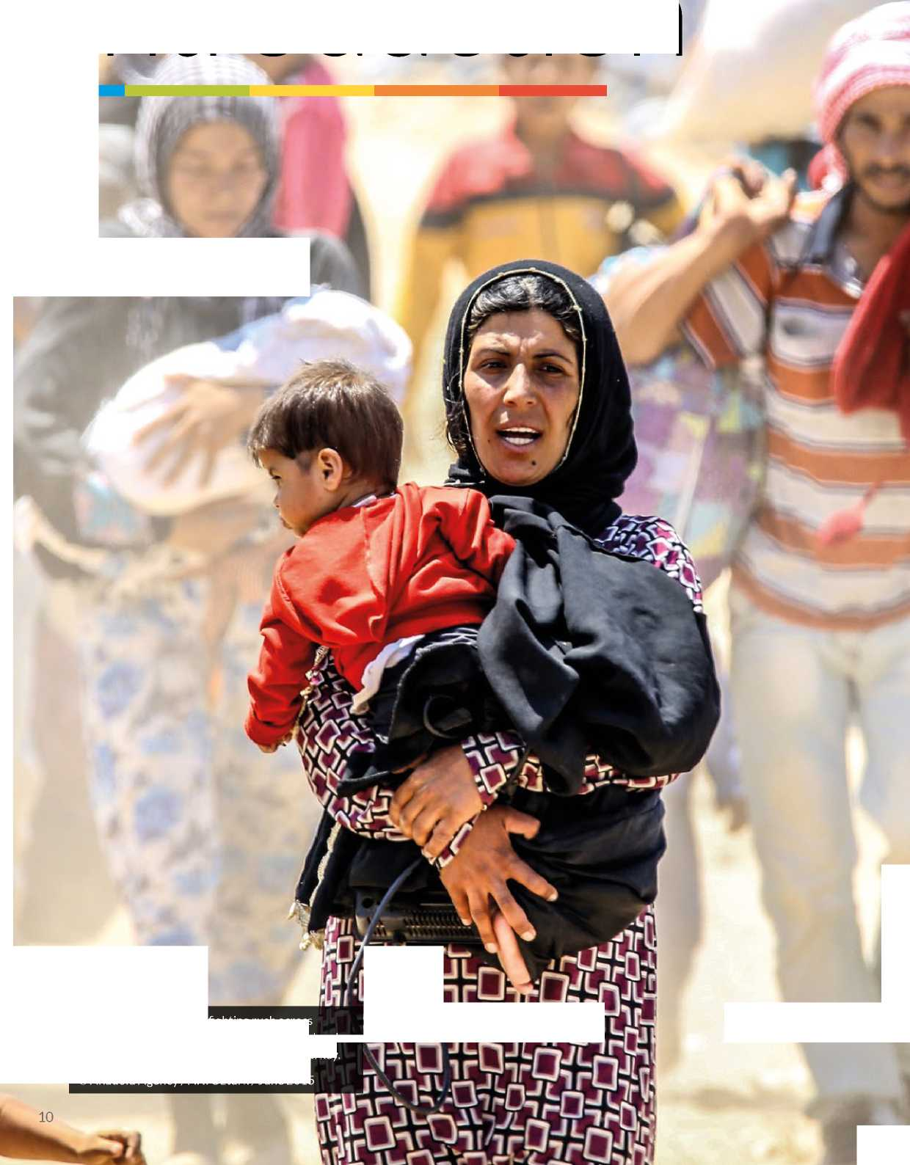

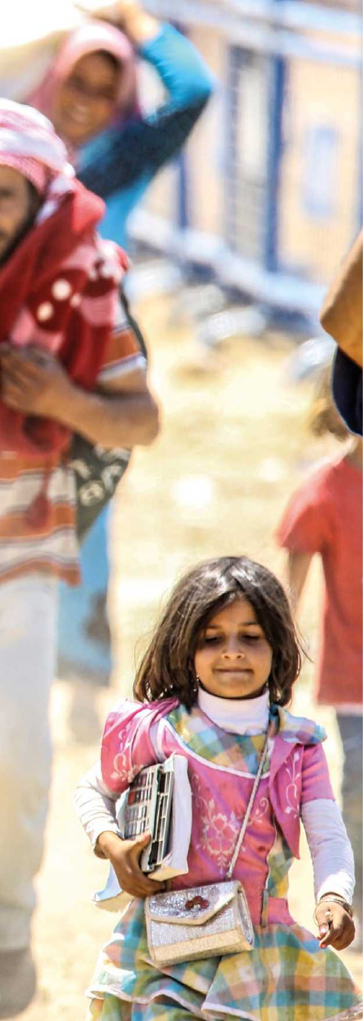

INTRODUCTION

2015-2016 will be remembered as defining years in situating resettlement at the centre of the global protection and solutions agenda. As the scope of resettlement has expanded exponentially, there has equally been an increasing realization that other humanitarian and additional pathways for admission need to be made available if the growing needs of refugees around the world are to be met. 2015 concluded with more than a million refugees and migrants having crossed the Mediterranean, and conflicts in Syria and elsewhere continue to generate staggering levels of human suffering, exceeding all previous records for global forced displacement. Events in Europe placed refugees at the centre of international media attention and political agendas. In response to this complex scenario, resettlement played a crucial role in UNHCR's efforts to find solutions and advocate for equitable responsibility-sharing for refugees. Expanding significantly as a tangible protection response to those in need, resettlement continues to prove to be a flexible tool able to deliver protection in an expedited manner.

This Chapter provides statistical updates for 2015, including resettlement submission and departures figures, and outlines the most important regional trends through comparison to previous years. It summarizes UNHCR's initiatives to upscale and expand resettlement capacity, and provides the estimated global resettlement needs and capacity for 2017, based on planning figures provided by UNHCR field offices around the world. The Chapter provides an overview of the most important policy-related developments and activities which took place in 2015 and early 2016, and outlines the main elements and initiatives that will inform UNHCR's strategic direction for 2016-2017.

2015 Trends and Developments

Over the past decade, UNHCR submitted more than one million refugees to States for resettlement. Submissions for 2015 were the highest recorded during this period (134,044) representing 29 per cent more than in 2014 (103,890). This compares to 74,840 in 2012 and 92,915 in 2013, respectively. Within a span of four years, annual UNHCR submissions had thus increased by a striking 79 per cent.

Refugees from Myanmar, Iraq, Bhutan and Somalia have over the past decade been the target of a large number of resettlement submissions. However, the magnitude of the Syrian crisis provoked an important shift which resonated in the 2014 and 2015 programme years. With some 80,000 refugees having been referred to States for resettlement since the outbreak of conflict in early 2011,1 Syria became the largest country of origin in 2014 and 2015. In 2015, on average two out of five submissions

1 Up to 31 December 2015. were Syrians compared to one out of five just one year earlier. Other top countries of origin referred to States in 2015 include the Democratic Republic of the Congo (20,527), Iraq (11,161), Somalia (10,193) and Myanmar (9,738). These four countries and Syria accounted for almost 80 per cent, or four out of five, submissions for the year.

Globally, resettlement continued to act as a key protection tool throughout the period. Legal and Physical Protection Needs constituted about one third of all cases submitted for resettlement in 2014 and 2015. Survivors of Violence and/or Torture was the second largest category in 2015 at 24 per cent. This category has almost quadrupled since 2005 reflecting in part renewed focus on this profile by some resettlement countries. The category Lack of Foreseeable Alternative Durable Solutions accounted for 22 per cent of submissions in 2015, a drop from 26 per cent a year earlier.

The continuous prioritization of Women and Girls at Risk meant that levels remained fairly stable in recent years at around 12 per cent, exceeding UNHCR's objective of submitting at least 10 per cent of resettlement cases under this category for the fifth consecutive year.

The United States of America (USA) remained the main recipient of UNHCR referrals with 82,491 submissions registered during 2015 (62 per cent of all submissions), followed by Canada (22,886 submissions), Australia (9,321), Norway (3,806) and the United Kingdom (3,622). All four countries saw increases in year-to-year submissions ranging from 52 per cent (Canada) to 268 per cent (United Kingdom).

Some 53,331 referrals originated from UNHCR's offices in the MENA region, which constituted a 22 per cent increase in respect of the submissions in 2014 for this region. Submissions from the MENA region also accounted for 40 per cent of the overall global submission number. 2015 ended with this region having implemented important innovative initiatives, in conjunction with resettlement countries, for the development and piloting of several streamlined resettlement methodologies specific to Syrian refugees that resulted in expedited processing and the aforementioned increase in submissions. Examples of such approaches include the Pilot Identification Programme with Australia, the Humanitarian Transfer Programme with Canada and the Simplified identification Form with the USA.

UNHCR offices in Europe's region recorded the highest number of submissions for the decade in 2015 (18,833), the majority of which were from Turkey. The large refugee influx into Europe resulted in this region also developing a number of resettlement related initiatives, including the adoption in July 2015 of the Council of the European Union Conclusions on Resettlement, as a result of which some 22,500 resettlement places were made available by 27 Member States plus Iceland, Liechtenstein, Norway and Switzerland during the period 2015-2017. As a result, countries such as Bulgaria, Croatia, Cyprus, Estonia, Greece, Latvia, Lithuania, Malta, Poland, Slovakia and Slovenia will be implementing a formal resettlement programme for the first time. UNHCR has already begun working with these emerging resettlement countries to develop their programmes, providing guidance, advice and technical expertise in both case processing and integration matters. In addition, and as a result of the agreements between the EU and Turkey to address the situation of refugees and migrants moving into Europe from and through Turkey, the number of resettlement spaces offered by European countries for Syrians in Turkey has increased exponentially. The implementation of an expedited resettlement process for resettlement of Syrian refugees out of Turkey, beginning late March 2016, as well as the ongoing discussions with European States on a Voluntary Humanitarian Admission Scheme has increased the possibility for Syrian refugees in Turkey to gain access to a durable solution.

With regard to Africa, despite an increase in the number of submissions from 35,079 in 2014 to 38,870 one year later, the region's relative share dropped from 34 to 29 per cent. The Great Lakes Core Group continued, however, supporting a sub-regional strategy to enhance durable solutions for Congolese refugees. This strategy includes a multi-year plan of action to enhance resettlement of Congolese refugees from Burundi, Rwanda, United Republic of Tanzania, and Uganda, as well as to promote livelihoods and self-reliance activities and to support host communities. Over 43,000 refugees from the Democratic Republic of the Congo have been submitted for resettlement as part of the commitment to resettle at least 50,000 refugees between 2012 and 2017; as such, UNHCR anticipates the remaining target will be met without difficulties.

Countries in the Asia and Pacific region accounted for 21,620 submissions during 2015, or 16 per cent of the overall global submission. It constitutes a drop from 27,450 in 2014 (26%) and a significant shift from levels in the previous decade due to the realisation of other solutions within this part of the world. However, the region also marked a notable milestone; in November 2015 it was announced that 100,000 refugees from Bhutan have been resettled from Nepal's camps to third countries, 85 per cent of them to the USA.

Finally, some 1,390 submissions originated from the Americas region (1,800 in 2014), a decrease in numbers reflecting renewed efforts in Ecuador to focus on local integration initiatives for Colombian refugees. Despite the decline in numerical submissions, the region has seen some innovative thinking in fostering resettlement as a protection tool and as a durable solution. For instance, the deteriorating situation in the countries comprisingthe Central American Northern Triangle compelled UNHCR, in late 2015, to start discussions with a view of expanding the role of resettlement in some countries in Central America. In addition, in the context of the Brazil Declaration and Plan of Action, unanimously adopted by Latin America and Caribbean governments to mark the 30th anniversary of the 1984 Cartagena Declaration, Argentina, Brazil, Chile, Paraguay and Uruguay undertook, with support from UNHCR, an independent evaluation of the Solidarity Resettlement Programme. The evaluation assisted stakeholders in understanding what went well, gather feedback from the refugees themselves, share best practices, and make recommendations for a way forward, which are currently being discussed and assessed.

Upscaling Resettlement - Projected Global Resettlement Needs and Capacity for 2017

The magnitude of the refugee crisis in Europe led a number of resettlement States including Canada, the United Kingdom, the United States, Norway and Australia to generously announce in the last quarter of 2015 significant increases in their resettlement quotas, benefitting refugees from Syria and other countries in several regions.

In order to meet such a need for an increase in submissions, UNHCR prepared in late 2015 the Plan of Action for Urgent Up-scaling of Resettlement, Legal Pathways and Stabilization/Comprehensive Local Integration (referred herewith as the Plan of Action). Anticipating a need to increase resettlement submissions by 37 per cent in respect of 2014 figures, the Plan of Action outlined the immediate additional workforce needed to meet the growing demands from countries as well as the main functional areas where such additional resources would be deployed, including registration and community based protection; refugee status determination where relevant; and integrity of individual case protection chains. At a more strategic level, the Plan of Action acknowledged that meeting increased resettlement quotas can only be sustained over time by substantially reforming current resettlement procedures; and furthermore recognized that increased resettlement would also need to be complemented with greater efforts to expand humanitarian and other complementary pathways for admission to protection and solutions.

In order to implement all the activities detailed in the Plan of Action, UNHCR launched in February 2016 the Supplementary Appeal for Strengthening Refugee Resettlement and other Pathways to Admission and Solutions (hereinafter referred to as The Supplementary Appeal). As of May 2016 approximately 60-70 per cent of the additional workforce needed to meet the extra demands has been recruited. Training activities have been substantially boosted to swiftly meet the needs

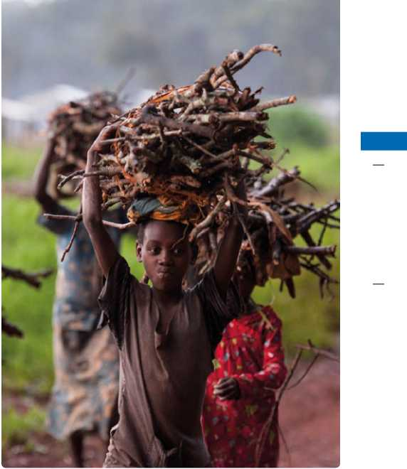of new staff (further details below), and a number of activities in the area of integrity and anti-fraud, including the recruitment of expert positions, have also been undertaken.

Young Burundi refugee girls collect firewood in the rain at the UNHCR refugee camp Nduta in the Kigoma district Tanzania. © UNHCR / S. Rich / February 2016

INTRODUCTION

However, despite the generous increases in resettlement quotas by resettlement countries, and the striking increases in submission numbers and progress made in expanding the resettlement programme, the reality is that resettlement needs of refugees around the world continue to vastly outnumber current capacity. In 2017, UNHCR estimates the global resettlement needs to be over 1,190,000 persons, including the resettlement needs of refugees in a protracted situation where resettlement is envisioned over a period of several years. This figure represents a marginal increase of 3 per cent compared with the total projected resettlement needs in the previous year (approximately 1,153,000 persons). However, when compared to the projected needs of 691,000 persons in 2014, 2017 represents a considerable increase of 72 per cent. This sharp increase is partly explained by the fact that resettlement needs for Syrians were not included in the 2014 projections due to the fluid nature of developments for this refugee population at the time.

Syrians account for 40 per cent of the 1,190,000 refugees in need of resettlement, the highest figure since outbreak of conflict in the country in early 2011. This compares to 37 per cent one year earlier and a reflection of a continuously deteriorating humanitarian situation. Sudan (11%), Afghanistan (10%), and the Democratic Republic ofthe Congo (9%) are other major refugee groups in need of resettlement.

The Syria crisis also has an impact on the regional distribution of projected resettlement needs for 2017. Europe reports a growth of 43 per cent compared to the previous year with needs estimated at close to 307,000 persons; 90 per cent of them being Syrians from Turkey. Africa too reports an increase in resettlement needs, albeit at a lower scale (13%). Some 441,500 persons were in need of resettlement in this region, about half of them either from Sudan (27%) or the Democratic Republic of the Congo (25%).

As for Asia, the 2017 overall estimated resettlement needs are 153,400 individuals, a decrease of 11 per cent from the 169,600 individuals reported to be in need of resettlement in 2016. The overall resettlement needs in this region have decreased for a fourth consecutive year, reflecting the continuing gradual phase out of large-scale resettlement operations in Thailand and Nepal, following the successful completion of multi-year resettlement programmes.

The Americas remained the region with the lowest resettlement needs in numerical terms. Approximately 7,800 persons were estimated in need of resettlement, representing a 4 per cent increase over last year's figure (7,500).

The table below provides a breakdown of the global resettlement needs and UNHCR's capacity to address them. As in previous years, operations have applied a standard methodology to estimate their capacity to process cases for resettlement in 2017 according to identified resettlement needs. Also as in previous years, the table illustrates the gap between the resettlement needs and UNHCR's capacity to meet them, as well as the gap between UNHCR's yearly target and its core staff capacity.

In this regard, the breakdown by region of asylum is provided in column (A), whereas column (B) shows the total number of persons deemed by UNHCR to be in need of resettlement, including populations where resettlement is envisioned over a period of several years. Drawing from this number (361,090 cases/1,190,519 persons), column (C) indicates the number of persons UNHCR plans to prioritize and submit in 2017 (52,891 cases/169,789 persons). This is UNHCR's 2017 submission target.

Protection needs, as well as indications from resettlement States of specific solutions strategies, will be taken into account in prioritizing resettlement interventions. While the number provided in column (C) is equivalent to UNHCR's total capacity inclusive of affiliate workforce,2 column (D) indicates the number of persons the Office is equipped to process for resettlement with existing core staff capacity only (19,009 cases/55,514 persons). The difference between columns (C) and (D) is indicative of UNHCR's capacity shortfall to meet its 2017 submission targets. It is estimated that without support from the affiliate workforce, UNHCR will be able to process resettlement applications for only 33 per cent of refugees requiring resettlement submissions in 2017.

2 The affiliate workforce refers to consultants, deployees and additional staff who are not UNHCR staff members.

UNHCR projected global resettlement needs and capacity for 2017 by region of refugees' country of asylum

| A. Region of Asylum | B. Total projected resettlement needs* | | C. UNHCR submissions planned for 2017 (target)** | | D. UNHCR core staff capacity in 2017 | |
| --- | --- | --- | --- | --- | --- | --- |
| cases | persons | cases | persons | cases | persons |
| Africa | 126,036 | 441,523 | 16,928 | 55,387 | 5,946 | 19,862 |
| Asia | 50,004 | 153,358 | 4,388 | 9,200 | 2,381 | 4,787 |
| Europe | 83,335 | 306,950 | 15,945 | 52,950 | 6,000 | 17,605 |
| MENA | 98,808 | 280,915 | 14,850 | 50,500 | 5,261 | 15,981 |
| The Americas | 2,907 | 7,773 | 780 | 1,752 | 209 | 529 |
| Grand Total | **361,090** | **1,190,519** | **52,891** | **169,789** | **19,797** | **58,764** |

* including multi-year planning

** based upon UNHCR total capacity (core staff + affiliate work force) in 2017

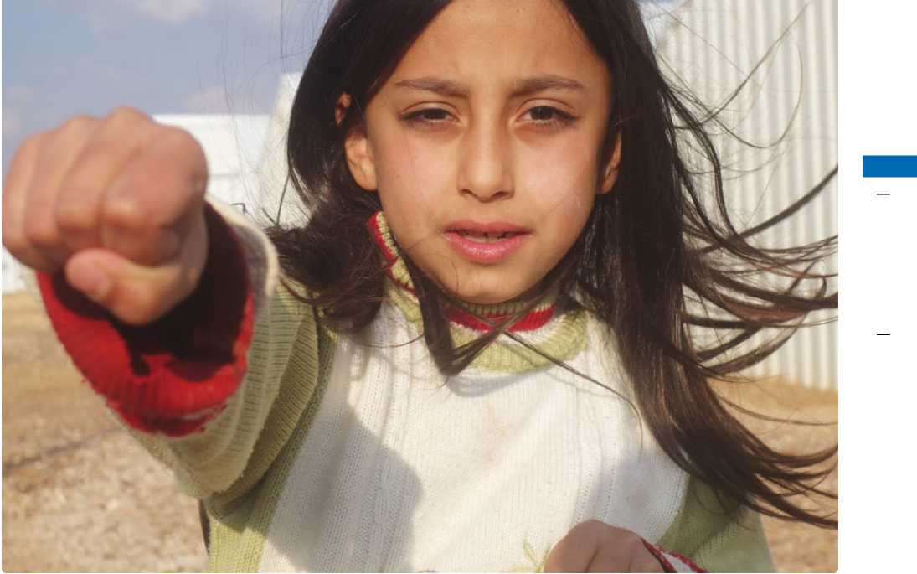Managing and Implementing Resettlement

Solaf, a Syrian refugee in Azraq camp, shows us her best Taekwondo moves. Solaf, a nine year-old Syrian refugee, joined a Taekwondo class given at the sports ground, built thanks to International Olympic Committee support, a few days after she arrived in Azraq camp in Jordan. “When I saw the movements the kids were doing, I knew that was something I wanted to learn,” explains Solaf. At that time more than 50 boys and only two girls were part of the training. She decided to join them. “I love jumping and breaking wooden boards.” Restless, Solaf now has also enrolled in football and volleyball training. She is good at sports but her finest kick is her mind.

© UNHCR / A. Bino / December 2015

INTRODUCTION

Integrity

Factors such as the significant expansion of resettlement activities around the world, requirements for expedited processing, and concerns over national security and public safety have made the need for a comprehensive policy to combat external fraud a very real and urgent one for all stakeholders involved in the resettlement effort.

Following up on preparatory work done in 2014, which indicated the need to expand guidance on fraud committed by persons of concern to all stages of case processing, in 2015 UNHCR convened four multi-functional workshops to draft a new policy and operational guidelines on fraud committed by persons of concern. A first draft of these documents was completed by year-end for consultation and finalization in 2016. This new guidance will provide an overarching policy framework to address fraud committed by persons of concern in various areas including registration, refugee status determination (RSD), assistance and resettlement. Of particular note in the new policy will be an increased focus on reporting incidents of fraud and potential fraud so as to allow for proactive identification of fraud trends as well as increased transparency with resettlement

States. Work also continued on the development of a dedicated fraud module in the next generation of UNHCR's case management program, *proGres v4*, which will track the reporting requirements in the new policy.

In parallel, the Resettlement Service has provided support to several different UNHCR-wide anti-fraud projects, including the Financial Controller's anti-fraud initiative as well as continued its oversight and support to operations. One technical support mission occurred to Chad, as part of UNHCR's efforts to strengthen its procedures in order to reduce the operation's vulnerability to fraud and to identify measures that could be undertaken to increase staff accountability. Other operations received advice on individual fraud investigations and operational oversight structures. UNHCR also continued its dialogue with resettlement States on how to increase integrity in resettlement programming under the framework of the ATCR Working Group on Integrity. Two working group meetings were held, which focused on sharing best practices and how to increase collaboration on the use of biometrics.

The global rollout of UNHCR's Biometrics Project, which ponders for biometric enrolment as part of refugee registration activities, continued in 2015 with enhanced biometrics being deployed to over ten operations and several more operations planned for deployment in

2016. The creation of a new Identity Management and Registration Section will allow increased collaboration between registration and resettlement, to ensure that potential fraud is addressed from the very first point of contact with a person of concern. The Resettlement Service is also developing a range of tools to support the implementation of the policy, including training materials and detailed operational guidance.

Training and Capacity Building

A number of important developments took place in the field of training and capacity building throughout 2015.

Building on the results of the first Resettlement Learning Needs Survey, which took place in early 2015, and following extensive consultations with the relevant units, UNHCR launched the first Learning Strategy for staff working in the area of resettlement. The Strategy outlines the most important skills and functional knowledge needed to successfully perform resettlement related activities, and provides the relevant framework for the most important training activities in the near future. The Strategy also set out a clear accountability framework for the Resettlement Service, Regional Hubs, Regional Offices and Country Offices with regard to conducting training activities. Finally, the Strategy acknowledged the importance of rigorous evaluations in the implementation of successful and effective training initiatives.

The Learning Strategy has proven to be useful in light of the massive training and capacity building that UNHCR is conducting in the context of the global upscaling of resettlement activities. A Training Plan of Action was developed in early 2016 which, building on the Learning Needs Survey and the Learning Strategy itself, will have as main goals and deliverables the design and implementation of the first Resettlement Learning Programme targeting individual case processing managers at P-3 and P-4 levels; the design and implementation of on-the-job training packages targeting newly recruited deployees and staff members; and the design and implementation of a Resettlement Learning Programme (RLP) Facilitators Guide. In addition, and also in the context of the Training Plan of Action, eight RLPs targeting approximately 250 staff in the MENA and Africa regions were launched in the first quarter of 2016. The RLP is a three-month thematic programme that complements the Protection Learning Programme by offering tutored self-study modules, videos and webinars through distance learning and a workshop that specifically covers the skills needed to undertake resettlement activities, aiming to ensure the effective delivery of resettlement that addresses the needs of refugees with diligence, transparency and accountability.

Reforming the Resettlement Process

The need to meet the resettlement needs of Syrian refugees in an expeditious manner prompted UNHCR, resettlement States and other partners to rethink existing traditional resettlement procedures. UNHCR has on many occasions expressed the need to re-design the resettlement process based on each resettlement partner's strength and added value, avoiding redundancies where appropriate. The 2017 submission target takes into account the continuation and further roll out of some key streamlining reforms.

During 2015, in close collaboration with key resettlement States, a number of modified processing and referral modalities were developed and piloted. Building on previous experiences implementing streamlined resettlement programmes for specific refugee populations, and in order to move forward with the discussions, in 2016, UNHCR will conduct a full evaluation of the resettlement processing framework.

In doing so, UNHCR will take into account principles of common value to all partners involved, with a view to come up with recommendations towards achieving a streamlined resettlement process that can be implemented globally.

Emergency Resettlement and use of Emergency Transit Facilities

Wherever possible, cases involving refugees with emergency or urgent resettlement needs should be processed expeditiously, and resettled directly to their destination country. In 2015, 14,727 individuals were submitted for resettlement under urgent priority, representing about 11 per cent of the overall submission number of 134,044, and an increase from the 2014 figure (10,305). 548 individuals, or less than one per cent of the overall figure of 134,044, were submitted under the emergency priority, almost 200 fewer than in 2014. UNHCR continues to work with resettlement States and other partners to maximize the use of emergency resettlement quotas through improved processing and collaboration.

In 2015 Emergency Transit Facilities (ETFs) continued to be utilized to facilitate the resettlement of refugees in need of expeditious removal from the country of asylum, as well as an alternative site for the case processing of refugee populations not accessible to resettlement States. UNHCR conducted a comprehensive evaluation throughout 2015 of the ETFs in Romania and Slovakia since they started to operate in 2008. Initial findings highlighted the positive perception of the ETFs among partners such as the International Organization for Migration (IOM), resettlement States, host countries and refugees, outlining that ETFs make resettlement accessible to refugees in countries of asylum where it would not otherwise be possible. Initial findings alsoemphasize the continued relevancy of the ETFs as a life-saving mechanism for emergency or urgent cases, but draw attention to a decrease over the last years in the number of emergency cases accommodated by ETFs, and an increasing tendency to employ the facilities as alternative processing sites for refugee populations otherwise impossible to access in their country of asylum. UNHCR will continue to work with resettlement States in order to maximize occupancy levels, reduce the average stays in the ETFs, and streamline the procedure needed to accede to ETFs.

Since inception, more than 2,500 refugees have departed for resettlement from the ETFs in Romania and Slovakia, while the ETF programme in Manila was discontinued in late 2015.

Partnership and Coordination

UNHCR continued to actively support the efforts of the Annual Tripartite Consultations on Resettlement/ Working Group on Resettlement (ATCR/WGR). As 2015 Chair, Norway led the implementation of the outcomes of the Reform process which concluded the previous year under the Danish Chair. As a result of the reform, three theme-focused Working Groups were convened addressing topics such as the integrity of the resettlement process, the simplification of resettlement procedures, and integration of refugees in resettlement countries. A separate meeting for Chairs of Core and Contact Groups under the umbrella of the ATCR/WGR was also organized, in order to discuss issues affecting the accountability and governability of the Groups.

Within this context, in 2015 the Syria Core Group played a considerable role in mobilizing increased support for the large-scale resettlement of refugees from Syria, and ensuring continued support for resettlement from host States in the region, by demonstrating that large-scale resettlement can be an effective means of sharing the responsibility for refugee protection. UNHCR has also convened the Geneva-based Host Country Resettlement Working Group with representatives from the host countries neighbouring the Syrian Arab Republic and in the region, to regularly exchange information and provide feedback on the implementation of the resettlement and humanitarian admission programmes for Syrian refugees.

With regard to collaboration with NGOs, RefugePoint and UNHCR jointly conducted a mapping exercise of the existing engagement between UNHCR offices and NGOs around the identification and referral of refugees in need of resettlement. The findings of the mapping project helped to formulate recommendations for both UNHCR and NGOs to advance the goal of increasing and enhancing UNHCR-NGO resettlement partnerships in areas such as data-gathering and reporting on UNHCR-NGO resettlement collaboration; enhancing and standardizing tools for training and mentoring

NGOs; and standardizing, receiving and processing NGO referrals.

In addition, UNHCR continued to work closely with NGO partners to enhance the timely and effective deployment of affiliate workforce to field offices, whose contribution to the resettlement effort remains of critical importance. In 2015 UNHCR expanded the network of NGOs able to assist in rapidly resourcing resettlement operations, and made considerable progress in ensuring the harmonization of service conditions among staff deployed under this scheme. In 2015, deployments were carried out through the International Catholic Migration Commission (ICMC) globally and through RefugePoint mostly in Africa; the number of deployments has doubled between 2013 and 2015, and with new deployment partners including the Danish Refugee Council (DRC) and the International Refugee Assistance Project (IRAP) joining the Deployment Scheme for 2016, it is anticipated this number will further increase. On average over 200 additional qualified workforce were working in the field during each month last year, making the resettlement deployment scheme the largest one.

Complementary Pathways for Admission

Given the scale of the displacement and the prolonged nature of the Syrian crisis, UNHCR and resettlement States are pursuing complementary pathways to admit refugees. Pathways for admission may include any mechanism which allows for legal entry to and stay within a third country. In addition to serving as a concrete expression of responsibility sharing, complementary pathways for admission can reduce the need for refugees to resort to irregular and dangerous onward movements. Such pathways also allow destination States to put in place proper screening and facilitation procedures for refugees arriving on their territory.

Over the course of 2015 and into 2016, UNHCR has steadily advanced data and analysis into creating or expanding pathways for admission; worked with countries to facilitate access to complementary pathways for admission; increased capacity to negotiate and build the conditions necessary for pathways to solutions to become a reality for more refugees; and facilitated the take-up of opportunities for longer term solutions where available in host countries and in countries of migration.

In addition, and responding to a call by the United Nations Secretary General, UNHCR convened in late 2015 a ministerial level meeting to garner increased support for refugees as well as host countries through concrete pledges for resettlement and other forms of admission for at least 10 per cent of the Syrian refugee population by the end of 2018 as a demonstration of international solidarity and responsibility sharing. The meeting took place on 30th of March 2016 and resulted in progress in a number of areas, including, *inter alia*, increased pledges on the part of some States, new States confirming scholarships and students visas for Syrian refugees, and a number of States affirming their commitments to family reunification. The results of the 30th of March 2016 meeting will feed into a High Level Plenary meeting of the United Nations General Assembly on Addressing Large Movements of Refugees and Migrants, which will take place on 19 September 2016 in New York.

INTRODUCTION

Strategic Response 2016-2017

The year 2015 concluded having witnessed a paradigm shift in the approach to resettlement activities, as resettlement global capacity has dramatically expanded; there has been an increased recognition on the part of relevant stakeholders about the need to design new processing modalities; and a realisation of the value in considering pathways to third countries outside of the traditional resettlement framework. Building on the progress made and acknowledging the challenges ahead, the Resettlement Service will:

• Continue to implement the strengthened processing capacity in line with, and subject to, the support of the Supplementary Appeal of February 2016

• In partnership with States, conduct a comprehensive review of our processes, with an attempt to better understand the nexus between UNHCR and State processing; reduce overlaps and redundancy, strengthen quality in decision-making and utilize the innovations in processing tested in the Syrian context

• Continue to deliver and advocate for resettlement programmes that are both global and preserve its humanitarian nature through a focus on vulnerability criteria. Related to this, optimize and sharpen the utility of critical emergency resettlement quotas through enhanced advocacy, coordination and process reform

• Take forward efforts related to complementary pathways including the roll out of operational guidance and training to support refugee take-up of such solutions where appropriate

• Build on efforts to date to strengthen the integrity of the resettlement process including through: the roll out of a revised anti-fraud policy that addresses all stages of case processing, along with training tools, oversight multi-functional missions, and a networked group of experts in the field; and close cooperation with UNHCR staff engaged in registration activities to take forward initiatives related to electronic transfer of files and UNHCR's biometric enrolment

• Foster capacity and capabilities in resettlement through the tripartite partnership by continuing the implementation of the ATCR/WGR reform process; ensuring the focus and utility of Core and Contact groups that are under the ATCR umbrella; promoting the inclusion of new and emerging resettlement states; and revisiting mechanisms for twinning and capacity building in resettlement between States

• Expanding the network of NGOs involved in the identification and referral of refugees in need of resettlement, by enhancing the collaboration between UNHCR field offices and local NGOs in accordance with the recommendations of the abovementioned mapping project

Resettlement has proven to be an invaluable protection tool, a durable solution, and a responsibility sharing instrument that has stood the test of time. Identifying and processing for resettlement almost 170,000 refugees is indeed a remarkable challenge that UNHCR would not be able to undertake without the support and partnership of States and NGOs. UNHCR looks forward to continue working, in a tripartite spirit, to ensure an increasing number of refugees continue to avail of this solution.

INTRODUCTION

Young refugees sit on top of a tree and join thousands of others to watch a football game between Banfa from camp 4 and Twelve Disciples from camp 1 in Kakuma refugee camp in Kenya. © UNHCR / D. Nahr / June 2015

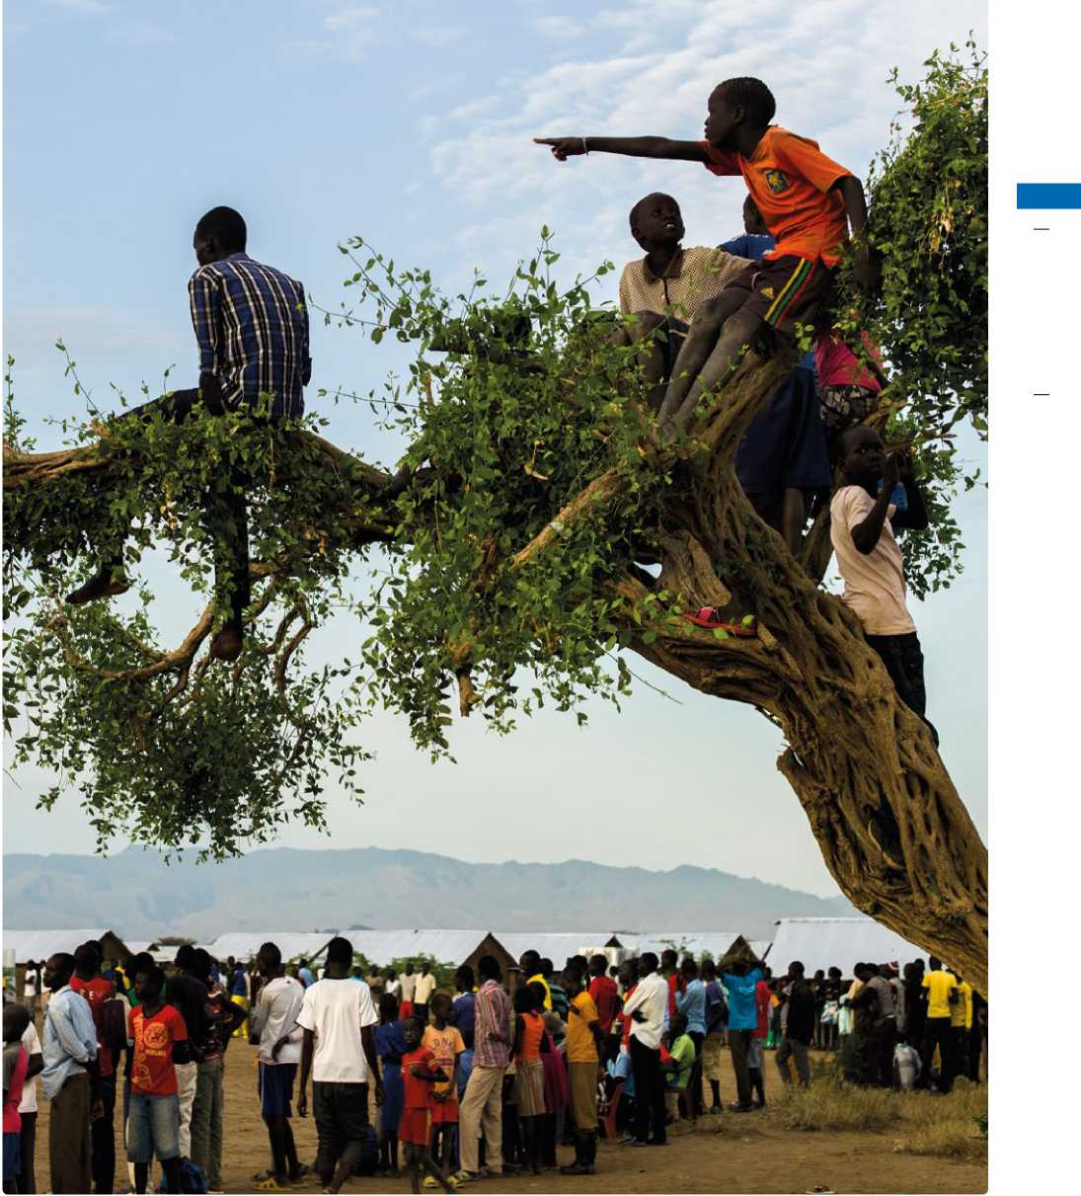

Africa

© UNHCR / B. Loyseau / April 2016

Life in Nduta refugee camp. A young refugee carrying wood back home. More than a quarter of a million Burundians have fled to neighbouring countries since April 25, 2015, most of them - 135,000 - to Tanzania. Nduta refugee camp is located in north-western Tanzania and can barely provide shelter, household items, latrines and showers to every refugee.

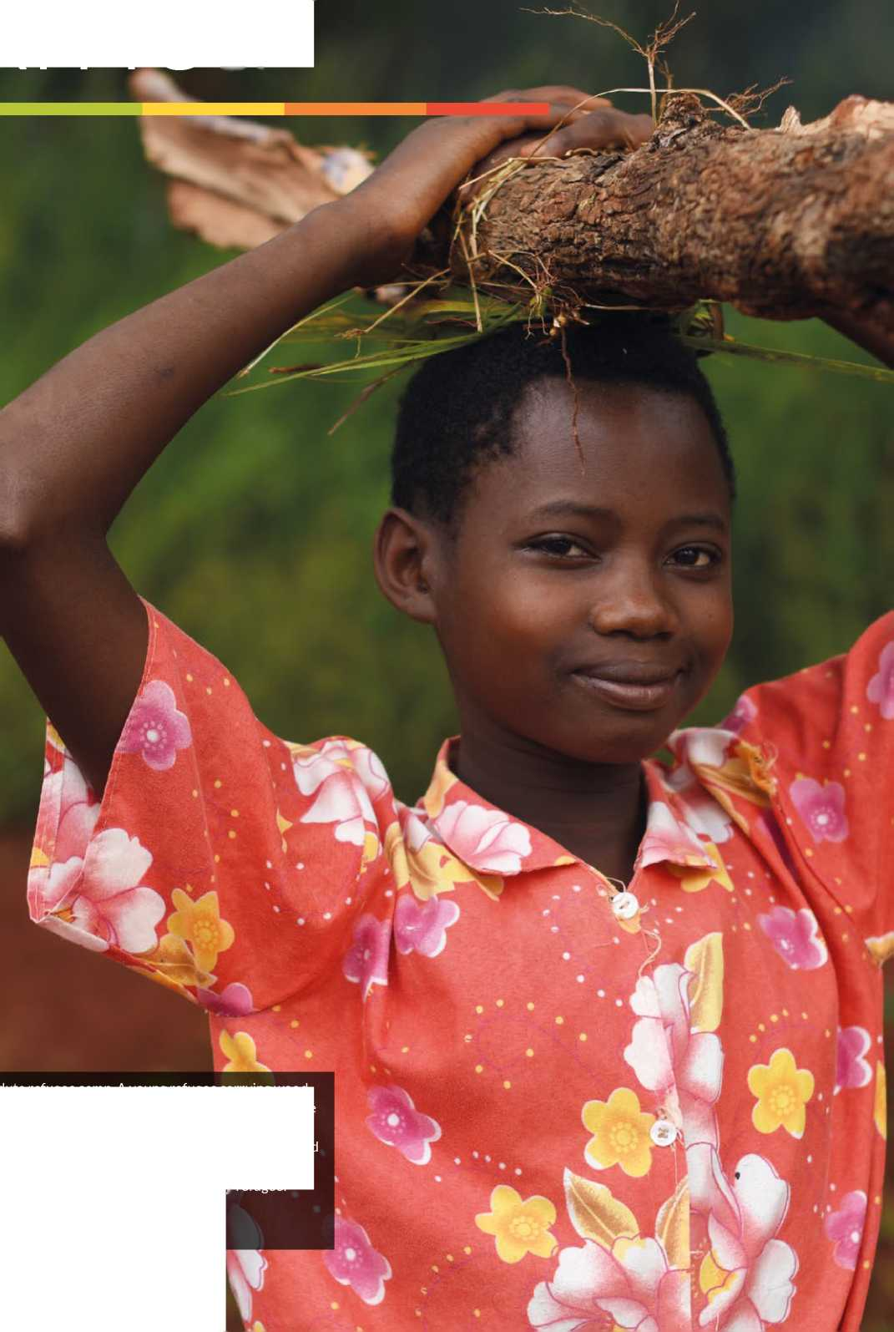

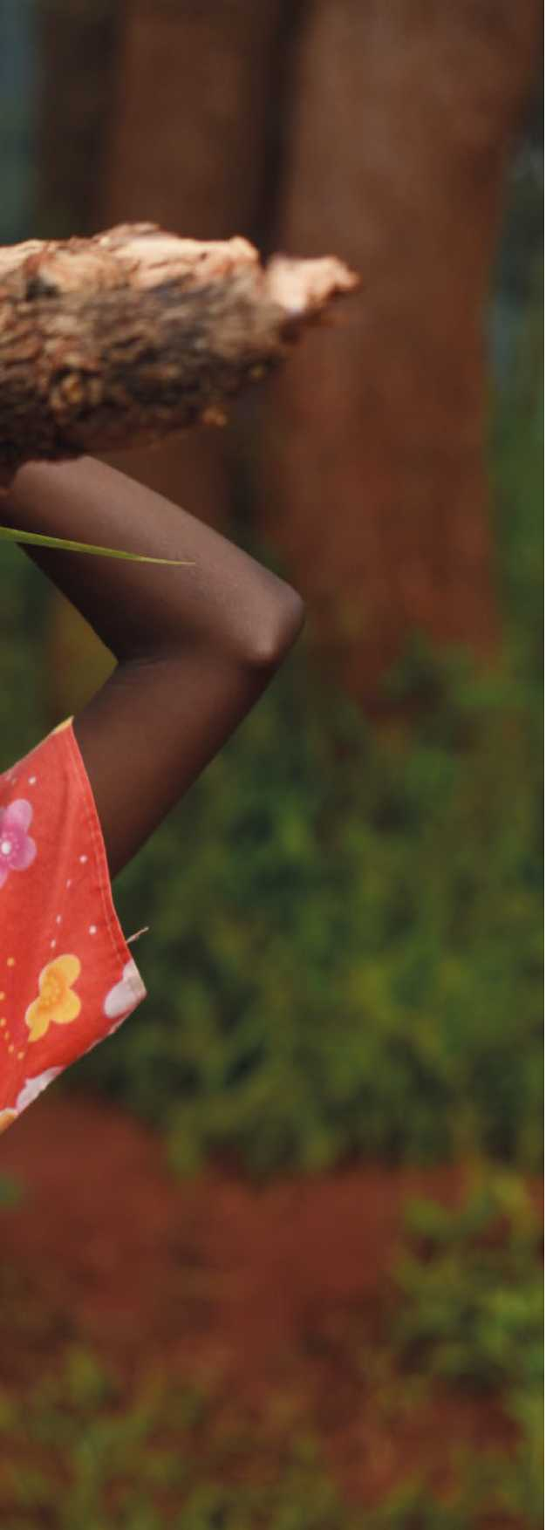

Trends in 2015

AFRICA

During 2015, submissions from sub-Saharan Africa totaled 38,870 refugees. This represents an 11 per cent increase from 35,079 submissions in 2014, and a 147 per cent increase from 15,710 submissions in 2012. The trend of increased submissions will continue with a total of 55,387 submissions planned for 2017. On the assumption that this target will be achieved, a 43 per cent increase from 2015 and a 253 per cent increase from 2012 in the following year is foreseen.

Refugees submitted for resettlement from Africa in 2015 originated from more than 28 countries of origin. Departures from Africa also increased significantly for the fourth year in a row with 24,016 refugees departing in 2015 (compared with 19,199 refugees departing in 2014; 14,858 in 2013; and 11,342 in 2012). The five main countries of origin for refugees submitted for resettlement were the Democratic Republic of the Congo (DRC) (53 per cent of submissions from Africa in 2015), Somalia (23 per cent), Eritrea (8 per cent), Sudan (5 per cent), and Ethiopia (3 per cent).

Submissions were made to 16 resettlement countries. The United States of America (USA) continued to receive the majority of submissions (90 per cent in 2015 compared to 76 per cent the year before), followed by Canada (3.5 per cent in 2015 compared to 16 per cent the year before), the United Kingdom (1.5 percent in 2015 compared to 2 per cent the year before) and Sweden (1.3 per cent in 2015 compared to 2 per cent the year before).

The continuing enormous upscaling of resettlement submissions out of Africa since 2012 is primarily attributed to the programme initiated in 2012 for the “Enhanced resettlement of Congolese” from the Great Lakes and Southern Africa region. As a result of this programme, UNHCR has submitted over 57,000 Congolese refugees from sub-Saharan Africa between 2012 and 2015. In this context of enhanced resettlement of Congolese, the USA has approved two groups for resettlement, the strategic use of resettlement remains a key element of phase-out strategies in Southern Africa region, and there continues to be an increased number of resettlement and Best Interest Determination (BID) deployees in key operations.

Regional developments

UNHCR in Africa continues to be confronted with processing challenges with regard to resettlement.

Resettlement processing remains a **resource intensive**, individual casework activity. Collection of the required information is time consuming, and documentation in support of resettlement of unaccompanied and/ or separated children and medical cases is not always

**MALI**

**NIGER**

**ERITREA**

**SENEGAL**

**SUDAN**

**GUINEA-BISSAU**

**DJIBOUTI**

**GUINEA**

**ETHIOPIA**

**LIBERIA**

**UGANDA**

**SOMALIA**

**KENYA**

**SAO TOME AND PRINCIPE**

**PUBLI**

**GABON**

**URUNDI**

**SEYCHELLES**

**COMOROS**

**ANGOLA**

800km

**MALAWI**

**ZAMBIA**

**MADAGASCAR**

**MOZAMBIQUE**

**ZIMBABWE**

**NAMIBIA**

**BOTSWANA**

**UNHCR's estimated total**

**resettlement capacity**

The boundaries and names shown and the

**SIERRA**

**LEONE**

**SOUTH AFRICA**

*INDIAN*

*OCEAN*

*NORTH ATLANTIC*

*OCEAN*

*SOUTH ATLANTIC*

*OCEAN*

**REP. OF**

**CHAD**

**BURKINA**

**FASO**

designations used on this map do not imply official endorsement or acceptance by the

**COTE**

**D'IVOIRE**

**UNITED REPUBLIC OF TANZANIA**

UNHCR total resettlement capacity includes core staffing and affiliate workforce

**EQUATORIAL GUINEA J**

*% Casp*

*Se*

UNHCR'S TOTAL RESETTLEMENT

CAPACITY FOR 2017

**BY COUNTRY OF ASYLUM\***

**AFRICA**

**as of 25 May 2016**

|  |  |  |  |  |  |  |
| --- | --- | --- | --- | --- | --- | --- |
|  | |  |  |  |  | **\ J** |
|  | |  | **• f >** |  | **? —** | **1** |
|  | **TO** | **GO** | **NIGERIA** |  |  | J I |
| **' A t** |  |  |  | **CENTRAL** | **\ •** |  |
| **• J** |  |  |  | **AFRICAN** | **SOUTH** |  |
| **GHANA** |  |  |  | **REPUBLIC** | **SUDAN** |  |

**CAMEROON**

|  |  |  |
| --- | --- | --- |
| **GO** | • | **RWANDA** |
|  | **DEMOCRATIC**  **REPUBLIC OF** |  |

**THE CONGO**

United Nations.

© UNHCR - Geneva, 25 May 2016

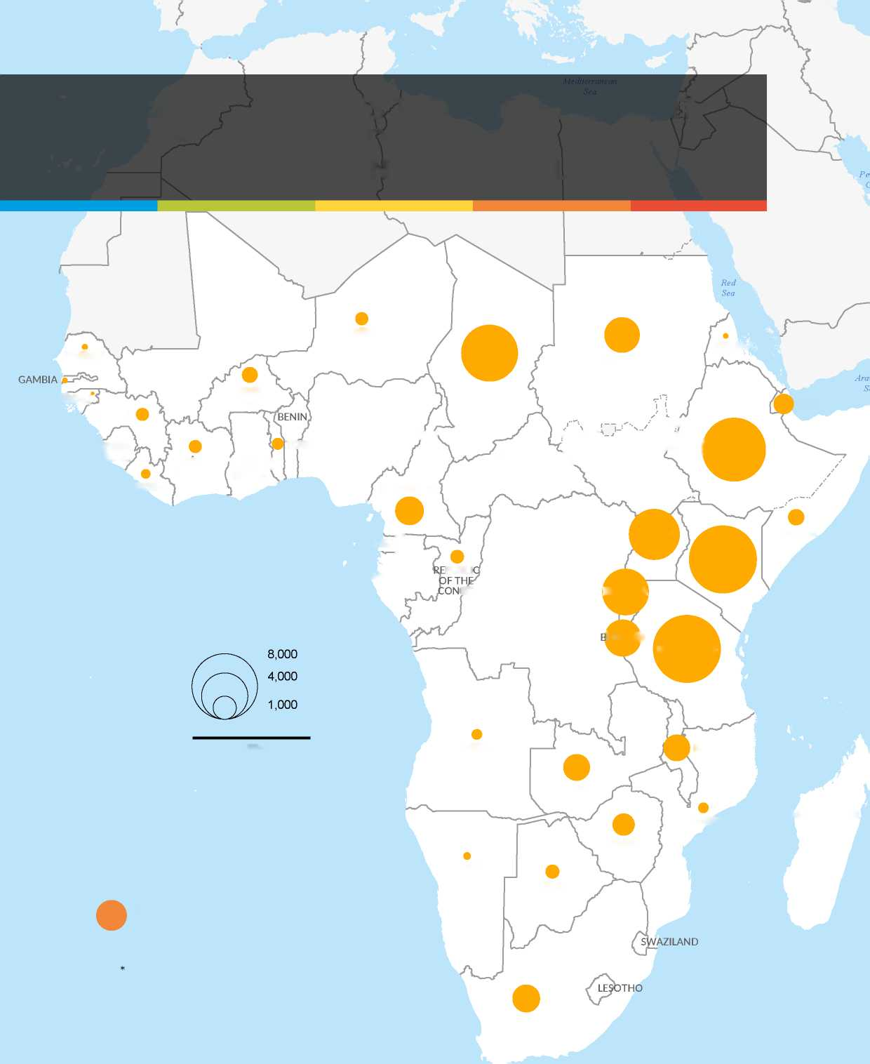

AFRICA

easily available. Given the continuously increasing resettlement submission targets for the sub-Saharan African continent, and the minimal efficiency and acceptance that the Global Abridged Resettlement Registration Form (RRF) has provided to operations since its introduction in 2012, African operations have implemented technical innovations and adjustments in an effort to accelerate processing out of Africa. Efforts also continue for identifying additional group and other expedited processing scenarios following systematic collection and maintenance of registration data country by country. With the USA's acceptance of a second group resettlement proposal for the Congolese population in 2015 (some 30,000 Congolese refugees in Tanzania), submissions of Congolese will continue to be high over the coming years.[1]

In the meantime, the Resettlement Service at UNHCR Headquarters continues with the process of seeking further simplification of procedures on a global level.

Numerous operations in Africa continue to be supported by resettlement and child protection experts deployed through the UNHCR Resettlement Deployment Scheme, which enhances UNHCR's capacity to submit refugees for resettlement and strengthens Best Interests Assessment (BIA) and Best Interests Determination (BID) capacity for a large number of unaccompanied and separated refugee children in Africa and globally. The Resettlement Deployment Scheme is implemented since early 2016 globally by four Deployment Partners, three of which provide experts to operations in sub-Saharan Africa (International Catholic Migration Commission [ICMC], RefugePoint and Danish Refugee Council [DRC]). In 2016, more than 200 Deployees will be working over 12 months in UNHCR operations across the world, with almost two-thirds deployed in sub-Saharan Africa.

**Identification** of potential resettlement cases remains a challenge, with the exception of the enhanced resettlement of Congolese programme (under which Congolese refugees are identified in large numbers by their arrival dates, thus greatly facilitating the resettlement process). Inaccurate or lack of registration data in some operations, and lack of capacity to carry out registration reverification exercises, continue to pose a challenge in the identification of potential resettlement cases and result in insufficient resettlement referrals. This is a particular challenge on a large continent, where the majority of refugees are located in remote camp locations or dispersed across urban areas. While resettlement identification and processing has considerably improved where data re-verification exercises have taken place, such as in Rwanda (2012), Burundi (2013), Uganda (2012, 2013, 2015-2016), Tanzania (2014), Djibouti (2014/2015), Chad (2015), and currently ongoing in Cameroon, much remains to be done to increase data verification and to keep the already collected data current. Systematic efforts have already been undertaken to involve protection and other staff as well as partners in strengthening identification mechanisms.

Resettlement from sub-Saharan Africa takes place in 36 countries, most with multiple processing sites. The camps/settlements are often in remote locations far from the capitals, resulting in considerable **logistical and access challenges** relating to travel, weather and sometimes security. In spite of all the investments already undertaken, the logistics around resettlement processing in Africa remains very resource intensive. In Tanzania, the future completion of the new processing site in Makere (close to Nyarugusu Camp), generously funded by the USA, will alleviate some of the aforementioned logistical difficulties. In Kenya, Somali refugees from Dadaab camp will continue to be temporarily transported to Kakuma camp for resettlement processing. Resettlement countries continue facing difficulties in obtaining entry visas for processing of refugees (mostly Somali) in Eritrea, which results in large numbers of refugee resettlement cases submitted by UNHCR pending for years. UNHCR continues to offer the use of video­conference technology and would generally require a much increased dossier quota for processing refugee populations that cannot be accessed by resettlement country missions.

Each year **large scale emergencies** continue in Africa and add on to the large and overly **protracted refugee situations**. The vast majority of refugees in Africa have been living in protracted refugee situations for over 20 years. UNHCR continues to be flexible and finds creative solutions or diverts resources to other countries where processing can compensate for eventual shortfalls in order to alleviate the impact of emergencies on the overall targets.

Other challenges include **complex family composition** issues and the **high level of vulnerability** among the refugee populations in Africa with little access to durable solutions other than resettlement.

Considering the above, expedited processing modalities, the resolution of logistical challenges in reaching refugee populations, maintaining data quality and staffing capacity, as well as multi-functional engagement by UNHCR Offices and partners, will remain critical in reaching the resettlement targets in 2017.

Strengthening the protection environment

UNHCR continues to target solutions, including resettlement, for the major refugee populations in Africa, which consist of refugees from Somalia, the DRC, Eritrea and Sudan.

In Uganda, Rwanda, Tanzania and in Burundi (albeit decreased due to the current political instability) and in the Southern Africa region, the focus will remain on the implementation of the enhanced resettlement of the Congolese.

In Kenya and Ethiopia, the focus will remain on refugees from Somalia and Eritrea. Refugees from Somalia will also continue to be a focus in South Africa, and it is hoped that Djibouti will be able to resume resettlement processing for mostly Somali refugees. In Chad the focus will remain on the resettlement of Sudanese and refugees from the Central African Republic (CAR). In Sudan, the focus will remain on Eritrean refugees. Finally, efforts have been undertaken to introduce increased resettlement for refugees who fled some of the more recent emergency situations (i.e. from CAR, Mali and South Sudan).

Resettlement remains of utmost importance in all refugee operations in Africa, although its direct impact on advancing other durable solutions in countries of asylum remains difficult to measure. The Congolese Refugee Core Group, which was established in 2013, expanded its terms of reference to all refugee situations in the Great Lakes region and now holds the name “Great Lakes Refugee Core Group.” Expectations are high that this Group, in close cooperation with the host countries, will not only carry out enhanced third country resettlement, but will also achieve enhanced conditions of asylum and integration in the context of larger comprehensive solutions initiatives, including the Solutions Alliance.

Priority will continue to be given to addressing protracted refugee situations by promoting comprehensive durable solutions strategies which are embedded in overall protection strategies and offer all three durable solutions as appropriate. The implementation of the Comprehensive Strategies and Ceased Circumstances Cessation Clause for Angolan, Liberian, and Rwandan refugees has paved the way for the voluntary repatriation and local integration of these populations. Also, resettlement remains a key protection tool in countries of asylum where refugees' rights are compromised, i.e. the xenophobic incidents in South Africa.

Africa: 2017 Projected needs and targets

The total projected resettlement needs for Africa in 2017 are 441,523 persons. The total number of persons projected for submission from Africa in 2017 is 55,387.

Sub-regional developments

Central Africa and the Great Lakes

By the end of 2015, over half a million refugees had fled the DRC, making the Congolese refugee population the sixth largest in the world.

At the end of 2015, in Burundi and Rwanda, Congolese refugees represent 99 and 51 per cent, respectively, of the total registered refugee population. In Uganda Congolese refugees make up 42 per cent of the total registered refugee population, and in Tanzania 26 per cent.

UNHCR continues to pursue the implementation of a multi-year plan of action to address the situation of refugees from the DRC who are living in sub-Saharan Africa, including an increase in resettlement over a multi-year period, which commenced in 2012. Since the 2013 Annual Tripartite Consultations on Resettlement (ATCR), Congolese refugees have been identified as one of UNHCR's priority situations for resettlement, which has helped to unlock a large protracted refugee situation. At least 50,000 Congolese refugees will be submitted for resettlement between 2012 and 2017. By the end of 2015, the Great Lakes region had already met 86 per cent of this multi-year submission target through the submission of almost 43,000 Congolese refugees.

UNHCR's projected resettlement needs in 2017 for Central Africa and the Great Lakes are 128,643 persons. This is again a substantial increase compared to the expressed needs of 124,806 in 2016 and 75,925 persons in 2015. This continued increase can be attributed to the escalation of violence in CAR and Nigeria causing a surge in refugee numbers in the region. Resettlement needs are reported for almost 35,800 CAR refugees (with approximately 23,400 located in Cameroon and 12,500 located in the DRC), and for 15,830 Nigerian refugees, including 9,000 Nigerians alone in Cameroon. In addition 3,200 Burundians in the DRC have been identified for resettlement consideration.

UNHCR's projected submissions in 2017 out of the Central Africa and the Great Lakes region are 17,130 persons. This is an overall increase of 18 per cent compared to 2016 due to increased submissions of Congolese refugees from Tanzania and Rwanda in the context of group resettlement.

East and Horn of Africa

In the East and Horn of Africa sub-region, protracted refugee situations continue to severely affect Somali refugees (in particular in Djibouti, Eritrea, Ethiopia, and Kenya) and Eritrean refugees (in particular in the east of Sudan and in Ethiopia).

In Sudan, around 5,015 Eritrean refugees have been processed for resettlement since 2011. The majority of the remaining Eritrean refugees out of the approximately 9,500 persons originally identified for resettlement will be processed before the end of 2016, with the rest to be processed in 2017.

In Ethiopia, the overall submission target has continued to increase significantly from 2014 (3,890) to almost double that in 2017 (7,500), in large part due to the increased target for Somali refugees (4,000 in 2017). Resettlement submissions/plans for Eritrean refugees increased from 975 persons in 2014 to 3,250 in 2016 and will stabilize at 2,000 in 2017.

The protracted Somali refugee situation in the region (in particular in Kenya, Ethiopia, Eritrea, and Djibouti) continues to be approached as a priority situation for the strategic use of resettlement. The majority of Somali refugees in these countries have not only been living in a refugee situation for a prolonged period, but they have also been faced with disproportionately lengthy waiting periods for resettlement acceptances and departures.

In Kenya, despite the start of a pilot project in December 2014 that provides assistance to spontaneous returnees, and the securitization of some parts of South Central Somalia, UNHCR has so far not observed large sustainable return movements to Somalia. The asylum climate in Kenya has changed drastically over the past couple of years due to rising incidents of terrorism within Kenya carried out by Al Shabaab, including the Westgate Mall incident, and recent cross-border incursions by Al-Shabaab operatives which resulted in large numbers of civilian casualties in Mandera, and more recently in Garissa. This has led to repeated calls from the Government for the closure of Dadaab refugee camp. The perceived connection between refugees and terrorists is frequently reiterated in the Kenyan media and official fora. The passing of new security driven laws, including laws aimed at anti-terror activities, leads to continued targeting of refugees by law enforcement authorities.

The unpredictable security situation in Dadaab refugee camp has resulted in limited access for resettlement countries, in turn affecting resettlement case processing negatively over the years. To mitigate this problem, refugees continue to be relocated from Dadaab to the USA-funded relocation center in Kakuma for processing purposes.

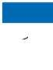The total projected resettlement needs in 2017 for East and Horn of Africa region are 262,718 persons. This is a 16 per cent increase from the needs projected for 2016, mostly linked to emergencies, the expression of resettlement needs for around 18,000 South Sudanese, the needs of around 44,500 Sudanese in South Sudan, and considerable increase of resettlement plans out of Kenya, Ethiopia and Chad.

In Chad, around 83,500 refugees are projected to be in need of resettlement in 2017. This is a slight decrease from the resettlement needs identified in 2015 of around 85,000, as a result of the 2015 biometric verification exercise.

In the context of a multi-year resettlement plan for Chad, UNHCR projects to resettle a total of some 22,600 refugees between 2015 and 2018. The majority will be Sudanese refugees followed by CAR refugees and various others.

In order to support the solutions strategy for the region, the Regional Support Center Nairobi (RSC Nairobi, formerly called the Regional Support Hub in Nairobi) provides oversight functions (including quality control review), coordination of submissions, policy support and training for resettlement activities in 13 countries: Burundi, the Democratic Republic of the Congo, Djibouti, Eritrea, Ethiopia, Gabon, the Republic of the Congo, Rwanda, South Sudan, Somalia, Sudan, Tanzania and Uganda.

Southern Africa

In the Southern Africa sub-region, the refugee situation has remained stable throughout 2015, with a comparatively slow but steady influx of asylum-seekers from the Great Lakes and East and Horn of Africa region, mostly into Zambia, Mozambique, Malawi and South Africa. Opportunities for local integration and voluntary repatriation continue to be pursued, albeit limited, due to ongoing violence and insecurity in countries or origin, as well as a lack of desire on the part of refugees to return. In addition, socio-economic and legal challenges remain when it comes to local integration in most asylum countries.

AFRICA

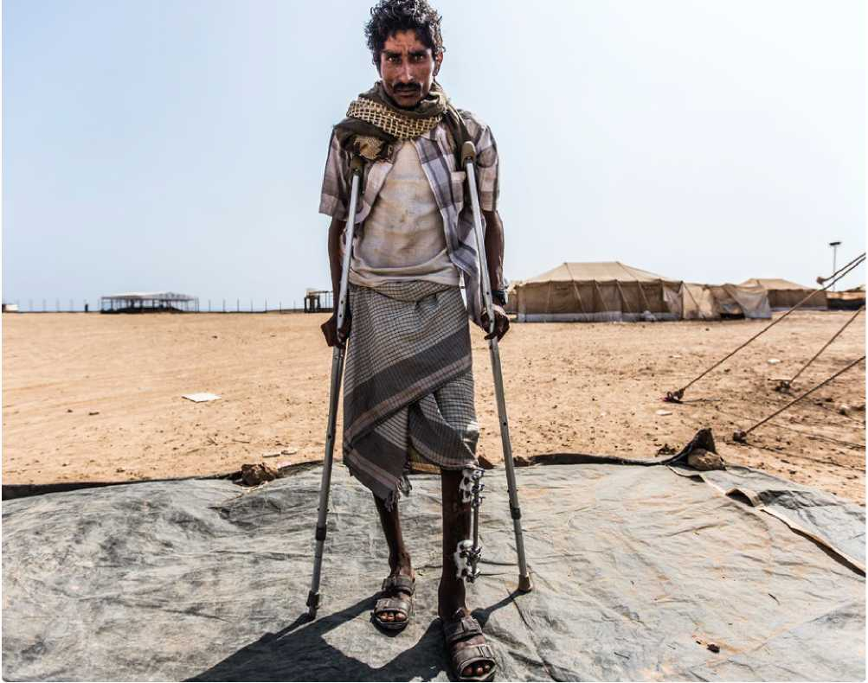All countries hosting significant numbers of Angolan refugees have invoked the cessation clause. In 2014, some 14,284 former Angolan refugees repatriated with UNHCR's assistance mainly from the DRC (12,482 persons), Zambia (1,620 persons) and from the Republic of the Congo (182 persons). During 2015, an additional 4,000 Angolan individuals returned from the DRC. Some Angolan refugees remain in countries of asylum, in particular in the DRC (561 persons), Zambia (19,293 persons), Namibia (1,313) and the Republic of the Congo (12,267). In addition, South Africa may invoke cessation clauses and implement comprehensive solutions for Rwandese, Liberian and Sierra Leonean refugees, with the affected population estimated at about 4,500 individuals.

Yemeni fisherman, Seif Zeid Abdullah, 27, was injured by shrapnel. Fearing he wouldn't receive the medical care he required in Yemen, he set out for Djibouti. He is now hoping to get the care he needs at the Markazi refugee camp.

© UNHCR / O. Khelifi / October 2015

Resettlement has played a key role in comprehensive solutions strategies in the Southern Africa sub-region. Following the closure of the UNHCR Office in Namibia on 30 June 2015, resettlement and local integration have been utilized in a complementary manner. Local integration is being promoted for the remaining former Angolan refugees, which has been coupled by enhanced resettlement of the residual camp population (mostly from the DRC) that will continue in 2016 through the Regional Resettlement Support Unit (RSU) in Pretoria. In Zambia, 1,300 refugees are planned to be submitted for resettlement in 2017 in conjunction with local integration initiatives for 10,000 former Angolan refugees and over 4,000 former Rwandan refugees.

The main challenges in the region remained the obligatory encampment of refugees in most of the countries in the region, xenophobic violence affecting refugees and asylum-seekers in urban areas, as well as restrictive refugee policies by several governments. For example, 1,400 refugees of mixed nationality, the majority of whom are Somalis, are identified and planned for submission from the operation in South Africa during 2016 based on physical protection needs linked to xenophobic violence.

In 2017, the total projected resettlement needs for Southern Africa region stands at 30,865 persons.

The total projected resettlement submissions from the Southern Africa sub-region are 5,750 persons, which marks a 35 per cent increase from the planned submissions of 4,270 persons in 2016. The increase is due to the protracted DRC refugee populations in the region, as well as the envisaged needs of rejected asylum-seekers from the DRC in Zimbabwe and Botswana

Finally, case identification challenges remain in some countries. Case identification mechanisms in the context of the durable solutions approach to resettlement arebased on profiling exercises focusing on protracted caseloads, including the DRC refugees, and protection needs assessments in certain urban areas. Consequently, out of the total planned submissions of 5,750 persons, and in line with the African regional enhanced resettlement of refugees from the DRC, the region plans to submit approximately 3,160 Congolese in 2017.

In order to support the solutions strategy, the RSU provides oversight, coordination, and support for resettlement activities in Angola, Botswana, Malawi, Mozambique, South Africa, Zambia, and Zimbabwe. There are no UNHCR Offices in Lesotho, Swaziland, Madagascar, or Namibia, but the RSU does process resettlement cases on an exceptional basis from these countries.

West Africa

In the West Africa region, UNHCR continues to proactively pursue comprehensive durable solutions strategies to resolve several protracted refugee situations, where repatriation is not an option, as demonstrated by very low repatriation figures. However, as of February 2016, more than 8,200 Ivorian refugees from Liberia have been assisted to return home.

During 2015, resettlement case processing continued to be negatively impacted by the Ebola disease in Liberia and the Republic of Guinea, where resettlement interviews could not be conducted due to movement restrictions.

Local integration in West Africa remains limited in spite of existing regional frameworks, such as the Protocol on the Free Movement of Persons, Residence, and establishment of the Economic Community of West African States (ECOWAS). Although, it has proven to be an important mechanism for local integration of Liberian refugees who opted for local integration during the cessation process.

For the Mali situation, despite the development of a return and reintegration strategy in early 2014, renewed clashes in May 2014 between Malian government forces and insurgents affected the intention of some Malian refugees to return home during 2014/2015. In the region, approximately 7,200 Malian refugees are projected to be in need of resettlement in 2017 (around 3,280 from Burkina Faso and 3,920 from Niger).

UNHCR is increasing its efforts to enhance its protection capacity in the sub-region, with particular emphasis on the identification of refugees with specific needs, and with the aim of boosting traditionally low resettlement numbers coming from this sub-region through the increased use of the Resettlement Deployment Scheme and missions from the Regional Resettlement Unit for West Africa (RRU) in Dakar. UNHCR maintains its advocacy for an increased quota for dossier submissions, in order to address the small, mixed refugee populations, which are living in remote areas.

The total projected resettlement needs in 2017 for West Africa are 19,297. This figure marks an increase from the figure of 19,072 refugees who were reported to be in need of resettlement in 2016. The rise in resettlement needs in the region is largely due to the projected resettlement needs of 6,800 Nigerian refugees in Niger and 3,200 Malian refugees in Burkina Faso. The total projected resettlement submissions planned in 2017 for West Africa are 2,140 refugees.

The RRU covers the following countries of West Africa:

Benin; Burkina Faso; Cote d'Ivoire; Gambia; Ghana; Guinea; Guinea Bissau; Liberia; Mali; Niger; Nigeria; Senegal; Sierra Leone; and Togo. The RRU also covers three countries in Central Africa: Cameroon; Central African Republic and Chad. The key functions of the RRU include regional coordination, operational support, capacity building through support missions to field offices, oversight and monitoring. It also provides quality control review of resettlement cases and makes resettlement submissions.

AFRICA

Africa: 2017 Projected needs and targets

|  |  |  |  |  |  |  |
| --- | --- | --- | --- | --- | --- | --- |
| A. Region of Asylum | B. Total projected resettlement needs* | | C. Total UNHCR submissions planned for 2017 (target)** | | D. UNHCR core staff capacity in 2017 | |
| cases | persons | cases | persons | cases | persons |
| Central Africa & the Great Lakes | 31,945 | 128,643 | 4,012 | 17,130 | 2,032 | 8,360 |
| East & Horn of Africa | 80,284 | 262,718 | 10,380 | 30,367 | 3,392 | 9,850 |
| Southern Africa | 9,293 | 30,865 | 1,805 | 5,750 | 370 | 1,215 |
| West Africa | 4,514 | 19,297 | 731 | 2,140 | 152 | 437 |
| Grand Total | **126,036** | **441,523** | **16,928** | **55,387** | **5,946** | **19,862** |

* including multi-year planning

** based upon UNHCR total capacity (core staff + affiliate workforce) in 2017

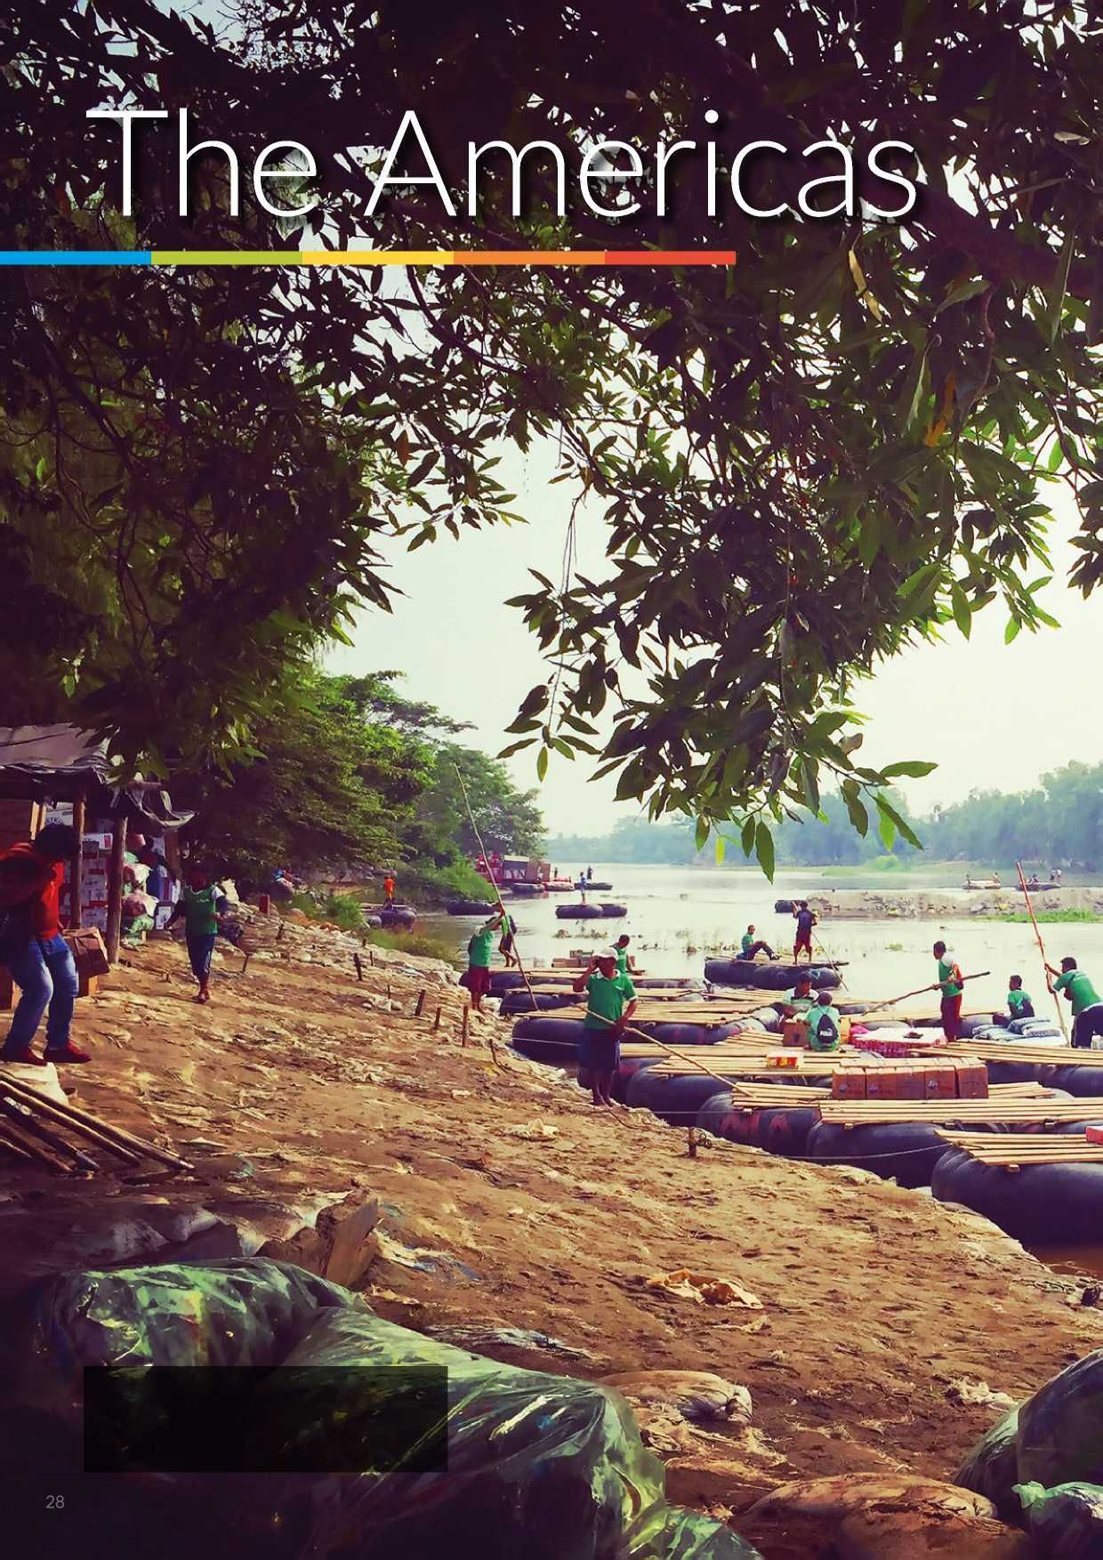

© UNHCR / L. Padoan / April 2016

The Suichate river border between Mexico and Guatemala. It costs 25 pesos to cross, but refugees can be charged one hundred times that amount.

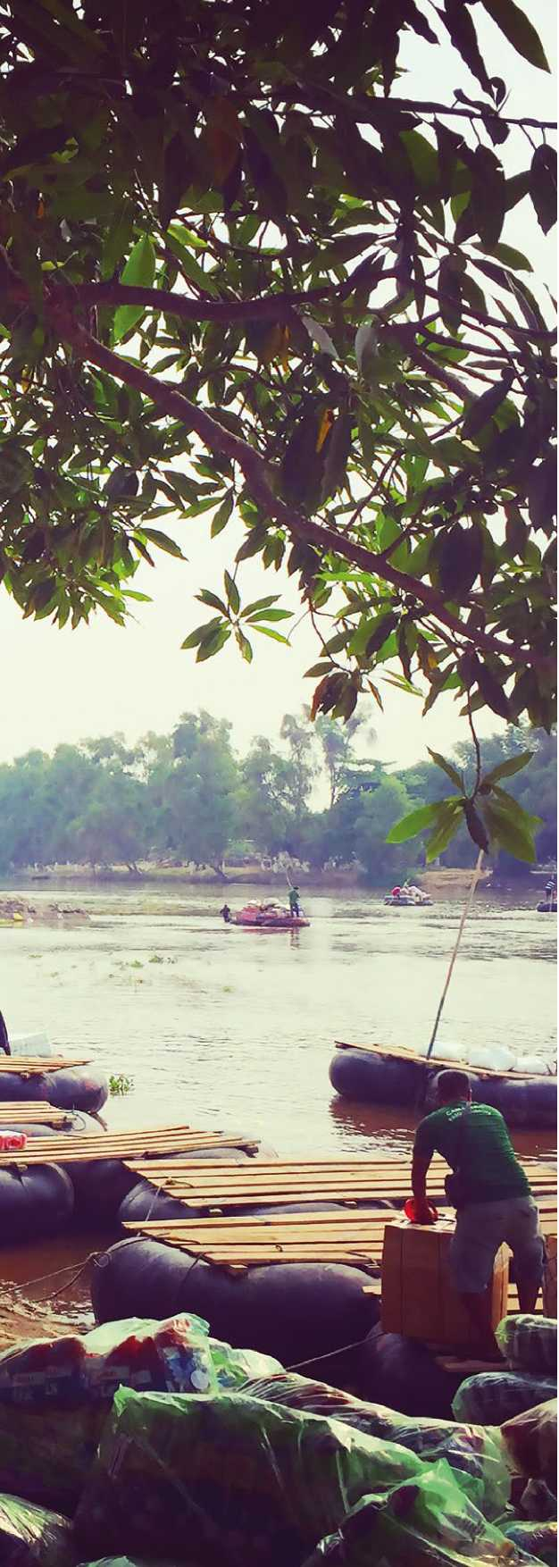

Trends in 2015

THE AMERICAS

1,390 refugees were submitted throughout 2015 in the Latin America and Caribbean region, representing a 23 per cent decline in respect of the figures reported for the previous year. Such decline is attributed to renewed efforts to strengthen local integration prospects for refugees in Ecuador, ensuring resettlement remains available for refugees presenting specific protection needs. With regard to departures, overall 892 refugees departed from the region; a 13 per cent decline compared with last year's departure figure.

Regional developments

The Brazil Declaration and Plan of Action (BPA), which was adopted by 28 States and three territories from Latin America and the Caribbean in 2014 at the culmination of the Cartagena +30 process, highlighted the importance of resettlement as an instrument of refugee protection, of solidarity with countries hosting large numbers of refugees, and of regional and international cooperation. As recommended by the BPA, the Governments of Argentina, Brazil, Chile, Paraguay, and Uruguay undertook in 2015, with technical support from UNHCR, an independent evaluation of the Solidarity Resettlement Programme in order to assist stakeholders in understanding what went well, gather feedback from the refugees themselves and share best practices.

In 2015 and early 2016, the Colombian Government continued to engage in peace talks with the Revolutionary Armed Forces of Colombia (FARC) to end the 50-year armed conflict that has generated over 6.76 million internally displaced persons (IDPs) and 360,000 refugees. Negotiations progressed and are expected to conclude with a peace agreement by mid-2016. On 30 March 2016, after more than two years of exploratory conversations, the Government of Colombia and second- largest armed group, the National Liberation Army (ELN), reached an agreement on an agenda for formal negotiations. While this is a positive development, the conclusion of negotiations will take time. The signature of an accord is the beginning of a peace-building process. It is hoped that the human rights situation will improve; some developments include sustained attention to the reintegration of IDPs and returning refugees, the quick establishment of a state presence in remote border areas, and effective responses to actions of new armed groups (post-demobilization groups and criminal entities). UNHCR will establish close coordination with the United Nations Mission in Colombia.



**THE AMERICAS** UNHCR'S TOTAL RESETTLEMENT **as of 25 May 2016** CAPACITY FOR 2017

**BY COUNTRY OF ASYLUM\***

**MEXICO**

**Cayman Islands(GBR)**

**UNITED STATES OF AMERICA**

**BAHAMAS**

**JAMAICA**

**DOMINICAN  
REPUBLIC  
HAITI**

**Curasao (K. of the Netherlands)**

**BARBADOS**

**TRINIDADAND TOBAGO**

**GRENADA**

**PANAMA**

**BOLIVARIAN**

**REPUBLIC OF**

**VENEZUELA GUYANA**

**ECUADOR**

**COLOMBIA**

**URINAME**

**PERU**

800km

**PLURINATIONAL**

**STATE OF**

**BOLIVIA**

**UNHCR's estimated total**

**resettlement capacity**

**CHILE**

**PARAGUAY**

* UNHCR total resettlement capacity includes core staffing and affiliate workforce

The boundaries and names shown and the

designations used on this map do not imply official endorsement or acceptance by the United Nations.

**ARGENTINA**

**BRAZIL**

**French Guiana (FRA)**

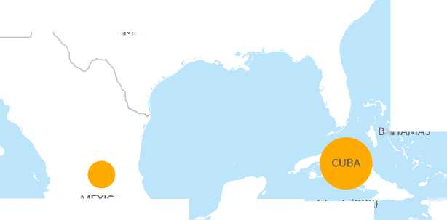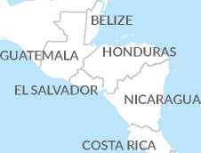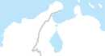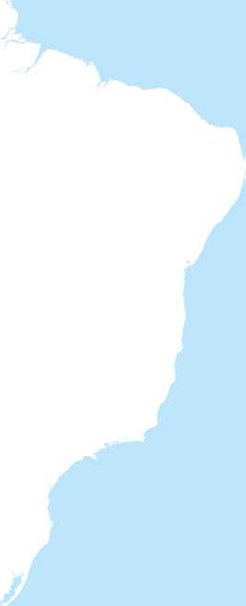

**URUGUAY**

© UNHCR - Geneva, 25 May 2016

Jose Ismael and Leonel Antonio Diaz and their sister Maritza Esmeralda from El Salvador at their house in Tapachula, Mexico. © UNHCR / M. Redondo / October 2015

THE AMERICAS

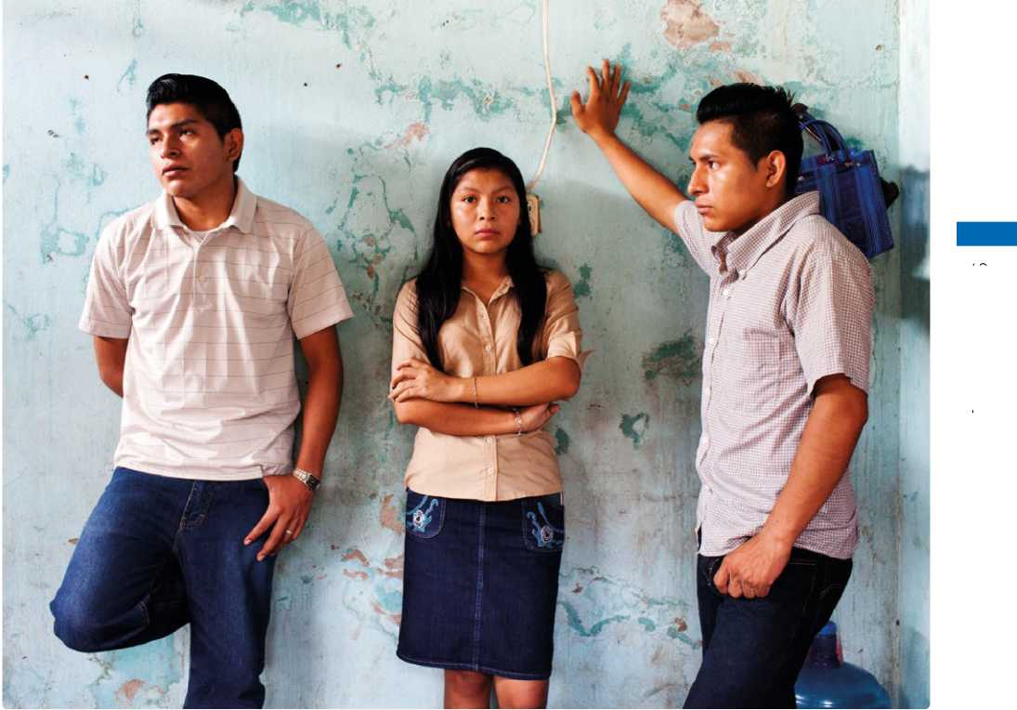

Notwithstanding an improving human rights situation, it is important that Colombian refugees and asylum­seekers continue to have access to international protection in asylum countries and that the repatriation of refugees is voluntary. In this context, UNHCR issued in September 2015 its revised Eligibility Guidelines for Assessing the International Protection Needs of Asylum­Seekers from Colombia, in order to provide updated information about developments that may have an impact on the assessment of international protection needs for persons from Colombia falling within certain risks profiles.

Recent years have seen a sharp escalation in the number of people fleeing persecution and insecurity in the Northern Triangle of Central America (NTCA), namely, El Salvador, Honduras and Guatemala. This is largely the result of growing levels of violence caused by non-state actors; many linked to criminal activity (mainly *maras*, *pandillas* and drug cartels), in addition to economic hardship. In 2014 and 2015, tens of thousands of women, men and children from the Northern Triangle sought asylum in the United States of America, while thousands more have fled to Mexico, Canada, Belize, Nicaragua, Costa Rica, and Panama. It is now clear that movements that were once considered purely socio­economic now include growing numbers of people affected by forced displacement. While poverty, social exclusion and family reunification remain contributing factors leading to migration, all stakeholders in the region increasingly acknowledge persecution, insecurity and violence as root causes of movement. Children and youth are particularly affected as they escape forced recruitment and a situation of extreme insecurity with no hope for the future. Women are also targets of violence and unable to find adequate protection due to their gender, suffering from multiple traumas.

In response to the protection crisis in NTCA, UNHCR has developed a multi-year regional protection and solutions strategy, focusing on strengthening the protection response for IDPs and deported persons with specific needs in NTCA countries; building sustainable and efficient asylum systems and strengthening access to quality asylum procedures; and scaling up solutions- oriented approaches.

The Caribbean region has been confronted with an increasingly complex phenomenon of mixed migration that involves asylum-seekers, refugees, victims of human trafficking and stateless persons, along with other categories of vulnerable migrants. The region has witnessed movements of persons of concern from Colombia, Cuba, Haiti and Jamaica, but also a sharp rise in the number of extra-continental arrivals from countries such as Syria, Bangladesh, Pakistan, Nigeria and several other African countries.

The Americas: 2017 Projected needs and targets

The total projected resettlement needs for the Latin America and Caribbean region in 2017, as identified by UNHCR offices, is 7,773 persons. UNHCR plans to submit 1,752 persons for resettlement from the region during 2017.

Sub-regional overview

South America

UNHCR has been implementing its multi-year Comprehensive Solutions Initiative (CSI) in Ecuador since 2014, which allows the operation to respond in a holistic manner to the refugee situation, by facilitating durable solutions and access to rights along the legal, economic and social dimensions. With regard to the voluntary repatriation option, UNHCR intends to conduct an updated intention survey once the peace agreement between the Government of Colombia and FARC has been signed, however, the outcomes of several studies carried out by UNHCR and its partners so far indicate the overwhelming majority (around 90 per cent) of Colombian refugees do not envisage voluntary repatriation in the near future.

Hence, while promoting the gradual inclusion of refugees in national plans and strengthening livelihoods opportunities to promote local integration, resettlement will continue to be utilized strategically as a responsibility sharing mechanism with Ecuador.

The Caribbean

As part of UNHCR's strategic use of resettlement within a wider comprehensive solutions approach, resettlement is meant to complement local integration efforts of Caribbean States and overseas territories, and preserve protection space. UNHCR pursues resettlement for the most vulnerable refugees in the Caribbean as a protection tool, a durable solution, and as a responsibility-sharing mechanism. UNHCR identifies potential cases for resettlement shortly after completing mandate RSD and an evaluation of the local integration prospects based on the individual circumstances in the country of asylum. With increasing numbers of refugees being identified in the region, resettlement from the Caribbean is also on the rise.

Central America and Mexico

UNHCR's two-pronged approach towards solutions in this sub-region includes enhancing local integration opportunities in countries of asylum (Belize, Costa Rica, Guatemala, Mexico and Panama) as well as targeted and small-scale resettlement of refugees with heightened protection risks. Resettlement will be pursued strategically and as an expression of responsibility sharing, in parallel with efforts to strengthen asylum systems and local integration prospects in these countries of asylum. Private sponsorship programmes can take place alongside or in hybrid arrangements with government resettlement programmes, which will also enable refugees to reunite with extended family members who may not otherwise qualify under family reunification resettlement category.

The Americas: 2017 Projected needs and targets

|  |  |  |  |  |  |  |
| --- | --- | --- | --- | --- | --- | --- |
| A. Region of Asylum | B. Total projected resettlement needs* | | C. Total UNHCR submissions planned for 2017 (target)** | | D. UNHCR core staff capacity in 2017 | |
| cases | persons | cases | persons | cases | persons |
| The Americas | 2,907 | 7,773 | 780 | 1,752 | 209 | 529 |
| Grand Total | **2,907** | **7,773** | **780** | **1,752** | **209** | **529** |

* including multi-year planning

** based upon UNHCR total capacity (core staff + affiliate workforce) in 2017

THE AMERICAS

Enjoying a rainy day outside her house in Chiapas, Mexico. Jessica and her family escaped gang violence in El Salvador.

They have been recognized as refugees in Mexico but they had problems to find work and to be accepted by the local community. © UNHCR / M. Redondo / October 2015

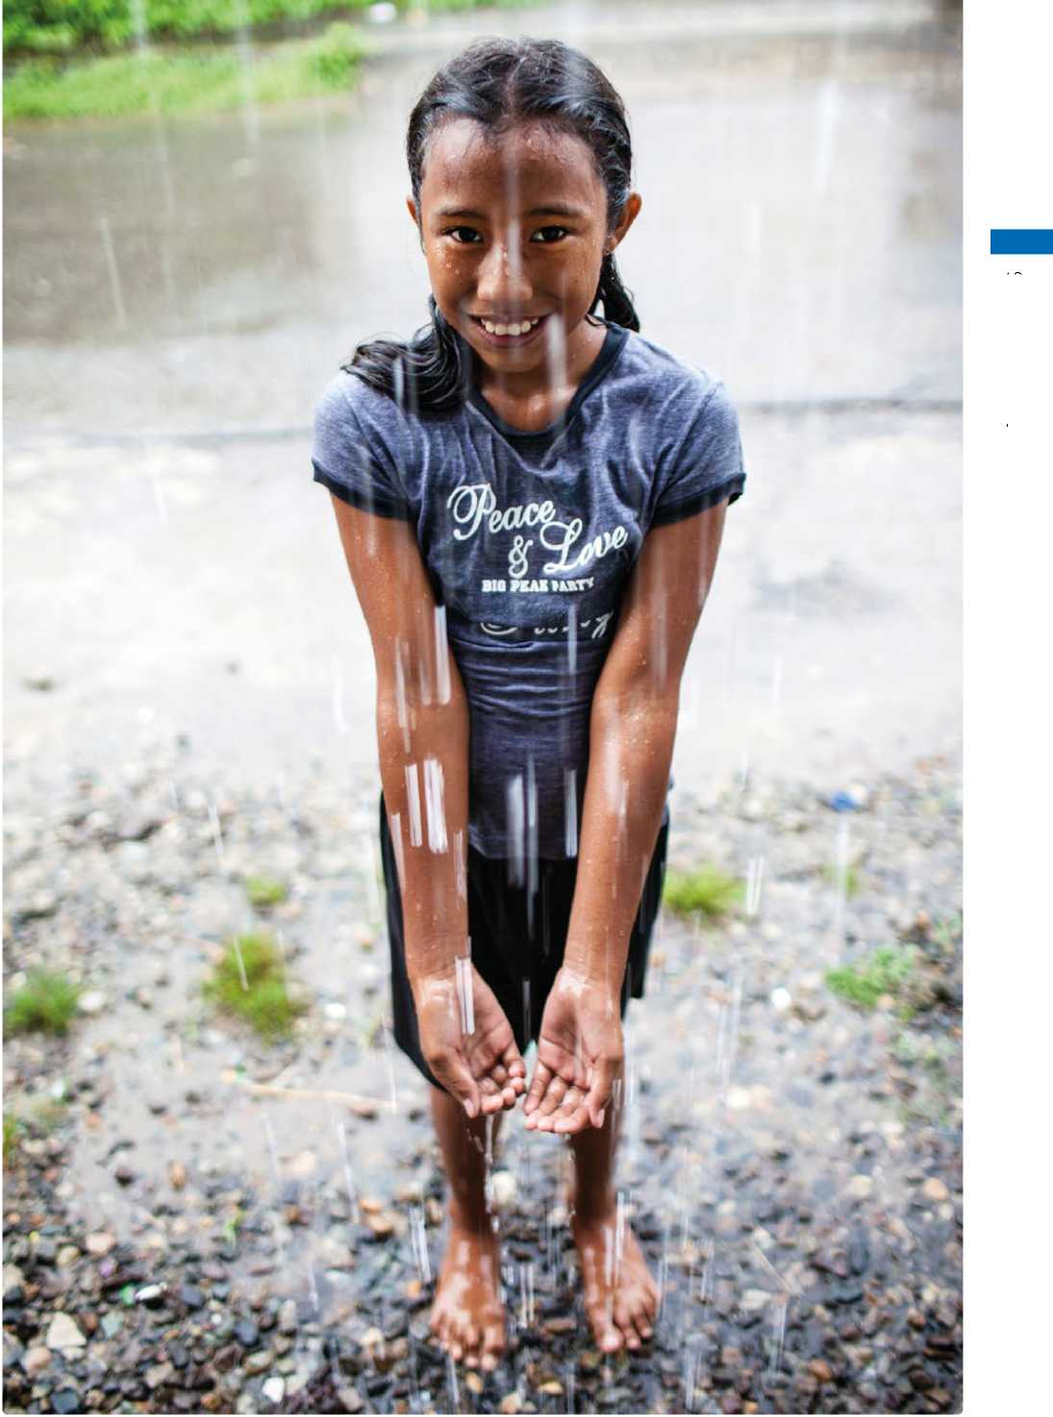

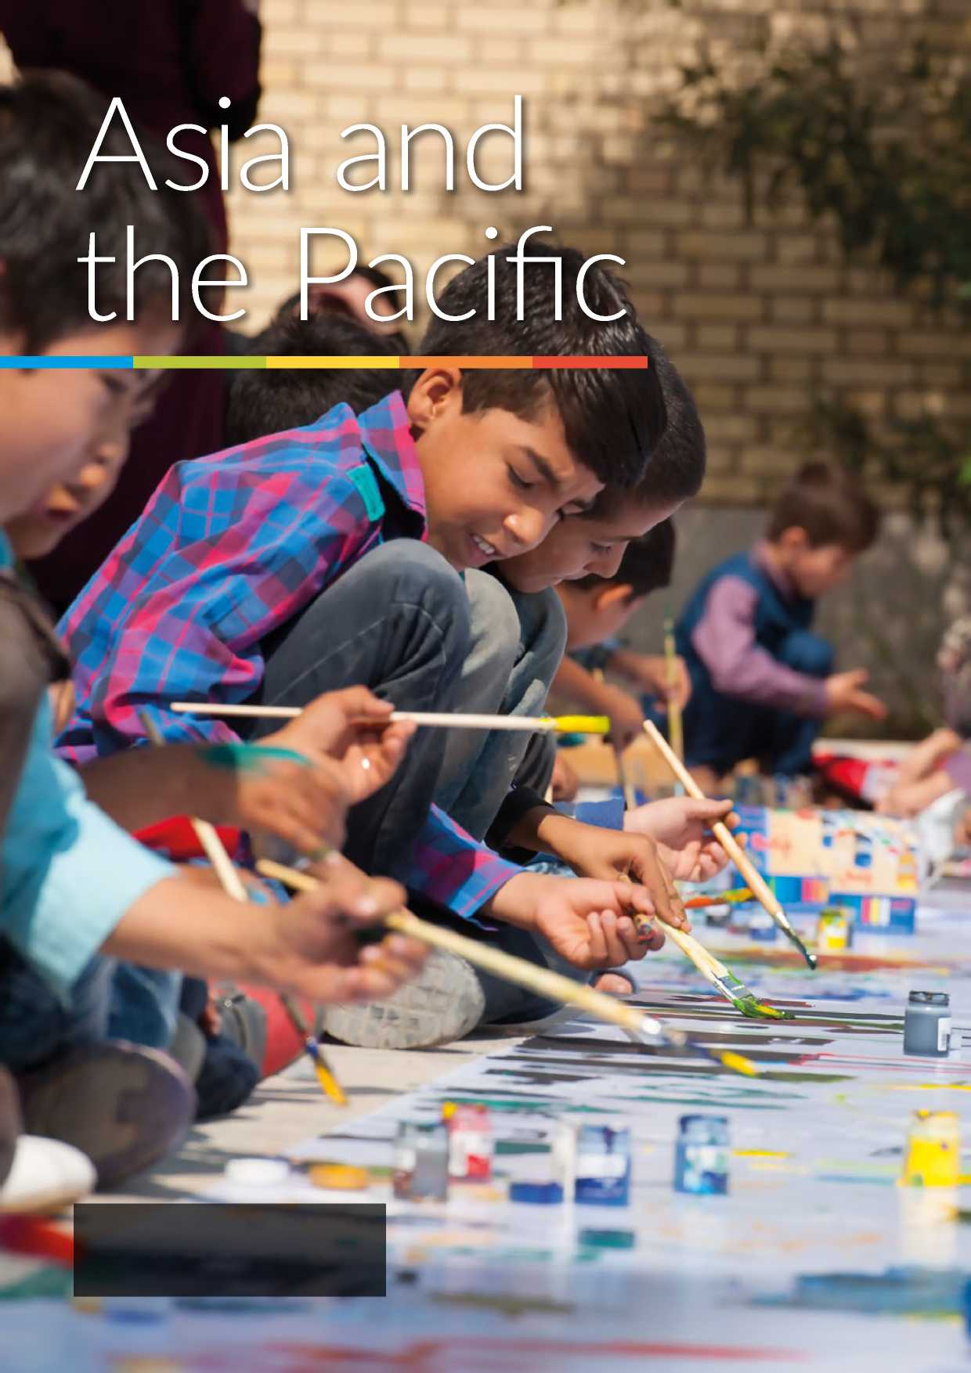

34

© UNHCR / S. Rich / September 2015

School children painting during summer school activities. Most of them were born and raised in Iran and have never been to Afghanistan.



Trends in 2015

ASIA AND THE PACIFIC

During 2015, Asia and the Pacific region submitted a total of 21,620 persons for resettlement. This constitutes a 21 per cent decrease compared with 27,450 submissions in 2014, and 37,599 submissions in 2013. The decrease is largely due to the winding down of group resettlement from Thailand, Malaysia and Nepal.

Refugees submitted for resettlement from Asia and the Pacific region in 2015 mainly originated from Myanmar (9,738), Bhutan (4,477), Afghanistan (4,124), Pakistan (800) and the State of Palestine (381). The main five countries of resettlement were: The United States of America (USA) receiving 78.5 per cent of the total submissions, Australia (10.8 per cent), New Zealand (4.8 per cent), Canada (1.9 per cent), and Norway (1.2 per cent).

Departures from Asia and the Pacific region decreased slightly with 29,701 refugees departing in 2015, compared to 30,827 persons in 2014. However, Asia and the Pacific region still had the highest regional figure for departures for 2015, constituting 36.3 per cent of all global departures

Regional developments

UNHCR's strategic priority in Asia and the Pacific region remains the promotion of sustainable comprehensive solutions for refugees. As resettlement decreases, the region will focus more on comprehensive solutions encompassing voluntary return, local solutions, including disembarkation, temporary protection and residence or migration through economic or free movement integration arrangements.

During 2015, South-East Asia experienced a significant decrease in asylum applications, in particular arrivals from Myanmar, Pakistan, Afghanistan and Sri Lanka. The number of newly registered asylum-seekers dropped in particular in Malaysia, Thailand and Indonesia.

The number of refugees being submitted under large group resettlement programmes covering refugees from Bhutan in Nepal and Myanmar refugees in both Thailand and Malaysia is decreasing. These operations are transitioning into increased processing of individual cases of diverse groups, including individuals from outside of the region (i.e. Afghans, Somalis, Syrians, Palestinians, Iraqis and so on) with special protection needs or family links.

KAZAKHSTAN

UZBEKISTAN

KYRGYZSTAN

TURKMENISTAN

TAJIKISTAN

AFGHANISTAN

CHINA

NEPAL

HUTA

PAKISTAN

BANGLADES

INDIA

3,000

1,000

*I*

100

800km

ISLAMIC REPUBLIC

OF IRAN

*Bay of Bengal*

SRI LANKA

*Arabian*

*Sea*

*Persian*

*Gulf*

*Caspian*

*Sea*

**as of 25 May 2016**

**ASIA AND**

**THE PACIFIC**

UNHCR'S TOTAL RESETTLEMENT

CAPACITY FOR 2017

**BY COUNTRY OF ASYLUM\***

*INDIAN*

*OCEAN*

**UNHCR's estimated total resettlement capacity**

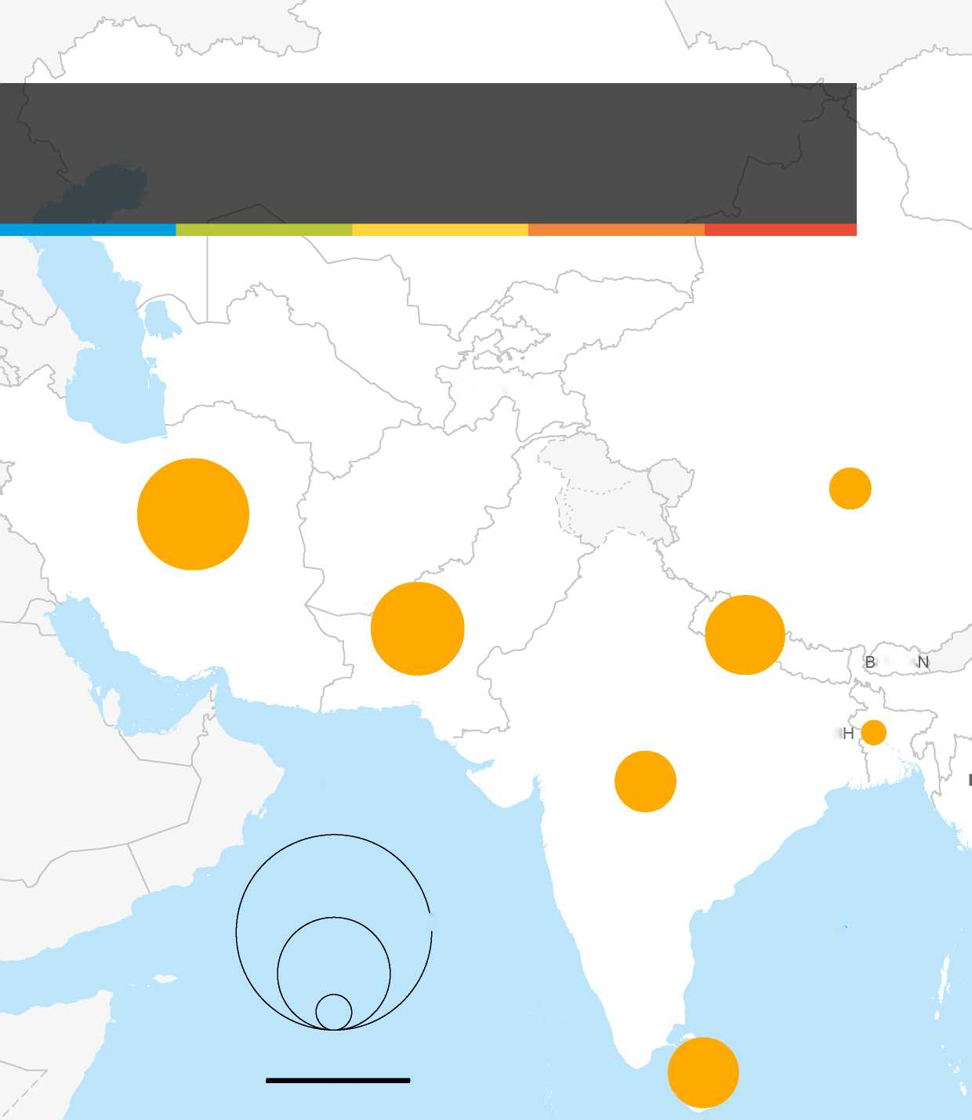

MALDIVES

* UNHCR total resettlement capacity includes core staffing and affiliate workforce

The boundaries and names shown and the designations used on this map do not imply official endorsement or acceptance by the United Nations.

© UNHCR - Geneva, 25 May 2016

36

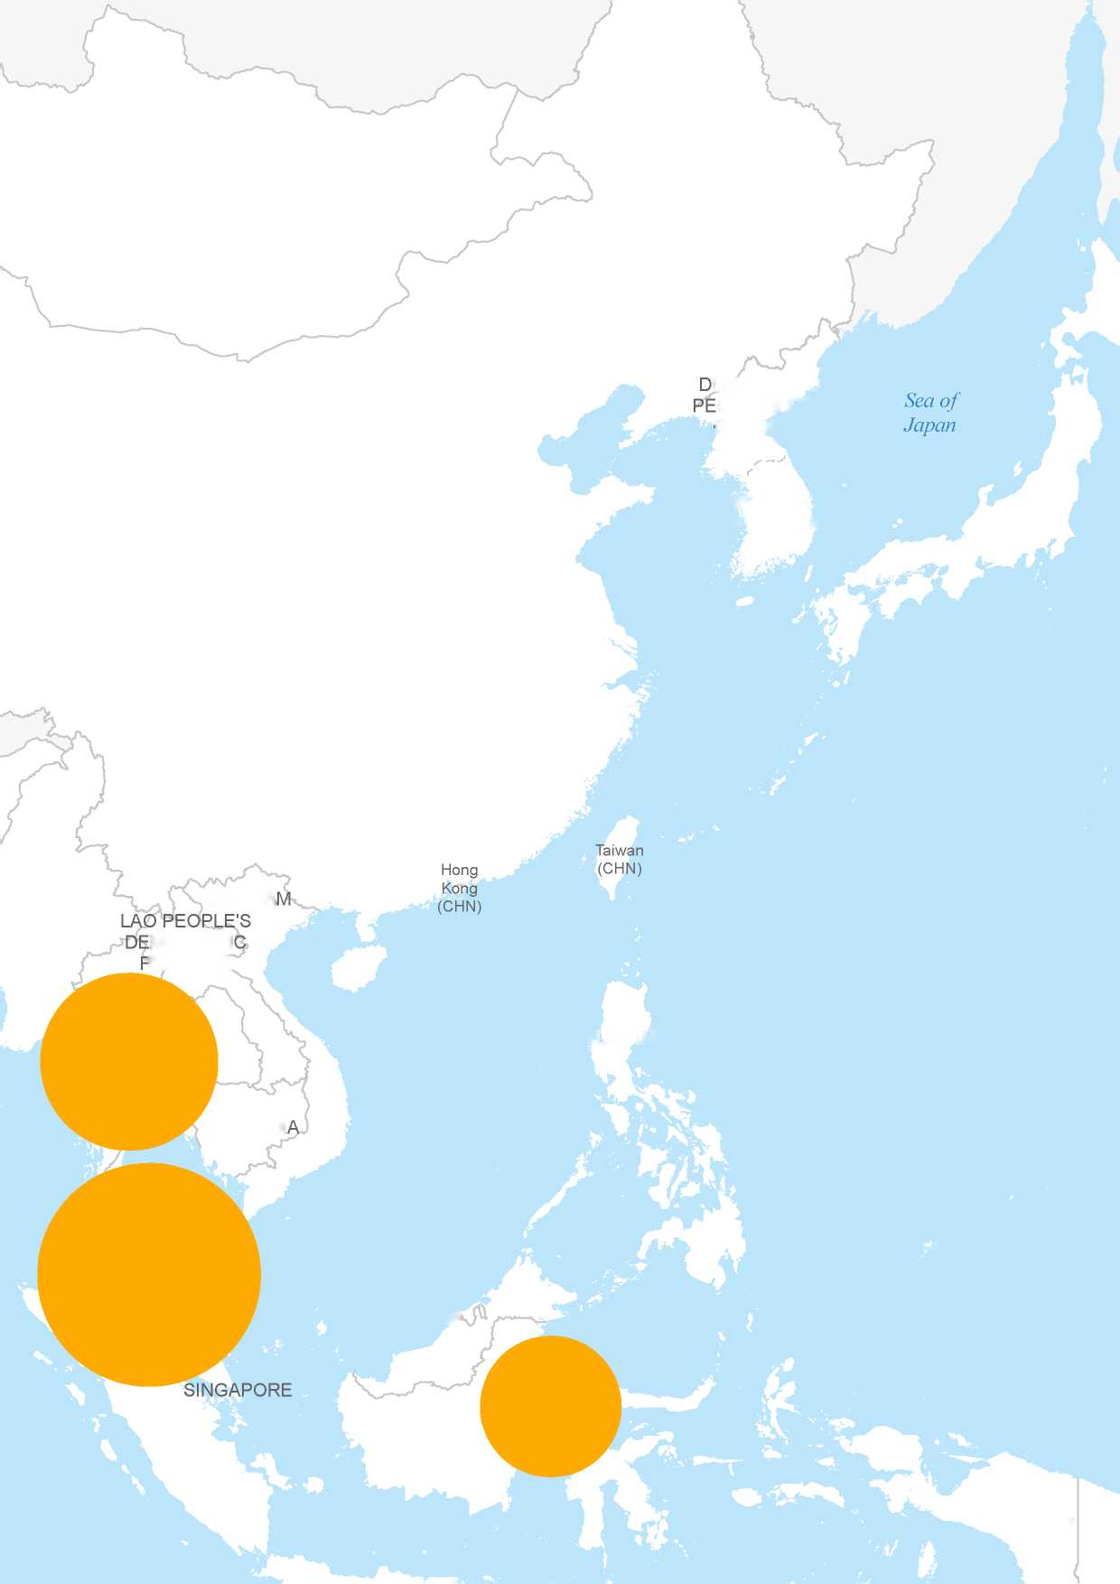

MONGOLIA

JAPAN

MYANMAR

VIET NA

PHILIPPINES

THAILAND

CAMBODI

PALAU

MALAYSIA

INDONESIA

37

REPUBLIC OF KOREA

MOCRATI REPUBLIC

PAP

G

*South*

*China Sea*

EMOCRATIC OPLE'S REP. OF KOREA

BRUNEI DARUSSALAM

*Philippine Sea*

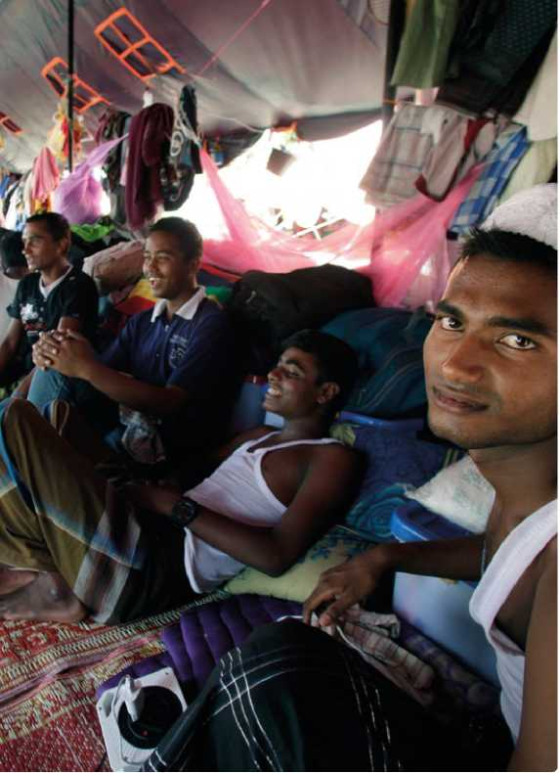

Rohingya men rest in a temporary shelter in Aceh, Indonesia, where they have been living since being rescued by Indonesian

fishermen from an abandoned smugglers' boat in May.

© UNHCR / T. Harva / July 2015

Afghan refugees constitute the second largest refugee population in the world and represent one of the most protracted situations. The regional Solutions Strategy for Afghan Refugees (SSAR), developed by the Islamic Republics of Afghanistan, Iran and Pakistan with the support of UNHCR, addresses the protracted situation of Afghan refugees by supporting voluntary repatriation, sustainable reintegration and assistance to host countries. Continued resettlement is also commensurate with the goals of the SSAR.

Asia: 2017 Projected needs and targets

The total projected resettlement needs for the Asia region in 2017, identified by UNHCR offices, is 153,358 persons. This marks a 11 per cent decrease from the projected needs for 2016, which were 169,559. The number of persons projected for submission in 2017 is 9,200. The 37 per cent decline from the 15,878 persons planned for submission in 2015 is due to the completion of group processing in Thailand and Nepal.

Sub-regional Overviews

South-East Asia, East Asia and the Pacific

The South-East Asia, East Asia and Pacific sub-region is comprised of Australia, Brunei Darussalam, Cambodia, China (including Hong Kong Special Administrative Region (SAR) and Macau SAR), Indonesia, Japan, the Lao People's Democratic Republic (Lao PDR), Malaysia, Mongolia, New Zealand, the Pacific Island States, Papua New Guinea, the Philippines, the Republic of Korea, Singapore, Thailand, Timor-Leste, and Viet Nam.

Half of the countries/territories in this sub-region have not acceded to the 1951 Refugee Convention and/or the 1967 Protocol (Brunei-Darussalam, Hong Kong SAR, Indonesia, the Lao PDR, Malaysia, Mongolia, most of the Pacific Island States, Singapore, and Thailand). The absence of national legal frameworks and procedures relating to refugee protection, limited local integration opportunities, and the lack of prospects for voluntary repatriation for the majority of the refugee populations demonstrate the continued need for resettlement as an important durable solution in the region.

In 2015, Malaysia was the fifth top global submission country, from which 7,147 refugees were submitted, and 12,574 departed for resettlement. Consequently, refugees from Myanmar represented the nationality with the fifth largest resettlement submission rate globally (9,738 persons in 2015 compared to 15,170 submitted in 2014). Thailand submitted 3,954 individuals in 2015 compared to 4,800 in 2014. Processing of refugees from Myanmar out of Southeast Asia has significantly reduced as the region moves away from resettlement processing and concentrates more on a wider durable solutions strategy.

ASIA AND THE PACIFIC

The suspension of resettlement activities out of Bangladesh has been in effect since 2010. However, the Government of Bangladesh announced a National Strategy for the Rohingya in 2014, which included the possibility to recommence resettlement after progress is made in implementing the National Strategy. UNHCR Bangladesh will prioritize the processing of the cases that were submitted prior to the suspension.

The Regional Office for South-East Asia in Bangkok, Thailand provides oversight, coordination, and support for resettlement activities in Bangladesh, Brunei Darussalam, Cambodia, Indonesia, Lao People's Democratic Republic, Malaysia, Mongolia, Myanmar, Philippines, Singapore, Thailand, Timor-Leste, and Viet Nam. It does so in accordance with the Regional Solutions Strategy.

In 2017, activities carried out by the Regional Office on resettlement within the region will include: providing operational support to country operations on resettlement; regional coordination and harmonization of resettlement approaches within the region as part of comprehensive solutions in accordance with the regional solutions strategy; provision of support to strengthen anti-fraud mechanisms to ensure integrity in resettlement; and resettlement processing for a small number of cases in countries in South-East Asia with no or limited UNHCR presence (i.e. Brunei-Darussalam, Cambodia, Lao PDR, Mongolia, Singapore, Timor-Leste, and Viet Nam) should the needs arise.

South Asia

The South Asia sub-region includes India, Nepal, and Sri Lanka. None of these countries have acceded to the 1951 Convention or the 1967 Protocol relating to the Status of Refugees, nor have they developed national legal frameworks and procedures relating to refugee protection. Local integration remains a limited option for refugees residing in this region, with the exception of India where the Government permits the naturalization of Afghan refugees of Sikh or Hindu origin, who arrived in the country after 2007.

Resettlement of Bhutanese refugees out of Nepal in 2015 reached a milestone of over 100,000 resettled since the launch of the programme in 2007. This equates to nearly nine out of ten refugees having been resettled. Resettlement in 2017 will continue to decrease out of Nepal with planned submissions of only 500 individuals in 2017, compared to 4,869 individuals submitted in 2015 and 5,726 in 2014 respectively.

South-West Asia

The South-West Asia sub-region comprises the Islamic Republic of Afghanistan, the Islamic Republic of Iran, and the Islamic Republic of Pakistan. Iran and Pakistan combined are currently hosting over 2.5 million registered Afghan refugees and they continue to be priority situations for the strategic use of resettlement.

Iran hosts the world's largest urban population (951,142 Afghan refugees and 28,268 Iraqi refugees), with 97 per cent living in urban or semi-urban areas, and the remainder living in settlements. UNHCR continues its efforts to promote and expand resettlement and other durable solutions out of Iran. The implementation of a regional multi-year strategy supports voluntary repatriation, sustainable reintegration and assistance to host countries (Afghanistan, Iran and Pakistan). Five outcomes that guide the strategy in Iran include voluntary repatriation, essential services and shelter, livelihood and food security, protection and resettlement. Resettlement will continue in 2017 for 1,000 individuals, focusing on the most vulnerable refugees, including those exposed to protection risks (such as Afghan refugee women and girls at risk) and those with serious medical needs. This helps to alleviate the burden on medical and social service providers in the country due to the current global sanctions on Iran, which have negatively impacted the service delivery of various sectors of the Government.

Asia: 2017 Projected global needs and targets

|  |  |  |  |  |  |  |
| --- | --- | --- | --- | --- | --- | --- |
| A. Region of Asylum | B. Total projected resettlement needs* | | C. Total UNHCR submissions planned for 2017 (target)** | | D. UNHCR core staff capacity in 2017 | |
| cases | persons | cases | persons | cases | persons |
| East Asia & the Pacific | 22,278 | 36,045 | 3,418 | 6,290 | 1,810 | 2,975 |
| South Asia | 1,393 | 3,413 | 465 | 1,210 | 212 | 607 |
| South-West Asia | 26,333 | 113,900 | 505 | 1,700 | 359 | 1,205 |
| Grand Total | **50,004** | **153,358** | **4,388** | **9,200** | **2,381** | **4,787** |

* including multi-year planning

** based upon UNHCR total capacity (core staff + affiliate workforce) in 2017

A young Syrian refugee girl plays in the late afternoon in Gaziantep province, Southeast Turkey.

© UNHCR / K. Porteous / September 2015

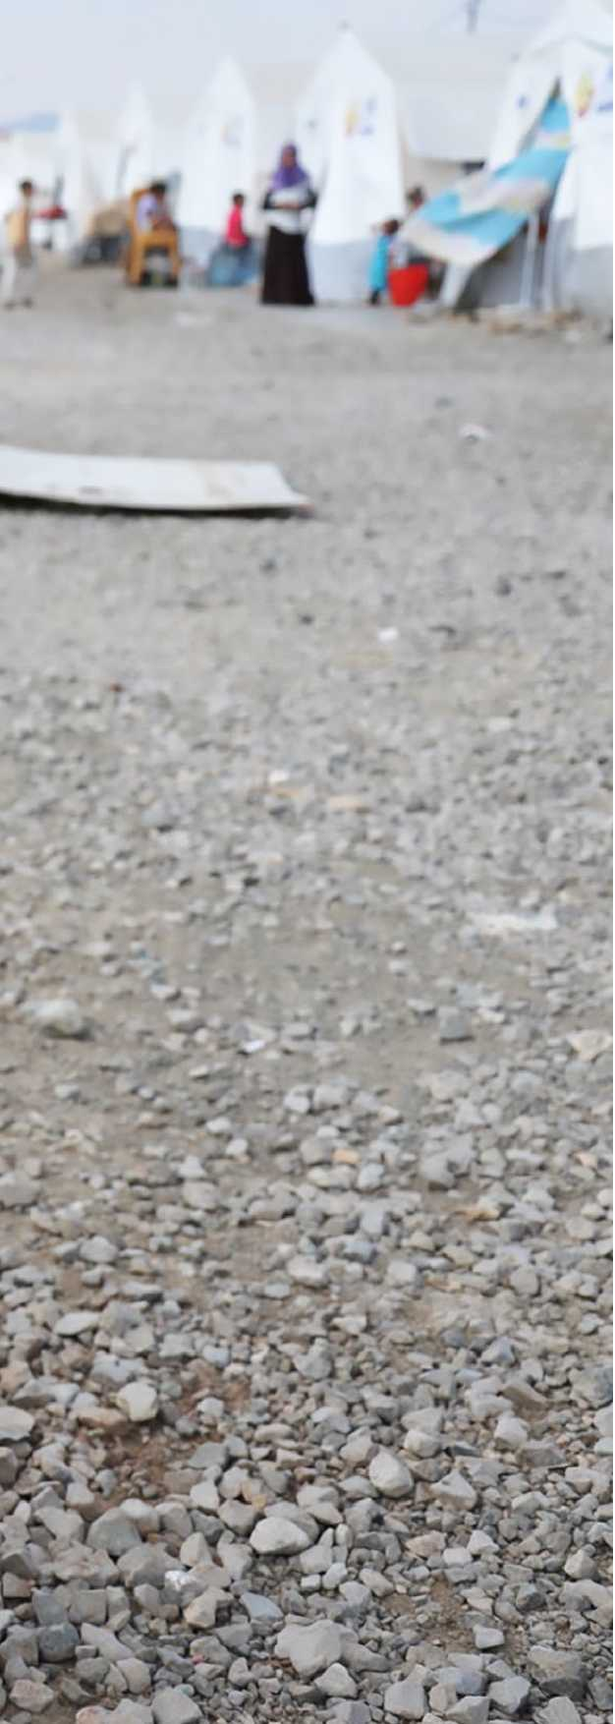

Trends in 2015

EUROPE

The number of resettlement submissions from Europe increased from 16,392 in 2014 to 18,833 in 2015, mainly due to the rise in the number of submissions made from Turkey. During 2015, UNHCR offices in Turkey submitted the third highest number of refugees for resettlement globally (18,260). Departures to resettlement countries from the region, however, decreased from 9,653 persons in 2014, to 8,336 in 2015.

During 2015 the Syrian refugee population in

Turkey increased from 1.5 million to over 2.5 million. Additionally, due to the conflict in Ukraine, over 300,000 refugees have sought protection in neighbouring countries, with the majority claiming asylum in the Russian Federation.

Resettlement continues to be a critical component of UNHCR's protection strategy in a number of European countries. In this regard, and depending on the context of each country, resettlement will be used strategically as well as a tool for protection and an expression of international solidarity and responsibility-sharing.

Regional developments

The volume of refugee and migrant flows in Europe reached unprecedented levels in 2015, and the vulnerability of people on the move and their humanitarian and protection needs have increased significantly. One million refugees and migrants made the perilous journey across the Mediterranean into Europe in 2015. The majority (850,000) crossed from Turkey to Greece through the Aegean and Dodecanese seas.1 This movement constitutes one of the largest movements of displaced people through European borders since the Second World War.

During the course of 2015, Turkey has become the largest refugee-hosting country in the world. Aside from the Syrian population, Turkey also hosts some 250,000 refugees and asylum-seekers from other countries with increasing arrivals from Iraq. Registering and hosting the refugee population on this scale continues to pose serious challenges to both the Turkish authorities and UNHCR. With the exception of Syrian nationals, asylum-seekers arriving from non-European countries currently undergo full registration and Refugee Status Determination (RSD) and are recognized on an individual basis by UNHCR under its mandate. Over the course of 2016, Turkey will take over full responsibility for registration and RSD of all nationalities, with UNHCR

1 Figures valid as of 31 December 2015, available at

<http://data.unhcr.org/mediterranean/country.php?id=83>

**NORWAY**

**ETHERLANDS**

**POLAND**

**BELGIUM**

**CZECH**

**EMBOURG**

**REPUBLIC**

**SLOVAKIA**

**AUSTRIA**

**LIECHTENSTEIN**

**HUNGARY**

**SWITZERLAND**

**FRANCE**

**SLOVENIA**

**CROATIA**

**BOSNIA AND**

**ITALY**

**HERZEGOVINA**

**MARINO**

**SERB**

**MONACO**

**ORM**

**GOSL**

**ANDORRA**

**ALBANIA**

**SPAIN**

**MALTA**

*Medit*

**EUROPE**

CAPACITY FOR 2017

**as of 25 May 2016**

**BY COUNTRY OF ASYLUM**

-»

**SWEDEN**

UNHCR'S TOTAL RESETTLEMENT

**UNITED KINGDOM**

**OF GREAT BRITAIN AND**

**NORTHERN IRELAND**

**GERMANY**

**HOLY SE**

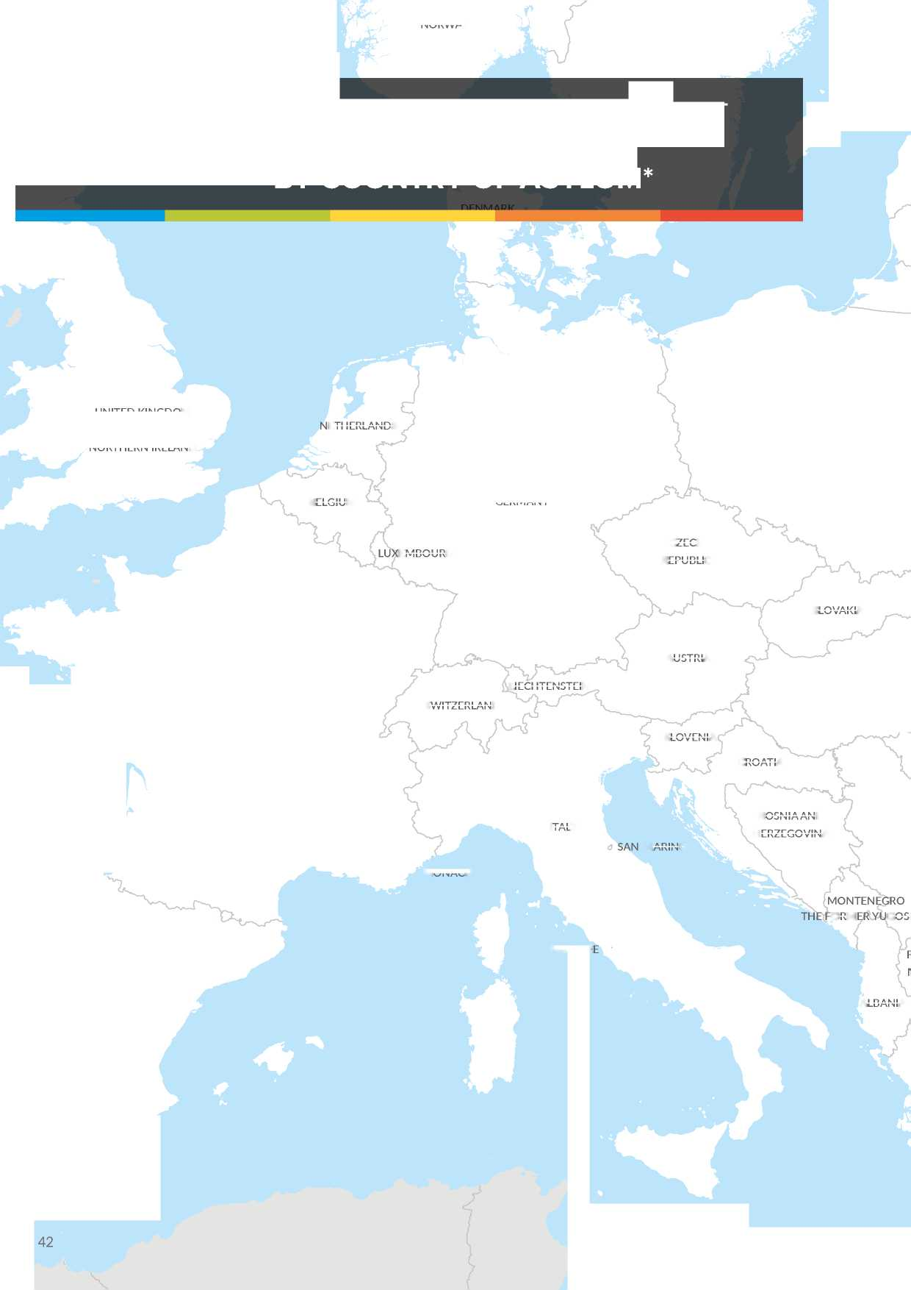

50,000

**ESTONIA**

**BELARUS**

**UKRAINE**

**REPUBLIC**

**MOLDO**

**BULGARIA**

**GEORGIA**

**ARMENIA**

43

*erranean*

*Sea*

**LATVIA**

20,000

1,000

**GREECE**

*Black Sea*

**TURKEY**

**CYPRUS**

**LITHUANIA**

5,000

**ROMANIA**

**LAV**

**EPUBLIC OF**

**ACEDONIA**

**UNHCR's estimated total resettlement capacity**

* UNHCR total resettlement capacity includes core staffing and affiliate workforce

The boundaries and names shown and the designations used on this map do not imply official endorsement or acceptance by the United Nations.

400km

© UNHCR - Geneva, 25 May 2016

**RUSSIAN**

**FEDERATION**

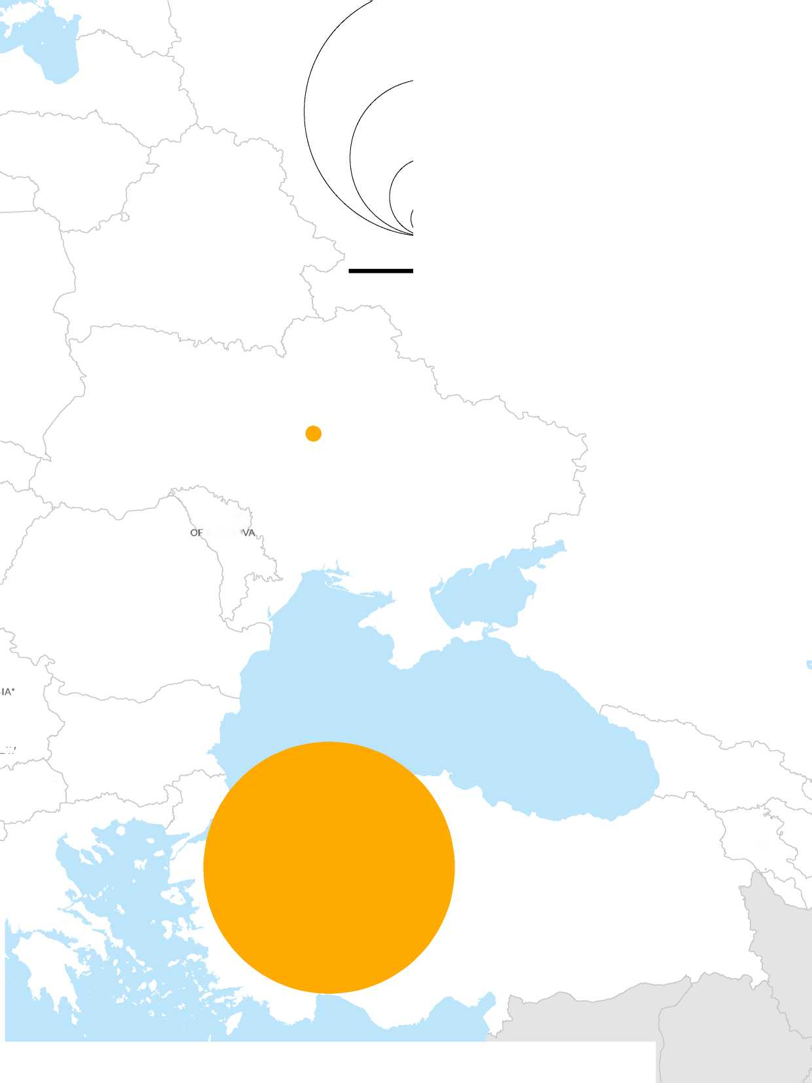

continuing to support through capacity building activities. UNHCR is planning to support the Directorate General of Migration Management (DGMM) in a verification exercise of the Syrian refugee population in Turkey, which should be completed in 2017.

As a result of the negotiations between the European Union (EU) and Turkey on mitigating measures to address the dramatic increase in the numbers of refugees moving to Europe from and through Turkey, the number of resettlement spaces offered by European countries for Syrians in Turkey has dramatically increased. The implementation of an expedited resettlement process, beginning in late March 2016, has increased the possibility for Syrian refugees in Turkey to gain access to a durable solution. In this context, resettlement will be used both as a tool for protection for those who are most in need as a well as a responsibility-sharing mechanism.

In certain Eastern European countries, national asylum systems lack the capacity to ensure effective protection. National RSD procedures, including access to RSD, often do not meet international standards. In the case of the Russian Federation, for example, access to asylum procedures continues to pose a particular challenge, notably for persons of certain nationalities or with specific profiles. Moreover, many of the existing national RSD procedures have insufficient safeguards to protect against the generally poor quality decision-making and frequent discriminatory practices. In some instances, these discriminatory practices included acts of overt racism and xenophobia directed towards persons of concern, which frequently threaten the physical security of refugees and asylum-seekers. UNHCR continues to work with the State authorities in Eastern Europe to help ensure access to quality RSD procedures and decision­making that meets international standards.

In those European States, UNHCR continues to use resettlement strategically to advocate for a more rights-based approach to asylum and greater protection, as well as improved living standards for all refugees. The continued resettlement for refugees with specific needs, particularly those at risk of *refoulement*, in need of medical care, and/or at risk of sexual or gender-based violence, help to relieve some of the burden placed on the increasingly strained resources of host governments.

In other European countries such as Malta, which has sound asylum systems yet limited absorption capacity, resettlement will continue to be used as a strategic protection tool in order to provide effective solutions for those with specific needs.

Europe: 2017 Projected needs and targets

Resettlement needs in Europe increased from 214,972 persons in 2016 to 306,950 in 2017. This marks a 43 per cent increase in needs since last year. The ongoing armed conflict in Syria was the principal reason for the upsurge in resettlement needs, with Syrians in Turkey making up 90 per cent of those projected to be in need of resettlement in Europe.

Sub-regional overviews

Eastern Europe

The estimated resettlement needs in Eastern Europe (Russian Federation and Ukraine) in 2017 is conservatively estimated to be some 1,500 people. These refugees originate primarily from Afghanistan, Syria, and the South Caucasus (Armenia, Azerbaijan, and Georgia).

Due to the ongoing fighting in eastern Ukraine, there are now over 800,000 internally displaced persons (IDPs) in Ukraine and more than 300,000 Ukrainians have sought asylum in neighbouring countries, mostly in the Russian Federation. In 2017, UNHCR's offices in Ukraine and the Russian Federation will continue to work on improving access to the national asylum system and RSD decision­making in both countries, as well as advocating for better local integration of refugees. In light of the deterioration in the protection environment within the region, UNHCR plans to increase resettlement submissions throughout the region, which will necessitate improvements to its current registration and case identification procedures. Presently, due to resource constraints, it is difficult to have an entirely accurate picture of the regional resettlement needs. However, it is expected that enhancements to UNHCR's registration procedures and identification of persons of concern in the Russian Federation as well as the planned verification exercise throughout Ukraine, both of which are to be undertaken in 2016, will allow for a much better assessment of regional resettlement needs. In consideration of this, the current estimate of 1,500 persons in need of resettlement will very likely need to be revised upwards, save a significant change in the currently volatile protection environment within the region.

South-Eastern Europe

The estimated total resettlement needs in South-Eastern Europe (Malta and Turkey) are 305,450 persons, of which 305,000 are currently living in Turkey. The projected resettlement needs of Syrians in Turkey rose from 170,000 in 2016, to 275,000 in 2017. The resettlement needs of Syrians in Turkey increased proportionally to the size of the Syrian refugee population in Turkey which has risen to over 2.5 million persons, and is projected to increase further to 2.75 million persons over the course of 2016.

EUROPE

Turkey plans to submit 40,000 Syrians for resettlement in 2017 which is double the target number of referrals for Syrians in Turkey in 2016. This increase is due to the large-scale resettlement to European countries envisaged under the EU-Turkey Statement of 18 March 2016. The planning figures represent a rough estimate based on the processing capacity and the number of resettlement spaces that are anticipated for refugees in Turkey. These estimates may, however, need to be revised should there be any further developments related to resettlement of Syrians from Turkey, particularly to European countries.

Resettlement will also continue to be sought for the most vulnerable among the refugee population in Malta, estimated at 350 persons.

Europe: 2017 Projected global needs and targets

|  |  |  |  |  |  |  |
| --- | --- | --- | --- | --- | --- | --- |
| A. Region of Asylum | B. Total projected resettlement needs* | | C. Total UNHCR submissions planned for 2017 (target)** | | D. UNHCR core staff capacity in 2017 | |
| cases | persons | cases | persons | cases | persons |
| Eastern Europe | 600 | 1,500 | 240 | 600 | 150 | 305 |
| South-Eastern Europe | 82,735 | 305,450 | 15,705 | 52,350 | 5,850 | 17,300 |
| Grand Total | **83,335** | **306,950** | **15,945** | **52,950** | **6,000** | **17,605** |

* including multi-year planning

** based upon UNHCR total capacity (core staff + affiliate workforce) in 2017

Middle East

and Nor

Abu Hamada (46 years), Syrian Refugee, watching the snow at the entrance of their tent in the Refugee Camp (Bekaa, Lebanon).

© UNHCR / H. Darwish / January 2016

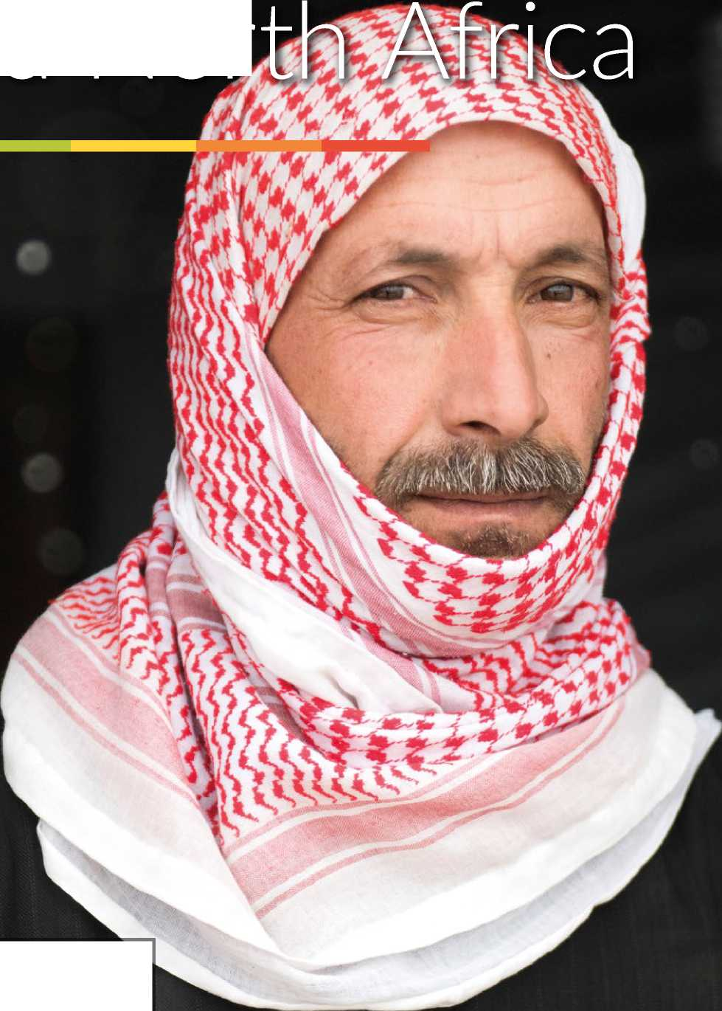



Trends in 2015

MIDDLE EAST AND NORTH AFRICA

In 2015, 18 UNHCR country offices in the Middle East and North Africa (MENA) submitted a total of 53,331 urban and camp-based refugees to 23 resettlement countries. The vast majority were Syrian refugees who constituted 84 per cent of the total submissions from the region. Resettlement from the MENA region increased significantly during the last quarter of 2015 when resettlement countries quickly and substantially expanded resettlement programmes for Syrian refugees as an expression of solidarity and responsibility-sharing towards the Syrian refugee crisis.

As a result, total submissions from the MENA region in 2015 were more than double the total number of submissions in 2014 (23,169). The increase in submission rates on this scale was achieved largely due to the use of innovative and streamlined resettlement and humanitarian admission processes. In this regard, the number of Syrians submitted for resettlement in 2015 (44,914) was nearly triple the number submitted in 2014 (15,470). In 2015, there was also a significant increase in resettlement departures from the MENA region as reported by UNHCR when a total of 18,948 refugees departed, compared with 12,309 in 2014. These figures represent departures that were reported to UNHCR, however it is likely that the actual number of departures is far higher - as not all data is shared by States with UNHCR.

In 2015, resettlement and humanitarian admission programmes served both as an immediate protection response for Syrian refugees who have compelling protection needs as well as a tool for responsibility­sharing towards the Syrian refugee crisis. The majority of submissions were made from the main Syrian refugee­hosting countries; Jordan, Lebanon, Turkey, Egypt and Iraq, with much smaller numbers being submitted from other countries in the region.

The volatile security situation in some parts of the region continues to impose constraints on the ability of resettlement countries to access or interview refugees for resettlement, causing the suspension of States' resettlement missions in Syria, Yemen, Libya and some parts of Iraq. In addition, the sharp deterioration in the security of many countries in the MENA region has caused operations to prioritize emergency response activities, which has impacted on resettlement processing.

In 2015, resettlement submissions of emergency, urgent, and medical cases on a dossier basis provided critical protection solutions to 321 individuals submitted from the region through these streams.

**MIDDLE EAST** UNHCR'S TOTAL RESETTLEMENT

**AND NORTH** CAPACITY FOR 2017

**AFRICA BY COUNTRY OF ASYLUM\***

**as of 25 May 2016**

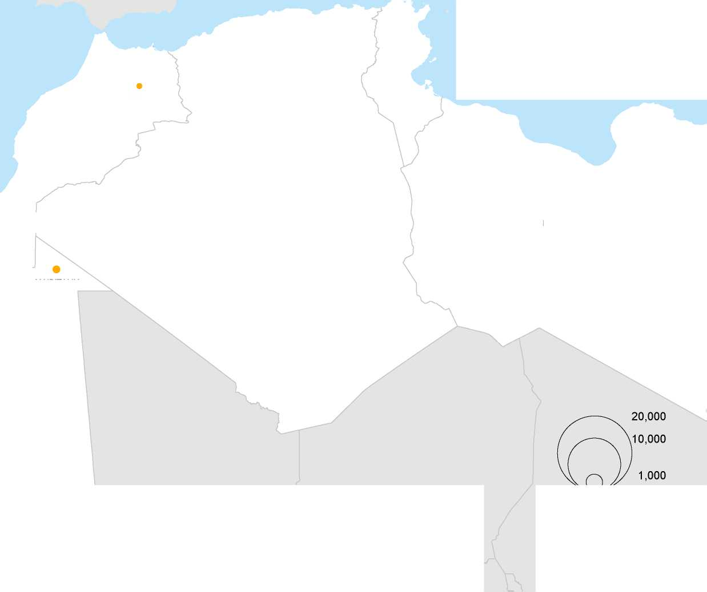

**TUNISIA**

**MOROCCO**

**MAURITANIA**

*Mediterra*

*Sea*

**LIBYA**

400km

**ALGERIA**

**UNHCR's estimated total resettlement capacity**

*Black*

*Sea*

*Gulf*

**SAUDI**

**ARABIA**

**BAHRAIN**

**QATAR**

**UNITED ARAB**

**EMIRATES**

**OMAN**

**YEMEN**

© UNHCR - Geneva, 25 May 2016

* UNHCR total resettlement capacity includes core staffing and affiliate workforce

The boundaries and names shown and the designations used on this map do not imply official endorsement or acceptance by the United Nations.

*a*

*INDIAN*

*OCEAN*

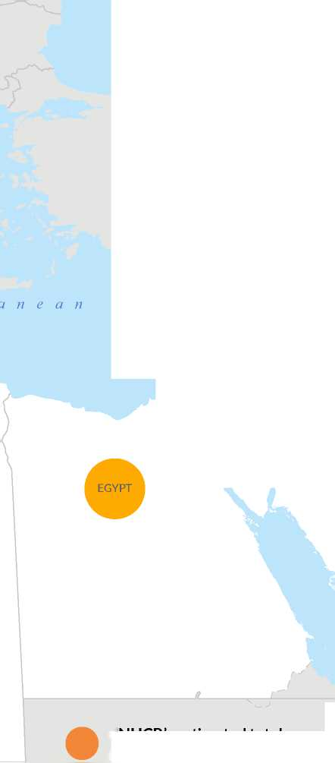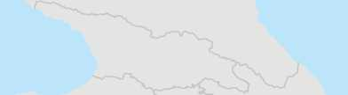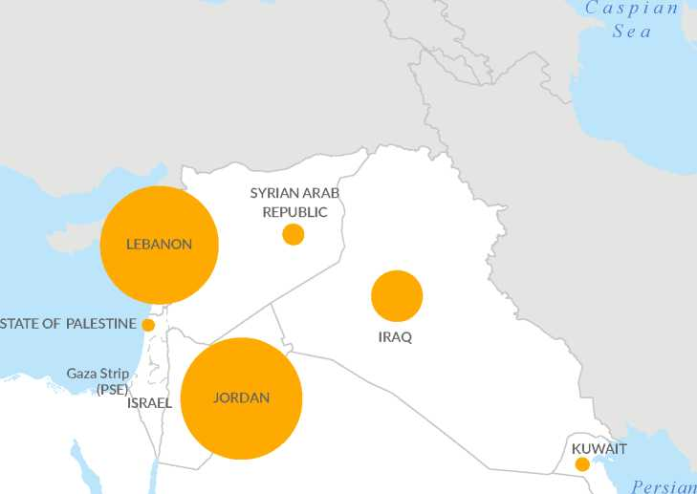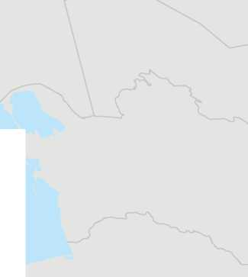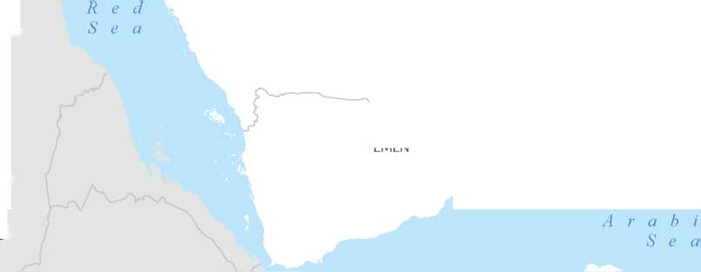

Regional developments

The region's protection environment is influenced by Level 3 emergencies in Syria, Iraq and Yemen, as well as protracted displacement in other countries. The operational context within the MENA region is volatile and is likely to remain so. The region is experiencing increasingly protracted crises with complex political outlooks, rapidly shifting strategic geo-political alliances, growing social and economic tensions, and escalating vulnerabilities as a result. Countries in the region are anticipating further internal displacement or refugee outflows triggered by shifts on political fronts.

The worsening protection space in the MENA region has forced increasing numbers of persons of concern to seek effective protection outside the region, including through perilous sea journeys across the Mediterranean. It is reported that over 181,000 people have made the sea crossing from Turkey and Northern Africa to Europe in 2016 and over one million in 2015. Global attention has focused on the risks refugees and migrants are willing to take to reach Europe, with over 1,200 refugees and migrants estimated to have died whilst undertaking the dangerous journey in 2016 alone. While recent developments related to movement from and through Turkey to Europe may reduce the number of dangerous Mediterranean crossings, it is equally probable that other routes to reach Europe will be identified, including through Sudan, Egypt and Libya.

The Syrian refugee crisis continues to remain at the top of the humanitarian agenda globally. The number of Syrian refugees registered with UNHCR in the five main host countries combined (Turkey, Lebanon, Jordan, Egypt and Iraq) exceeded 4.8 million in March 2016 and it is expected to increase to over five million by December 2017, unless significant changes occur on the military front or a substantive peace agreement is reached. Against this background, neighbouring countries continue to strictly manage access to territory citing security and limited absorption capacity.

Syrian civilians will continue to seek safety and protection across international borders in 2016 and beyond. Resettlement does not only provide Syrian refugees with a durable solution but has often been a critical and life-saving intervention for refugees with urgent protection needs and compelling vulnerabilities. Other pathways for admission have provided those Syrian refugees who benefitted from them with access to safety and protection. These solutions form an important component of UNHCR's protection strategy for Syrian refugees. Staffing resources as well as operational procedures have been put in place to identify the most vulnerable among the Syrian refugee population to be referred for resettlement and humanitarian admission.

Since September 2015, and in consultation with the relevant resettlement countries, UNHCR has developed and piloted several streamlined resettlement methodologies specific to Syrian refugees that have resulted in the expedited processing of a substantial number of refugees. These innovative approaches have looked to refine processes both within UNHCR and resettlement countries' procedures. For example, during the course of the year UNHCR has worked to implement the Pilot Identification Programme with Australia, the Humanitarian Transfer Programme with Canada and the Simplified Identification Form with the USA.

In a High Level Meeting on the 30th of March 2016, the UN Secretary General and the High Commissioner for Refugees called on States to increase opportunities for the admission of Syrian refugees through humanitarian and complementary pathways. Humanitarian pathways, including resettlement and humanitarian admission, private sponsorship programmes, humanitarian visas and admission on medical grounds, are designed specifically to provide protection and solutions to refugees at risk. Complementary pathways, such as family and extended family reunification, labour mobility schemes and academic scholarships and apprenticeships, can also provide opportunities for refugees to regain self­sufficiency and normality of life. During the course of 2015, there has been an increase in awareness both within UNHCR and among States that these pathways also offer viable protection and solutions mechanism to refugees as well as serve as an important expression of solidarity and responsibility-sharing.

Between 2013 and March 2016, States have generously offered over 200,000 places for resettlement and other admission pathways for Syrian refugees. Consequently, the first milestone of 130,000 places by 2016 called for by UNHCR has been achieved. In an effort to address the ever growing plight of Syrian refugees, UNHCR is advocating for resettlement and other admission pathways for at least 10 per cent of the Syrian refugee population by the end of 2018 as a demonstration of international solidarity and responsibility-sharing.

The MENA region continues to host significant numbers of Iraqi, Somalis, Sudanese, Eritreans and Palestinian refugees. The number of Iraqi refugees in the region significantly increased in late 2014 and early 2015, owing to renewed violence in Iraq, and many of them have survived or witnessed severe violence. Refugees from sub-Saharan African countries in the MENA region often endure prolonged asylum, and are affected by the limited assistance and support mechanisms in the countries of asylum. Several refugee groups in the MENA region continue to be at risk of sexual and gender-based violence and arrest and detention. Protection risks are particularly heightened for certain refugee profiles such as Lesbian, Gay, Bisexual, Transgender and Intersex (LGBTI) and victims of trafficking. Resettlement remains the main

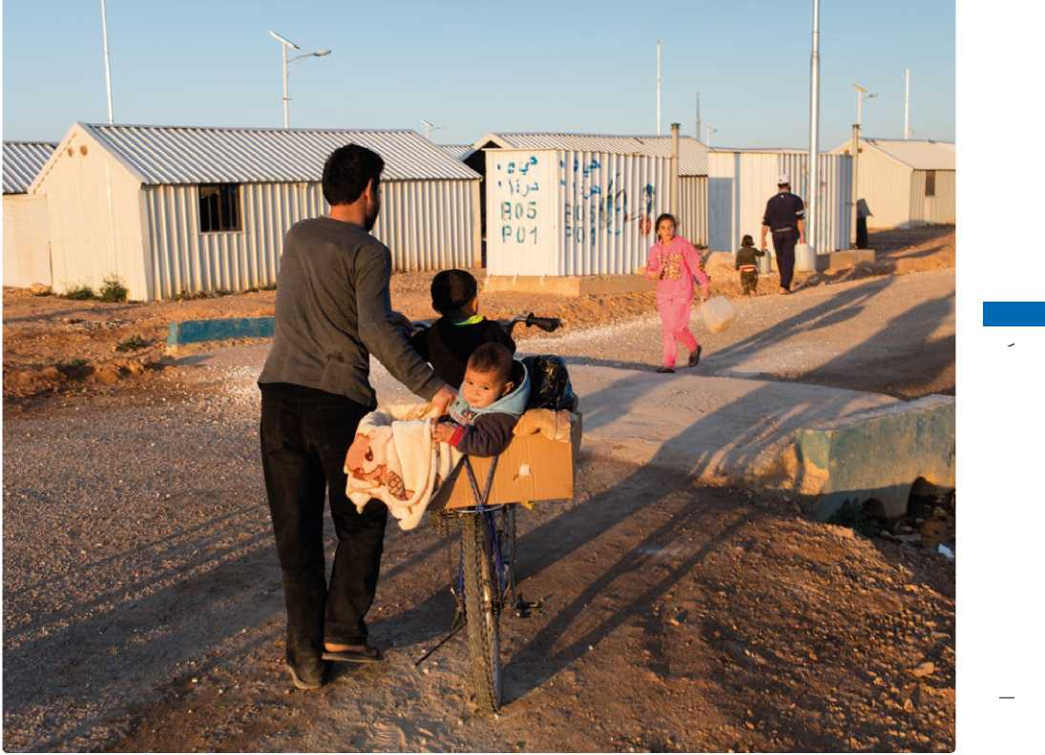protection tool and the only durable solution for many refugees in the region when conditions in their countries of origin are not conducive to return in safety and dignity. Despite the needs, resettlement quotas are limited for these refugee populations. An increased and diversified resettlement quota from States is needed in order to address the needs of the most vulnerable refugees from all refugee populations in the region.

A Syrian man wheels his two sons through Azraq refugee camp in Northern Jordan, where nearly 35,000 Syrian refugees are now living. © UNHCR / I. Prickett / March 2016

MIDDLE EAST AND NORTH AFRICA

UNHCR will continue to advocate and facilitate resettlement from countries in conflict such as Yemen, Libya, Syria and Iraq. In these countries, refugees are often trapped in the midst of fighting and resettlement serves as a critical protection tool and a life-saving intervention. UNHCR will continue to facilitate the use of videoconference technology to ensure access to refugees whom resettlement countries cannot access in person.

Much progress has been made during recent years with regard to the use of biometrics and the majority (90 per cent) of Syrian refugees above the age of seven in the region have been iris-scanned. The enhanced use of biometrics to verify the identity of refugees before resettlement country processing is being piloted in Jordan. UNHCR also assists resettlement countries in collecting biometric data.

Palestinian refugees living in Baghdad continue to face both indiscriminate and targeted attacks, including harassment and threats based on nationality, verbal and physical abuse, sexual violence, kidnapping and extortion, killings as well as house-to-house searches at the hands of state and non-state actors. The renewed violence in Central Iraq and discrimination against some groups, in particular persons of Palestinian origin, has also resulted in heightened protection risks for refugees. It has been estimated that 3,000 Palestinian refugees in Iraq are in need of resettlement, and these refugee populations will be prioritised for resettlement processing in 2017.

Palestinian refugees formerly resident in Iraq and currently located in Syria who are neither registered nor eligible to register with United Nations Relief and Works Agency (UNRWA), have benefited from prioritization for resettlement. Approximately 100 persons from this population continue to have resettlement needs and will be prioritized for submission in 2017.

The MENA Protection Service will continue to coordinate the submission of the emergency, urgent and medical cases, and facilitate evacuations to the Emergency Transit Facilities (ETFs) in Romania and Slovakia for emergency cases in need of immediate protection while their resettlement cases are processed.

In addition, UNHCR will continue its efforts to find solutions for those Iranians in need of international protection who remain in Camp Liberty in Iraq.

In all of its protection activities, including resettlement, UNHCR prioritizes those who are most vulnerable and at risk, without making distinctions on any grounds, including nationality, gender, ethnic background, religious belief, class or political opinion. Prioritization based on specific needs naturally results in programming that addresses the protection and assistance needs of individuals who may have faced persecution and abuse due to their gender, ethnic or religious backgrounds.

The MENA Protection Service

The MENA Protection Service provides oversight, coordination, and support for resettlement activities in Algeria, Egypt, Iraq, Israel, Jordan, Kuwait, Libya, Lebanon, Mauritania, Morocco, Saudi Arabia (covering Bahrain, Oman and Qatar), Syria, Tunisia, United Arab Emirates and Yemen.

In 2017, activities by the MENA Protection Service to promote resettlement and other admission pathways in coordination with the Division of International Protection include: operational support to country offices for Syrian and non-Syrian caseloads through the deployment of resettlement experts; technical missions; case-review/advice; oversight; training of UNHCR and affiliate work force staff and other capacity building modalities; regional and bilateral consultations on annual planning and where applicable, contingency planning; drafting of submission plans and contingencies; development of processing methodologies; collection and analysis of relevant data; evidence-based advocacy as well as coordination with internal and external actors such as members of the Core Group on Resettlement of Syrians, other countries with humanitarian and additional pathways for admission, the International Organization for Migration (IOM), NGOs and private sector; technical support, including training of embassy and consulate staff on reception and assessment of applications for humanitarian visa; and research and piloting of projects in the area of other admission pathways.

MENA: 2017 Projected needs and targets

The total projected resettlement needs for the MENA region in 2017, identified by UNHCR offices is 280,915 persons. This marks a decrease compared with the projected needs for the region of 369,334 individuals in 2016. The reason for the decrease in the total resettlement needs is largely methodological: firstly, since UNHCR has not been able to verify the presence of registered refugees in Libya due to the security environment, a different approach to the calculation of the needs was adopted compared with previous years; and secondly, the number of registered Syrian refugees in Lebanon did not increase as anticipated due to the change of residency requirements in Lebanon in early 2015, thus impacting on projected resettlement needs which are calculated based on the projected population figures. This apparent reduction does not reflect a decrease in the resettlement needs, which remain high for Syrians and other refugee populations in the region.

It should also be noted that the projected resettlement needs and targets for the MENA region do not include the relevant figures for Turkey, where 275,000 Syrian refugees are projected to be in need of resettlement. It is estimated that ten per cent of the Syrian refugee population are in need of resettlement, amounting to projected resettlement needs in 2017 for a total of 477,000 Syrians in Egypt, Iraq, Jordan, Lebanon and Turkey[2]. This marks a 16 per cent increase in the projected resettlement needs for Syrian refugees compared with 2016 when 410,000 Syrians were estimated to be in need of resettlement in the same five operations.

Projected submissions from the MENA region in 2017 are 50,500; mainly Syrian refugees in Jordan, Lebanon, Egypt, and Iraq, which represents an almost 100% increase from 2016 initial targets (26,865). This large increase in targets is mainly attributed to the dramatic increase in pledges and quotas for resettlement of Syrian refugees from the MENA region.

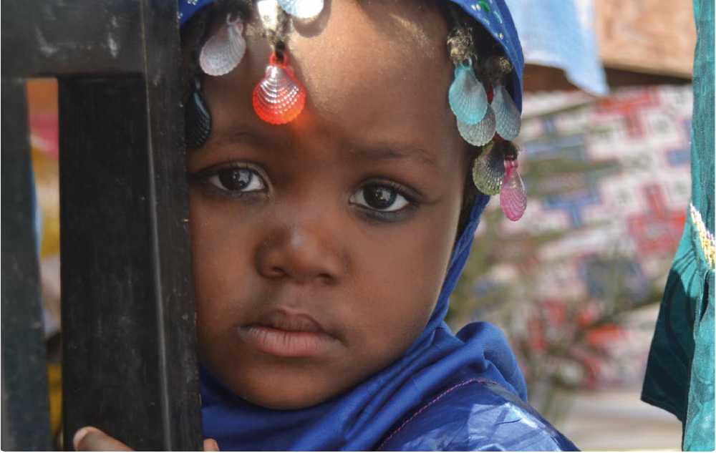Sub-regional overviews

Two-year-old Moona displays a traditional West African outfit in commemoration of International Women's Day at the Women Refugees Centre in Nouakchott. © UNHCR / H. Pes / March 2016

MIDDLE EAST AND NORTH AFRICA

The Middle-East and the Gulf

The total projected resettlement needs for 2017 for the Middle East and the Gulf are 262,910 persons. Since 2013, UNHCR has put in place a rigorous identification mechanism allowing UNHCR to identify those who are most in need of resettlement. As displacement situations in the region remain protracted and vulnerabilities exacerbate, UNHCR will continue its efforts to identify and process vulnerable refugees for resettlement, including through its community-based protection and outreach activities. Refugees with compelling specific protection needs from Iraq, but also others from Somalia, Sudan, and Eritrea as well as Palestinian refugees continue to be in need of resettlement, and will be referred along with Syrian refugees from all the countries in the Middle East and the Gulf. In particular, Palestinians in Iraq will be a priority caseload for resettlement in 2017.

North Africa

The total projected resettlement needs are 18,005 persons. North Africa is characterized by mixed- migration movements from sub-Saharan Africa, with modest refugee populations of these nationalities registered in the host countries, as well as Syrians and others. For UNHCR the challenge remains to ensure access to those in need of protection and resettlement, while avoiding the impression that resettlement might be an alternative migration route. As in previous years, resettlement will be limited to those refugees with compelling protection needs requiring urgent or emergency resettlement.

Middle East and North Africa: 2017 Projected global needs and targets

|  |  |  |  |  |  |  |
| --- | --- | --- | --- | --- | --- | --- |
| A. Region of Asylum | B. Total projected resettlement needs* | | C. Total UNHCR submissions planned for 2017 (target)** | | D. UNHCR core staff capacity in 2017 | |
| cases | persons | cases | persons | cases | persons |
| Middle East | 92,808 | 262,910 | 11,994 | 42,490 | 3,822 | 11,992 |
| North Africa | 6,000 | 18,005 | 2,856 | 8,010 | 1,439 | 3,989 |
| Grand Total | **98,808** | **280,915** | **14,850** | **50,500** | **5,261** | **15,981** |

* including multi-year planning

** based upon UNHCR total capacity (core staff + affiliate workforce) in 2017

Annex

UNHCR Global Resettlement

Statistical Report 2015

Introduction

This report summarizes the resettlement activities of UNHCR Offices worldwide in 2015. The information for this report is drawn from the UNHCR Resettlement Statistical Reports (RSR), which are submitted by UNHCR Country Offices on a quarterly basis.

Certain information in this report is organized by regions, reflecting the five UNHCR Regional Bureaus: Africa, the Americas, Asia and the Pacific, Europe and MENA (Middle East and North Africa).

For the purposes of this report, country of asylum refers to the country form which refugees are submitted to and from which they departed for resettlement. Country of resettlement refers to the country to which refugees are submitted for resettlement and to which they arrive on resettlement. Country of origin refers to the country where refugees derive their nationality. The submission figures include those made through UNHCR Regional Resettlement Hubs, Regional Offices as well as Headquarters.

At a Glance Figures

|  |  |  |  |  |  |
| --- | --- | --- | --- | --- | --- |
| \ 2011 | | 2012 | 2013 | 2014 | 2015 |
| Submissions | 91 843 | 74 840 | 92 915 | 103 890 | 134044 |
| Departures | 61 649 | 69 252 | 71 449 | 73 608 | 81 893 |
| Countries of Asylum | 79 | 80 | 80 | 90 | 84 |
| Countries of Origin | 77 | 79 | 69 | 70 | 70 |
| Countries of Resettlement | 22 | 26 | 25 | 31 | 30 |

Submissions*

Top Ten: UNHCR Resettlement Submissions in 2015

ANNEX

|  |  |  |
| --- | --- | --- |
| Country of Resettlement | Persons | 10, |
| United States | 82,491 |  |
| Canada | 22,886 |  |
| Australia | 9,321 |  |
| Norway | 3,806 |  |
| United Kingdom | 3,622 |  |
| New Zealand | 1,980 | ■ |
| Sweden | 1,595 | I |
| France | 1,456 | 1 |
| Finland | 1,296 | 1 |
| Germany | 964 |  |
| All Others | 4,627 |  |

Grand Total

134,044

,000 20,000 30,000 40,000 50,000 60,000 70,000 80,000

* Resettlement submission figures from resettlement countries may not match UNHCR reported figures.

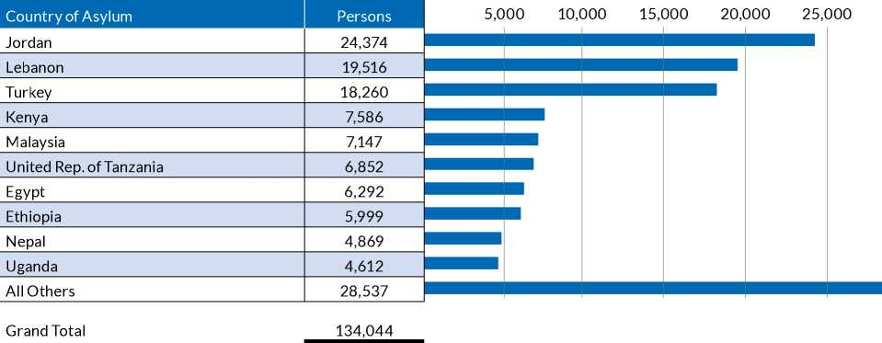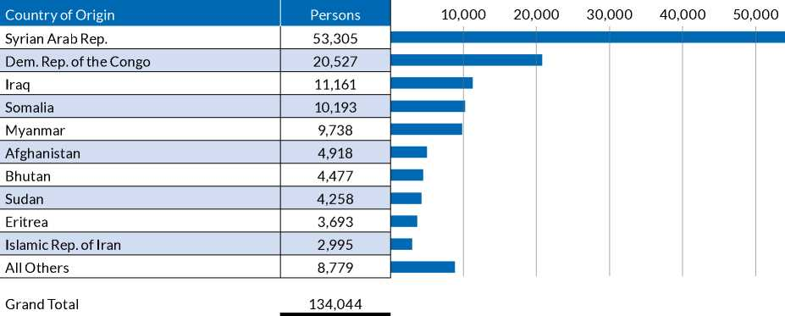

UNHCR Resettlement Submissions in 2015

|  |  |  |  |
| --- | --- | --- | --- |
| Submissions by Region of Asylum | Cases | Persons | Per cent Total (persons) |
| Africa | 11,411 | 38,870 | 29.0% |
| Asia & the Pacific | 7,261 | 21,620 | 16.1% |
| Europe | 6,575 | 18,833 | 14.0% |
| MENA | 11,700 | 53,331 | 39.8% |
| The Americas | 438 | 1,390 | 1.0% |

Grand Total

37,385

134,044

100.0%

|  |  |  |  |
| --- | --- | --- | --- |
| Submissions by Region of Origin | Cases | Persons | Per cent Total (persons) |
| Africa | 13,693 | 43,800 | 32.7% |
| Asia & the Pacific | 8,670 | 24,258 | 18.1% |
| Europe | 3 | 12 | <1% |
| MENA | 14,612 | 64,593 | 48.2% |
| The Americas | 403 | 1,351 | 1.0% |
| Stateless | 4 | 30 | <1% |

Grand Total

37,385

134,044

100.0%

UNHCR Submissions by Region of Asylum 2011-2015

|  |  |  |  |  |  |
| --- | --- | --- | --- | --- | --- |
| Region of Asylum | 2011 | 2012 | 2013 | 2014 | 2015 |
| Africa | 22,267 | 15,710 | 28,141 | 35,079 | 38,870 |
| Asia & the Pacific | 38,404 | 38,020 | 37,559 | 27,450 | 21,620 |
| Europe | 7,716 | 8,526 | 11,096 | 16,392 | 18,833 |
| MENA | 22,493 | 10,519 | 14,247 | 23,169 | 53,331 |
| The Americas | 963 | 2,065 | 1,872 | 1,800 | 1,390 |

Grand Total

91,843 74,840

92,915 103,890 134,044

UNHCR Submissions by Region of Asylum 2011-2015

60,000

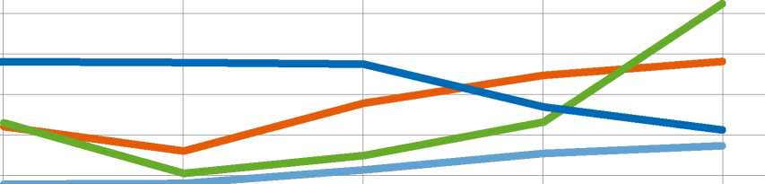50,000

40,000

30,000

20,000

10,000

0

2011

2012

2014

2015

| MENA | I | Europe | I | The Americas |
| --- | --- | --- | --- | --- |

2013

Asia & the Pacific Africa

Departures*

Top Ten: UNHCR Resettlement Departures in 2015

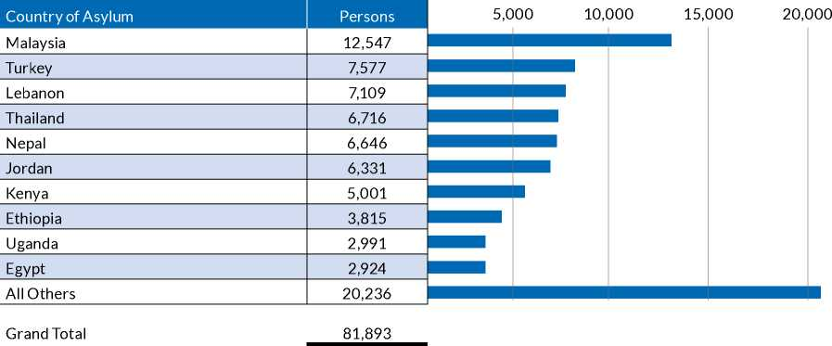

25,000

ANNEX

|  |  |  |  |  |  |  |  |  |
| --- | --- | --- | --- | --- | --- | --- | --- | --- |
| Country of Origin | Persons | 5,000 | 10,000 | 15,000 | 20,000 | | 25,000 | |
| Myanmar | 18,503 |  |  |  |  |  |  |  |
| Syrian Arab Rep. | 13,816 |  |  |  |  |  |  |  |
| Dem. Rep. of the Congo | 10,701 |  |  |  |  |  |  |  |
| Somalia | 8,406 |  |  |  |  |  |  |  |
| Iraq | 7,590 |  |  |  |  |  |  |  |
|  |  |  |  |  |  |  |  |  |
| Bhutan | 6,332 | 1 |  |  |  |  |  |  |
|  |  |  |  |  |  |  |  |  |
| Afghanistan | 3,412 |  |  |  |  |  |  |  |
|  |  |  |  |  |  |  |  |  |
| Eritrea | 2,533 |  |  |  |  |  |  |  |
|  |  |  |  |  |  |  |  |  |
| Islamic Rep. of Iran | 2,297 |  |  |  |  |  |  |  |
|  |  |  |  |  |  |  |  |  |
| Sudan | 2,092 |  |  |  |  |  |  |  |
|  |  |  |  |  |  |  |  |  |
| All Others | 6,211 | I |  |  |  |  |  |  |
| Grand Total | 81,893 |  |  |  |  |  |  | |

|  |  |  |  |  |  |  |
| --- | --- | --- | --- | --- | --- | --- |
| Country of Resettlement | Persons | 10,000 | 20,000 | 30,000 | 40,000 | 50,000 |
| United States | 52,583 |
| Canada | 10,236 |  |  |  |  |  |
| Australia | 5,211 |  |  |  |  |  |
| Norway | 2,220 |  |  |  |  |  |
| Germany | 2,097 |  |  |  |  |  |
| Sweden | 1,808 |  |  |  |  |  |
| United Kingdom | 1,768 |  |  |  |  |  |
| Finland | 964 | ■ |  |  |  |  |
| New Zealand | 756 | ■ |  |  |  |  |
| France | 700 | 1 |  |  |  |  |
| All Others | 3,550 |  |  |  |  |  |

Grand Total 81,893

Departure figures from resettlement countries may not match UNHCR reported figures as resettlement country figures may include submissions received outside of UNHCR auspices. UNHCR figures may also include cases in which UNHCR assisted , i.e. obtained exit permits for humanitarian admissions or family reunion but did not primarily submit.

UNHCR Resettlement Departures in 2015

|  |  |  |
| --- | --- | --- |
| Departures by Region of Asylum | Persons | Per cent Total (persons) |
| Africa | 24,016 | 29.3% |
| Asia & the Pacific | 29,701 | 36.3% |
| Europe | 8,336 | 10.2% |
| MENA | 18,948 | 23.1% |
| The Americas | 892 | 1.1% |
| Grand Total | 81,893 | 100.0% |

|  |  |  |
| --- | --- | --- |
| Departures by Region of Origin | Persons | Per cent Total (persons) |
| Africa | 27,593 | 33.7% |
| Asia & the Pacific | 31,942 | 39.0% |
| Europe | 10 | <1% |
| MENA | 21,468 | 26.2% |
| The Americas | 865 | 1.1% |
| Stateless | 15 | <1% |
| Grand Total | 81,893 | 100.0% |

UNHCR Departures by Region of Asylum 2011-2015

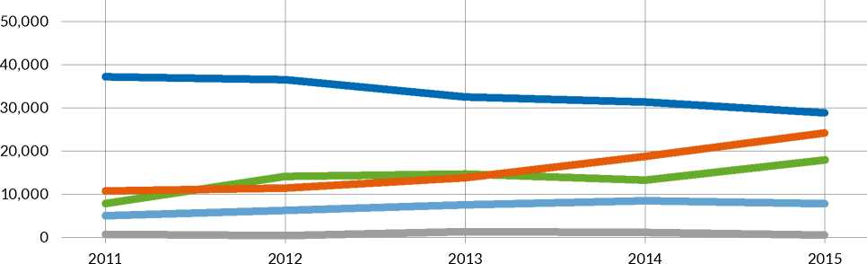

**UNHCR Departures by Region of Asylum 2011-2015**

|  |  |  |  |  |  |
| --- | --- | --- | --- | --- | --- |
| Region of Asylum | 2011 | 2012 | 2013 | 2014 | 2015 |
| Africa | 10,431 | 11,342 | 14,699 | 19,250 | 24,016 |
| Asia & the Pacific | 37,975 | 37,394 | 32,731 | 30,827 | 29,701 |
| Europe | 4,916 | 6,473 | 7,939 | 9,653 | 8,336 |
| MENA | 7,833 | 13,725 | 14,855 | 12,851 | 18,948 |
| The Americas | 494 | 318 | 1,225 | 1,027 | 892 |

Grand Total

61,649 69,252

71,449 73,608 81,893

|  |  |  |  |  |  |  |  |  |
| --- | --- | --- | --- | --- | --- | --- | --- | --- |
| Asia & the Pacific | I | Africa | I | MENA | I | Europe | ■ | The Americas |

UNHCR Resettlement Departures 2011-2015*

|  |  |  |  |  |  |
| --- | --- | --- | --- | --- | --- |
| Country of Resettlement | 2011 | 2012 | 2013 | 2014 | 2015 |
| Albania** | - | 0 | 197 | 278 | 483 |
| Argentina | 24 | 5 | 7 | 21 | 0 |
| Australia | 5,597 | 5,079 | 11,117 | 6,162 | 5,211 |
| Austria | 0 | 0 | 4 | 269 | 642 |
| Belarus | 0 | 0 | 0 | 0 | 14 |
| Belgium | 19 | 1 | 100 | 32 | 276 |
| Brazil | 23 | 8 | 56 | 44 | 6 |
| Canada | 6,827 | 4,755 | 5,113 | 7,233 | 10,236 |
| Chile | 22 | 3 | 3 | 0 | 0 |
| Czech Rep. | 0 | 25 | 1 | 4 | 0 |
| Denmark | 606 | 324 | 471 | 332 | 486 |
| Finland | 573 | 763 | 665 | 1,011 | 964 |
| France | 42 | 84 | 100 | 378 | 700 |
| Germany | 22 | 323 | 1,092 | 3,467 | 2,097 |
| Hungary | 0 | 1 | 0 | 4 | 2 |
| Iceland | 0 | 9 | 0 | 4 | 13 |
| Ireland | 36 | 40 | 62 | 98 | 178 |
| Italy | 0 | 9 | 0 | 0 | 96 |
| Japan | 18 | 0 | 18 | 23 | 19 |
| Liechtenstein | 0 | 0 | 0 | 5 | 17 |
| Luxembourg | 0 | 0 | 0 | 28 | 49 |
| Mexico | 0 | 0 | 0 | 1 | 0 |
| Netherlands | 479 | 262 | 362 | 743 | 428 |
| New Zealand | 477 | 719 | 682 | 639 | 756 |
| Norway | 1,258 | 1,137 | 938 | 1,188 | 2,220 |
| Paraguay | 13 | 0 | 0 | 0 | 0 |
| Poland | 0 | 0 | 0 | 0 | 2 |
| Portugal | 28 | 21 | 6 | 14 | 39 |
| Rep. of Korea | 11 | 20 | 31 | 14 | 42 |
| Romania | 0 | 0 | 0 | 44 | 2 |
| Spain | 0 | 80 | 0 | 30 | 92 |
| Sweden | 1,896 | 1,483 | 1,832 | 1,812 | 1,808 |
| Switzerland | 39 | 54 | 78 | 139 | 664 |
| United Kingdom | 424 | 989 | 750 | 628 | 1,768 |
| United States of America | 43,215 | 53,053 | 47,750 | 48,911 | 52,583 |
| Uruguay | 0 | 5 | 14 | 52 | 0 |

Grand Total

61,649 69,252

71,449 73,608 81,893

ANNEX

* Note:

All figures in 2015 are provisional and subject to change.

This table includes revised figures for 2013 and 2014.

This table includes countries with special resettlement programmes/ad-hoc resettlement intake.

Resettlement country figures (submissions and departures) may not match UNHCR reported figures as resettlement country figures may include submissions received outside of UNHCR auspices. UNHCR figures may also include cases in which UNHCR assisted, i.e. obtained exit permits for humanitarian admissions or family reunion but did not primarily submit.

** These figures represent individuals relocated from Camp Hurriya in Iraq.

Resettlement Categories

UNHCR Resettlement by Submission Category in 2015

|  |  |  |  |  |  |
| --- | --- | --- | --- | --- | --- |
| Category | Cases  Submitted | Persons  Submitted | % Cases Submitted | Persons  Departed | % Persons  Departed |
| Legal and/or Protection Needs | 12,827 | 52,260 | 34.3% | 32,153 | 39.3% |
| Survivors of Violence and/or Torture | 8,931 | 34,206 | 23.9% | 18,094 | 22.1% |
| Lack of Foreseeable Alternative Durable Solutions | 8,290 | 24,321 | 22.2% | 18,517 | 22.6% |
| Women and Girls at Risk | 4,393 | 12,174 | 11.8% | 8,369 | 10.2% |
| Medical Needs | 1,554 | 6,589 | 4.2% | 2,404 | 2.9% |
| Children and Adolescents at Risk | 839 | 3,171 | 2.2% | 613 | 0.7% |
| Family Reunification | 530 | 1,268 | 1.4% | 1,360 | 1.7% |
| Others/Unspecified | 21 | 55 | 0.1% | 383 | 0.5% |

Grand Total

37,385 134,044 100.00% 81,893 100.00%

UNHCR Resettlement Under the Women and Girls at Risk (AWR) Category in 2015

**Women and Girls at Risk Cases as a Percentage of Total Resettlement Submissions by UNHCR, 2011-2015**

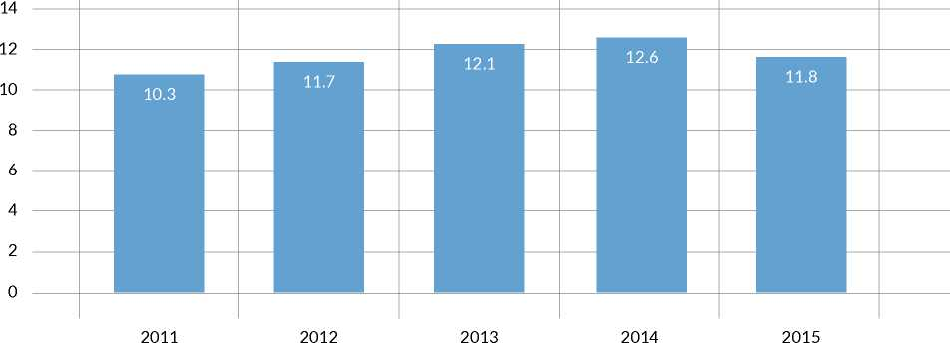

Per cent

**Top Ten Countries of Asylum: Submissions Under the Women and Girls at Risk Category, 2015**

|  |  |  |  |  |
| --- | --- | --- | --- | --- |
| Country of Asylum | Cases Submitted | Rate of AWR Submissions (% per Asylum Country) | Persons Submitted | Persons Departed |
| Turkey | 632 | 10.3% | 1,520 | 886 |
| Egypt | 524 | 27.2% | 1,314 | 665 |
| Kenya | 465 | 16.6% | 1,426 | 777 |
| Ethiopia | 421 | 22.0% | 1,348 | 678 |
| Pakistan | 298 | 40.3% | 897 | 682 |
| Lebanon | 269 | 8.0% | 738 | 380 |
| Burundi | 215 | 23.6% | 636 | 403 |
| Jordan | 191 | 3.5% | 447 | 174 |
| Uganda | 171 | 13.6% | 521 | 654 |
| Malaysia | 141 | 6.5% | 155 | 351 |

UNHCR Resettlement Under the Medical Needs Category in 2015



| Top Ten Submissions by Country of Asylum | Cases | Top Ten Submissions by Country of Origin | Cases | Top Ten Departures by Country of Resettlement | Persons |
| --- | --- | --- | --- | --- | --- |
| Turkey | 706 | Syrian Arab Rep. | 745 | United States | 1,253 |
| Jordan | 276 | Iraq | 366 | Canada | 254 |
| Lebanon | 117 | Somalia | 77 | United Kingdom | 178 |
| Malaysia | 76 | Myanmar | 63 | Sweden | 176 |
| Egypt | 66 | Dem. Rep. of the Congo | 63 | Norway | 154 |
| Kenya | 49 | Islamic Rep. of Iran | 44 | Germany | 81 |
| Iraq | 45 | Afghanistan | 43 | Denmark | 69 |
| Ethiopia | 31 | Sudan | 38 | Australia | 52 |
| Zambia | 26 | Eritrea | 32 | Finland | 44 |
| Uganda | 23 | Ethiopia | 14 | France | 42 |
| All Others | 139 | All Others | 69 | All Others | 101 |

Grand Total

_^^554__ Grand Total

Grand Total

2,404

ANNEX

**Resettlement Country Approval Rate Under the Medical Needs Category by Priority in 2015**

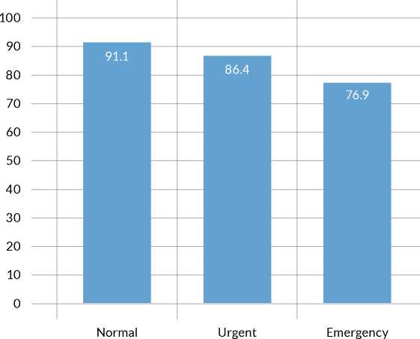

Approval Rate (in per cent)

UNHCR Resettlement by Priority in 2015

|  |  |  |  |  |  |
| --- | --- | --- | --- | --- | --- |
| UNHCR Submission Priority | Submissions | | | Departures | |
|  | Cases | % Cases | Persons | Persons | % Persons |
| Normal | 33,775 | 90.3% | 118,719 | 74,037 | 90.4% |
| Urgent | 3,352 | 9.0% | 14,727 | 6,770 | 8.3% |
| Emergency | 238 | 0.6% | 548 | 281 | 0.3% |
| Unspecified/Other | 20 | 0.1% | 50 | 805 | 1.0% |

Grand Total

37,385

100% 134,044 81,893

100%

**UNHCR Emergency Departures by Country of Resettlement, persons**

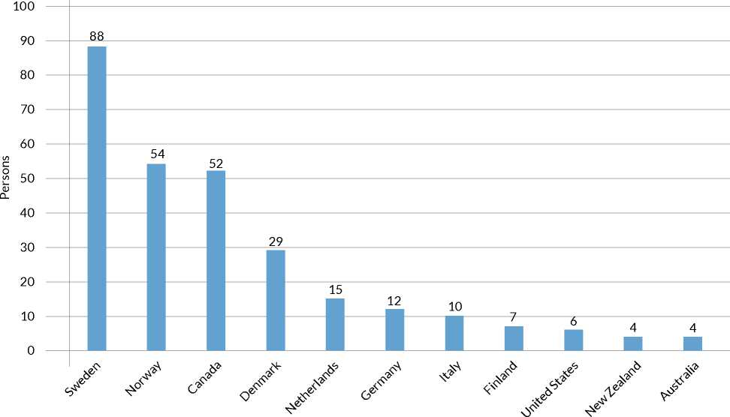

Emergency Cases as a Percentage of Total Resettlement Submissions by UNHCR (2011-2015, cases)

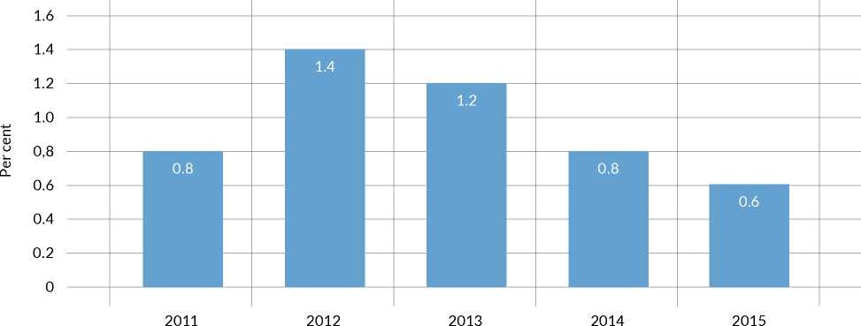

UNHCR Emergency Departures by Category, 2015

100%

Medical Needs - 121

43%

Legal and/or Protection Needs - 116  
41%

Women  
and Girls-

At-Risk

- 28

10%

Survivors of Violence and/or Torture - 10 - 4%

Other* - 6 - 2%

* Includes children/adolescents at risk, family reunification and lack of foreseeable alternative durable solution.

Acceptance Rates

Acceptance Rates of UNHCR Submissions by Resettlement Countries in 2015

Acceptance Rates of UNHCR Submissions by Country of Origin in 2015

Acceptance Rates of UNHCR Submissions by Submission Category in 2015

|  |  |  |
| --- | --- | --- |
| Country of Origin | Cases  Submitted | % Cases  Accepted |
| Syrian Arab Rep. | 10,372 | 92.6% |
| Dem. Rep. of the Congo | 5,114 | 95.9% |
| Iraq | 4,199 | 85.5% |
| Somalia | 3,515 | 85.3% |
| Myanmar | 3,082 | 98.0% |
| Eritrea | 1,765 | 95.3% |
| Islamic Rep. of Iran | 1,740 | 91.6% |
| Afghanistan | 1,689 | 84.8% |
| Bhutan | 1,500 | 98.3% |
| Sudan | 1,329 | 94.8% |
| All Others | 3,080 | 84.1% |

Grand Total

37,385 91.8%

|  |  |
| --- | --- |
| Submission Category | Acceptance  Rate |
| Family Reunification | 95.5% |
| Children and Adolescents at Risk | 93.8% |
| Legal and/or Protection Needs | 92.7% |
| Survivors of Violence and/or Torture | 91.9% |
| Women and Girls at Risk | 91.8% |
| Others/Unspecified | 91.3% |
| Lack of Foreseeable Alternative Durable Solutions | 90.5% |
| Medical Needs | 88.1% |

ANNEX

**Acceptance Rates of Resettlement Countries by UNHCR Resettlement Priority in 2015**

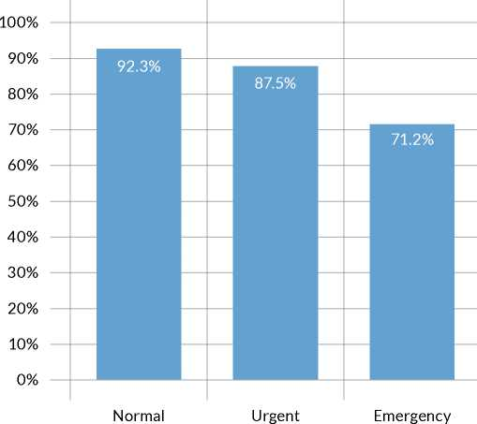

Priority Situations

Protracted Refugee Situations Where Resettlement Takes Place 2013-2015

**Comparison of UNHCR Resettlement Submissions and Departures 2013-2015**

|  |  |  |  |  |  |  |  |
| --- | --- | --- | --- | --- | --- | --- | --- |
| Country of origin | Country of Asylum | Submissions | | | Departures | | |
|  |  | 2013 | 2014 | 2015 | 2013 | 2014 | 2015 |
| Syrian Arab Rep. | Jordan | 373 | 6,084 | 22,273 | 184 | 1,539 | 4,776 |
| Lebanon | 4,769 | 7,318 | 18,476 | 983 | 4,903 | 6,547 |
| Turkey | 59 | 5,457 | 8,091 | 22 | 284 | 1,141 |
| Egypt | 0 | 1,581 | 3,074 | 0 | 187 | 889 |
| Iraq | 3 | 429 | 1,027 | 2 | 31 | 329 |
| Dem. Rep. of the  Congo | United Rep. of Tanzania | 362 | 3,823 | 6,638 | 433 | 221 | 1,168 |
| Uganda | 3,206 | 4,032 | 4,247 | 898 | 917 | 2,705 |
| Burundi | 1,064 | 3,776 | 3,310 | 348 | 549 | 1,824 |
| Rwanda | 2,606 | 2,699 | 2,568 | 922 | 2,569 | 1,382 |
| Iraq | Turkey | 7,145 | 6,852 | 6,611 | 4,253 | 5,803 | 4,073 |
| Jordan | 1,793 | 1,078 | 1,913 | 3,000 | 1,602 | 1,436 |
| Somalia | Kenya | 3,996 | 4,325 | 3,908 | 2,612 | 3,562 | 3,143 |
| Ethiopia | 2,308 | 1,977 | 3,459 | 1,782 | 3,070 | 2,613 |
| Myanmar | Malaysia | 14,441 | 10,814 | 6,190 | 8,072 | 10,566 | 11,962 |
| Thailand | 8,790 | 4,064 | 3,315 | 8,208 | 6,632 | 6,276 |
| Afghanistan | Pakistan | 1,405 | 2,075 | 2,338 | 990 | 876 | 1,110 |
| Islamic Rep. of Iran | 2,185 | 1,063 | 737 | 1,900 | 1,255 | 878 |
| Bhutan | Nepal | 7,070 | 5,566 | 4,477 | 10,665 | 8,395 | 6,332 |
| Sudan | Egypt | 1,262 | 1,043 | 1,943 | 1,253 | 37 | 1,098 |
| Eritrea | Ethiopia | 1,580 | 1,588 | 1,946 | 663 | 1,122 | 1,054 |

Per Capita Resettlement by Country of Resettlement in 2015

|  |  |  |  |
| --- | --- | --- | --- |
| Country of Resettlement | Persons Resettled in 2015 | National Population* | Population per Refugees Resettled |
| Liechtenstein | 17 | 38,000 | 2,235 |
| Norway | 2,220 | 5,211,000 | 2,347 |
| Canada | 10,236 | 35,940,000 | 3,511 |
| Australia | 5,211 | 23,969,000 | 4,600 |
| Sweden | 1,808 | 9,779,000 | 5,409 |
| Finland | 964 | 5,503,000 | 5,709 |
| New Zealand | 756 | 4,529,000 | 5,991 |
| Albania | 483 | 2,897,000 | 5,998 |
| United States | 52,583 | 321,774,000 | 6,119 |
| Luxembourg | 49 | 567,000 | 11,571 |
| Denmark | 486 | 5,669,000 | 11,665 |
| Switzerland | 664 | 8,299,000 | 12,498 |
| Austria | 642 | 8,545,000 | 13,310 |
| Iceland | 13 | 329,000 | 25,308 |
| Ireland | 178 | 4,688,000 | 26,337 |
| United Kingdom | 1,768 | 64,716,000 | 36,604 |
| Germany | 2,097 | 80,689,000 | 38,478 |
| Netherlands | 428 | 16,925,000 | 39,544 |
| Belgium | 276 | 11,299,000 | 40,938 |
| France | 700 | 64,395,000 | 91,993 |
| Portugal | 39 | 10,350,000 | 265,385 |
| Spain | 92 | 46,122,000 | 501,326 |
| Italy | 96 | 59,798,000 | 622,896 |
| Belarus | 14 | 9,496,000 | 678,286 |
| Rep. of Korea | 42 | 50,293,000 | 1,197,452 |
| Hungary | 2 | 9,855,000 | 4,927,500 |
| Japan | 19 | 126,573,000 | 6,661,737 |
| Romania | 2 | 19,511,000 | 9,755,500 |
| Poland | 2 | 38,612,000 | 19,306,000 |
| Brazil | 6 | 207,848,000 | 34,641,333 |

ANNEX

United Nations, Department of Economic and Social Affairs, Population Division (2015). World Population Prospects: The 2015 Revision, DVD Edition.

**66**

ANNEX

**68**

Refugee boy from the Democratic Republic of the Congo (DRC) in Gihembe Camp, Rwanda. The camp opened in 1997 for survivors of the M udende massacre, and today it is home to nearly 15,000 refugees from the eastern DRC.

© UNHCR / S. Masengesho / December 2015

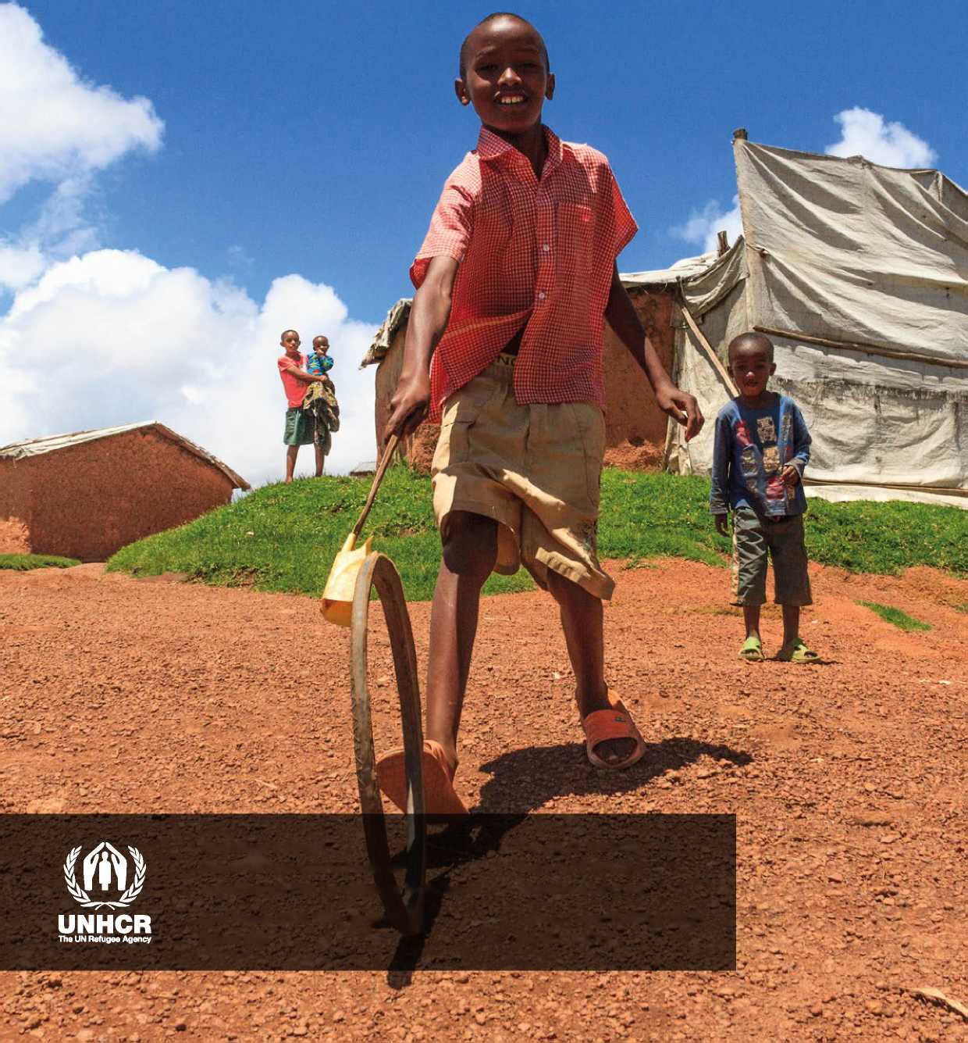

**Resettlement Service**

Tel: +41 22 739 8433

**Division of International Protection**

Fax: +41 22 739 7344

United Nations High Commissioner for Refugees

<http://www.unhcr.org>

Case Postale 2500, 1211 Geneva 2

Switzerland

Layout&Design: BakOS DESIGN © UNHCR 2016

1. In 2012 a group proposal for 10,000 Congolese refugees out of Rwanda was approved by the USA. A second proposal for Rwanda is under discussion.
2. This calculation is based on the projected Syrian refugee population in these five operations at the end of 2016.